Multi-Asset Commodity Risk Premia: Research Summary
Metals, Petroleum, Gas and Emissions, Precious Metals, NGL, Agriculture, Softs, US Power (Standalone), Correlation Analysis, and Cross-Commodity Portfolio
Basis of all results: daily returns net of 5 bp round-trip transaction costs, 1 January 2012 to 30 September 2026 for all seven buckets. Return is the annualised compound return, Vol the annualised volatility and IR their ratio (no risk-free rate). Each bucket has five sleeves: Momentum, Carry, Carry-Momentum, Value and Skewness (minus the skewness of the product's daily log returns over the past 252 observations; long if negative, short if positive). Equal Weight (EW PORT) averages the five sleeves equally; Inverse Vol weights each sleeve by the inverse of its trailing 63-day volatility, lagged one day. Periods (regimes): P1 2012-2016, P2 2017-2021, P3 2022-2026. Each product uses a short and a long tenor pair: Carry is the sign of the sum of the two pairs' z-scores (each against its own trailing 252 observations) and Carry-Momentum is the sign of the sum of the two pairs' slope changes over 20 observations (raw, not standardised); if a value is missing the last signal is kept. Signals are those of the main analysis, except that Value starts after 504 observations of the Value contract (two years), so that NGL Value is live before 2012; the Value contract is F3, except F2 for Precious Metals and Agriculture (changed on 1 November 2026). Naphtha is part of NGL, with Carry and Carry-Momentum on the F2-F4 pair only. US Power is a standalone bucket outside the cross-commodity book and is reported from 2 January 2017 (its data start in 2015 and Value needs two years of F3), so it has no P1. Relative to the previous version (v4_2012) Carry and Carry-Momentum add the two pairs instead of taking a sign vote (which left the position flat whenever the pairs disagreed), so every Carry, Carry-Momentum, portfolio, ranking and cross-commodity figure is re-derived; Momentum, Value and Skewness are unchanged.
Version note (v8, 10 November 2026). All seven buckets are on the data to 30 September 2026 and the current bucket definitions. Gas and Emissions (Henry Hub, TTF, UK Gas and EUA) is a new section, with its own appendix tables and figures; Henry Hub, previously part of Energy, is in it and UK Gas is new. NGL has five products (Ethane, Propane, Butane, Naphtha and Natural Gasoline): Naphtha is added to the three Mont Belvieu products, the CME Mont Belvieu natural gasoline swap (MMB) is added as the fifth on 10 November 2026, and Isobutane, the least liquid product in the data set, is removed from every bucket, pair, correlation and table. Agriculture is split in two on 10 November 2026: Agriculture (Corn, Wheat, Soybean and Live Cattle) and Softs (Sugar, Cocoa, Coffee and Cotton), a new section with its own appendix tables and figures; Soybean Oil is dropped, Live Cattle, Cocoa and Cotton are new, and the Carry tenor pairs are F1-F2 plus F1-F6 (F1-F7 for Soybean and Live Cattle). The single-pair, long-pair and two-pair Carry comparison of the Agriculture section is recomputed for the new pairs, in Agriculture and in Softs. The Correlation Analysis and the Cross-Commodity Portfolio cover the seven buckets and all twenty-one bucket pairs, so the Energy-ex-NatGas comparison no longer applies. US Power (PJM, ERCOT and MISO real-time monthly futures) is added as a standalone bucket with its own section, appendix tables and figures; it is not part of the cross-commodity book. The Key Findings, the liquidity section and table (36 products, with UK Gas, Naphtha, Natural Gasoline, Live Cattle, Cocoa, Cotton and the US Power series) and every appendix table and figure are redrawn on this basis, all figures as a cumulative return index starting at 100%, and tables and figures are renumbered.

Key Findings
- NGL is the strongest bucket in the research: Equal Weight (IR +1.35) and Inverse Vol (IR +1.35) are well ahead of every other bucket (the best of the rest is Petroleum at +0.84 and +0.89), and Momentum, Carry, and Carry-Momentum are each positive in every period, as they are in Petroleum. Naphtha, added as the fourth product in v8, lifted the Equal Weight IR from +1.20 (the three Mont Belvieu products) to +1.43; Natural Gasoline (CME MMB), added as the fifth product on 10 November 2026, lowers it to +1.35 (Inverse Vol +1.41 to +1.35) because its Momentum and Carry are close to zero, while the Equal Weight volatility and maximum drawdown are lower. Value (IR +0.08) and Skewness (IR +0.22) are the exceptions: Value is negative in P1 (-0.42), and Skewness is negative in P1 (-0.55) and strongly positive in P2 (+0.89).
- Gas and Emissions (Henry Hub, TTF, UK Gas and EUA) earns Equal Weight IR +0.62 and Inverse Vol IR +0.60 at 16.5% volatility, with Carry the strongest sleeve (IR +0.64) and Value (IR -0.14) the only negative one. The edge sits in European gas, TTF (combined IR +0.90) and UK Gas (+0.63), not in Henry Hub (-0.01) or EUA (-0.14), and in one episode: 2021 alone is 42% of the Equal Weight log return, and excluding July 2021 to June 2023 the IR falls to +0.30.
- US Power (PJM, ERCOT and MISO real-time monthly futures; standalone, outside the cross-commodity book) earns Equal Weight IR +0.30 and Inverse Vol IR +0.31 from 2017 at 29.4% volatility and a -47.1% maximum drawdown, with Value the best sleeve (IR +0.39) and Carry-Momentum the only negative one. It is a P2 result (Equal Weight IR +0.88 in P2, -0.03 in P3), 2022 is its worst year (Carry alone loses 1.85 of log return), and it is uncorrelated with the seven buckets (-0.02 to +0.05).
- Petroleum's Carry-Momentum is its strongest strategy (IR +0.71) and Value (IR -0.11) is the only core Petroleum strategy with a negative full-sample IR; the Equal Weight and Inverse Vol portfolios earn IR +0.84 and +0.89. Skewness is positive in Petroleum (IR +0.37), but mostly because it stayed long oil after the 2020 collapse: calendar years 2020, 2021, 2022 and 2026 add 2.23 of log return against a full-sample total of 1.67.
- In Metals, Value is the only strategy with a clear edge (IR +0.38); both portfolio constructions (Equal Weight -0.05, Inverse Vol +0.07) underperform simply holding Value alone, since blending four sleeves with little or no edge dilutes the one signal that works.
- Precious Metals, Agriculture and Softs are the three buckets where portfolio construction fails: neither earns a positive IR (Precious Metals Equal Weight -0.22, Inverse Vol -0.28; Agriculture -0.52 and -0.50; Softs -0.36 and -0.31), and in Precious Metals and Agriculture every core strategy is net negative full-sample, while in Softs only Value is positive (IR +0.13). Skewness is the only sleeve with a positive full-sample IR in Precious Metals (+0.09) and Agriculture (+0.45), where it trims the loss but does not reverse it; in Softs it is the weakest sleeve (-0.35) and lowers the portfolio IR (Equal Weight -0.21 to -0.36).
- Skewness is a different kind of premium from the other four. It is positive in five of the seven buckets (Petroleum, Gas and Emissions, NGL, Precious Metals and Agriculture) and negative in Metals and Softs, it is negative in P1 in five buckets and positive in P3 in five. Its gains in Petroleum, NGL and Precious Metals are largely long positions held after crashes (the four oil products were long on 89% to 100% of P3 days), consistent with its +0.41 correlation with a passive commodity index in the seven-bucket book, unlike Momentum, Carry and Carry-Momentum. Gas and Emissions is the exception to the long bias: Skewness is long on only 34% of TTF days and earns its gain on the short side.
- Petroleum-NGL is the most correlated pair of buckets for all seven series types (EW PORT correlation 0.56); Gas and Emissions-NGL (0.16), Petroleum-Gas and Emissions (0.13) and Metals-Precious Metals (0.12) follow, and no other pair exceeds 0.08. Yet standalone Petroleum-NGL is the best-performing of the twenty-one pairs under Equal Weight (IR +1.21, Inverse Vol IR +1.29) and second under Inverse Vol, behind Gas and Emissions-NGL (+1.32), proving correlation and performance are separate questions.
- The cross-commodity portfolio (each strategy equal-weighted across the seven buckets, then the five strategies combined) delivers Equal Weight IR +0.84 and Inverse Vol IR +0.90 at a volatility of 4.8% and 4.8%, and is positive in every period under both constructions. It is negatively correlated with equity (Equal Weight -0.09, Inverse Vol -0.10) and a traditional 60/40 portfolio (-0.10, -0.11), but with Skewness included it is positively correlated with a passive commodity index (+0.18, +0.15; -0.01 and -0.02 without Skewness), so it diversifies equity and bonds but is no longer free of commodity beta.
- Diversifying across all seven buckets lowers volatility but not risk-adjusted return: the Petroleum-NGL and Gas and Emissions-NGL pairs earn more per unit of risk (IR +1.21 and +1.29; +1.20 and +1.32) than the seven-bucket book (IR +0.84 and +0.90), at about 11.0% volatility against 4.8%, because the extra diversification comes from Metals, Precious Metals, Agriculture and Softs, where the core signals earn little or nothing.

Metals
- Momentum (Return -4.8%, Vol 14.7%, Max Drawdown -60.6%, IR -0.33): negative in P1 (IR -0.43) and P3 (-0.58) and roughly flat in P2 (+0.05). The P3 losses are in Lead (-1.17), Zinc (-0.52) and Copper (-0.33), the metals that spiked in 2021-2022 and then reversed sharply, which is the whipsaw a trend signal cannot avoid; only Aluminium made money in P3 (+0.61).
- Carry (Return +1.5%, Vol 12.3%, Max Drawdown -36.5%, IR +0.12) and Carry-Momentum (Return -1.1%, Vol 11.8%, Max Drawdown -57.6%, IR -0.09): both are positive only in P1 (IR +0.43 / +0.76); in P2 Carry is flat (+0.02) and Carry-Momentum negative (-0.57), and in P3 Carry is marginally negative (-0.07) and Carry-Momentum negative (-0.46). The P1 Carry result comes from Aluminium (IR +0.62), Zinc (+0.36) and Lead (+0.36), the three metals whose curves were in persistent contango (average F1-F13 slope of -4.3%, -2.3% and -1.8%, backwardated on only 1%, 3% and 1% of days), the years of large LME stocks, aluminium financing deals and warehouse queues of more than two years (Reuters, LME; at Access World's Vlissingen warehouse the aluminium queue peaked in 2014 at more than two years, Fastmarkets). Copper, whose curve was close to flat (average slope near zero, backwardated on 48% of days), lost (IR -0.29). Contango eased after P1 in Aluminium (average slope -2.6% in P2 and -2.3% in P3) and Zinc moved into backwardation (+1.2% in P2 and +1.2% in P3), but Lead's contango deepened again in P3 (-0.8% in P2, -2.8% in P3).
- Value (Return +4.2%, Vol 10.8%, Max Drawdown -27.3%, IR +0.38): the strongest strategy and the only one with a clear edge, positive in every period (P1 +0.34, P2 +0.08, P3 +0.79). It correlates at -0.50 with Momentum full-sample, the most negative pairing within the asset class and the strongest diversification relationship.
- The P3 Value result (+0.79) comes from the metals that overshot their five-year averages and fell back: Lead (+0.88), Zinc (+0.73) and Aluminium (+0.61). Aluminium peaked at $3,876 on 4 March 2022 in our series (settlement basis; the LME intraday record, about $4,073 in March, followed fears for European smelters under the energy crisis and for Russian supply) and was down to $2,076 by December 2023, and Zinc fell from $4,523 in April 2022 to $2,240 in May 2023. Copper (+0.15) is the exception because, after falling to $7,162 in July 2022, it rose to $14,851 on 22 September 2026, the high of our series (the LME three-month record reported by market sources is about $14,800 to $14,875 on 9 to 10 September), which market reports tie to US tariff turmoil, tight concentrate supply and electrification and data-centre demand.
- Skewness (Return -1.0%, Vol 12.0%, Max Drawdown -38.7%, IR -0.09): no stable edge, negative in P1 (IR -0.23) and P3 (-0.34) and positive in P2 (+0.35). No metal carries a lasting signal: full-sample IRs are Copper 0.00, Aluminium -0.03, Lead +0.03 and Zinc -0.17, and the sign of each metal changes between P1 and P2 (Aluminium +0.45, -0.40, -0.09; Zinc -0.54, +0.46, -0.37). The sleeve is long on 55% of days in Copper, 48% in Zinc, 47% in Lead and only 24% in Aluminium, and the short legs lose in Copper and Zinc (-0.24 and -0.62 in log return) but earn in Lead (+0.33) and Aluminium (+0.06). It correlates at -0.20 with Value and +0.01 with Momentum.
- Portfolio construction: Equal Weight (Return -0.3%, Vol 5.7%, Max Drawdown -25.2%, IR -0.05) and Inverse Vol (Return +0.4%, Vol 5.1%, Max Drawdown -20.4%, IR +0.07) both underperform holding Value alone (Return +4.2%, Vol 10.8%, Max Drawdown -27.3%, IR +0.38) on IR. Inverse Vol has the shallower drawdown and lower volatility of the two, but neither approaches Value's IR. Adding Skewness as a fifth sleeve lowers volatility (Equal Weight 6.6% to 5.7%, Inverse Vol 6.1% to 5.1%) but also lowers the IR (Equal Weight -0.02 to -0.05, Inverse Vol +0.14 to +0.07).
- Individual-metal decomposition: Momentum's blended IR of -0.33 masks a single working metal. Aluminium alone returns IR +0.21, the only positive result among the four, while Copper, Zinc, and Lead are all negative (Lead as low as -0.56). Value shows the opposite pattern, positive in every metal individually (+0.10 to +0.42), with blended volatility of 10.8% well below the roughly 15.9% average held by any one metal alone.
- Why neither construction beats Value: diversification only adds value when it combines more than one genuine edge. Value is the only strategy with a clear edge (IR +0.38); Carry adds little (+0.12) and Momentum (-0.33), Carry-Momentum (-0.09) and Skewness (-0.09) are negative, so blending them with Value dilutes the one real signal in the book instead of diversifying real risk. The same logic applies within a strategy: blending Momentum across metals dilutes Aluminium's one working signal, while blending Value across metals, where every metal carries a positive edge, lifts the IR above the average single metal (+0.38 against +0.27).
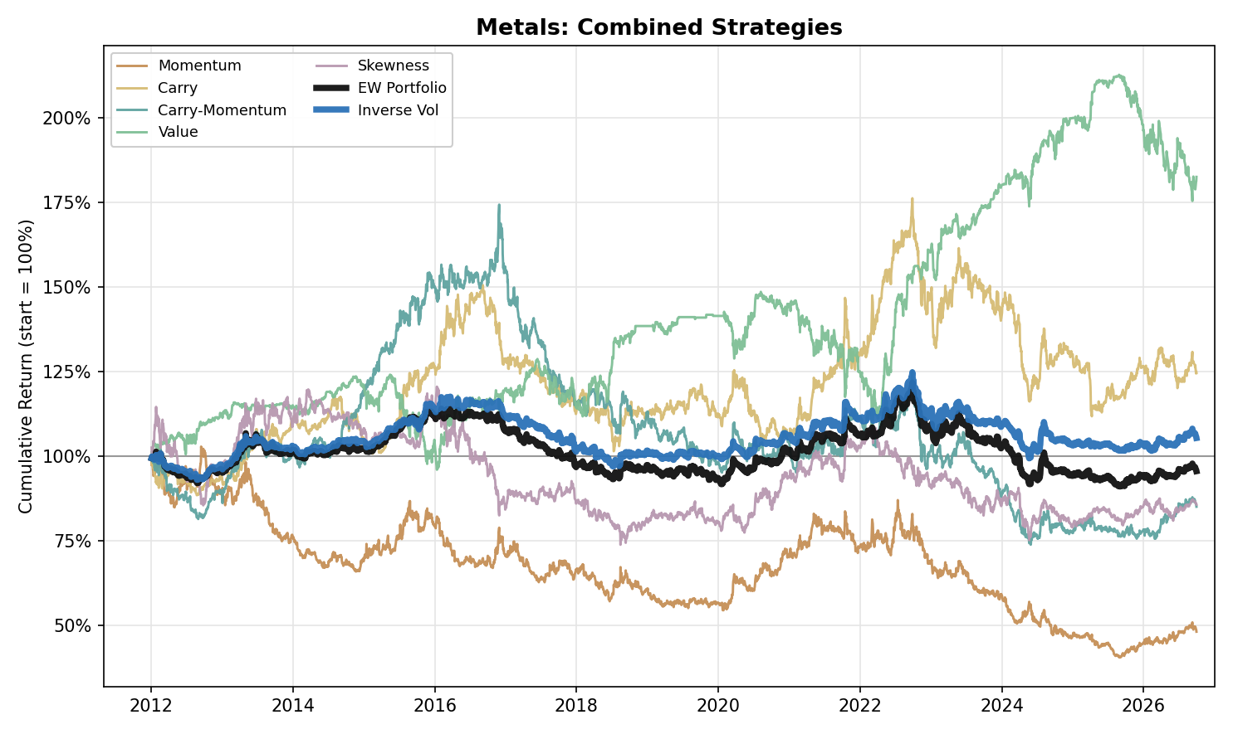
Figure 1. Metals: Combined Strategy Performance (Cumulative Return, 2012-2026)

Petroleum
- Petroleum is the four oil products (WTI, Brent, RBOB gasoline and Heating Oil). It replaces the Energy section of the previous version: Natural Gas has moved to the Gas and Emissions bucket, which has its own section, so the Natural Gas figures and the Energy ex-NatGas comparison are dropped. Figures run to 30 September 2026.
- Carry-Momentum (Return +19.6%, Vol 27.7%, Max Drawdown -43.2%, IR +0.71) is the strongest individual strategy in Petroleum and, like Momentum and Carry, is positive in every period (Carry-Momentum P1 +0.95, P2 +0.92, P3 +0.34), the clearest evidence in Petroleum that term-structure changes carry information that recurs across periods.
- Momentum (Return +17.5%, Vol 33.1%, Max Drawdown -50.4%, IR +0.53): positive in every period (P1 +0.57, P2 +0.66, P3 +0.36), with most of its return earned in a few large directional moves: calendar years 2014, 2015, 2020 and 2021 account for 87% of its cumulative log return. They coincide with the 2014-2016 price collapse (WTI fell from $107 on 20 June 2014 to $26 on 11 February 2016 in our series, after OPEC's 27 November 2014 decision to hold output against rising US shale supply), the 2020 demand collapse and the 2021 recovery. P3 is its weakest period even though it contains the March 2022 spike to $124 after Russia's invasion of Ukraine (calendar 2022 adds a further 14% of the total). The war between the United States, Israel and Iran that began on 28 February 2026 then disrupted Gulf supply on a scale the IEA calls the largest in the history of the oil market, and Brent futures went from $72 on 27 February to $118 on 31 March; the first nine months of 2026 alone are 24% of the sleeve's cumulative log return.
- Carry (Return +12.2%, Vol 31.0%, Max Drawdown -60.3%, IR +0.39) is positive in every period (P1 +0.45, P2 +0.68, P3 +0.04) but in P3 it is close to flat (IR +0.04), where crude oil is the problem (WTI -0.31, Brent -0.37, against RBOB +0.21 and Heating Oil +0.73) although the curves were the most backwardated of the sample (WTI F1-F3 backwardated on 87% of days in P3 against 24% in P1 and 46% in P2). Carry compares each pair's slope with its own trailing 252-day history, so a high level of backwardation does not by itself produce Carry returns.
- Value (Return -3.3%, Vol 31.0%, Max Drawdown -71.1%, IR -0.11) is the one consistent drag among the four core strategies on a full-sample basis, negative in P1 (IR -0.38) and marginally negative in P3 (-0.03) and marginally positive in P2 (+0.07). The 2014-2016 price collapse (WTI from $107 to $26), triggered by US shale supply growth and OPEC's decision to hold output, behaves as a persistent trend rather than a mean-reverting cycle, exactly the environment a reversion strategy is built to lose in. It correlates at -0.52 with Momentum and -0.53 with Carry, the same diversification relationship seen in Metals (-0.50 with Momentum).
- Skewness (Return +12.0%, Vol 32.6%, Max Drawdown -59.8%, IR +0.37): negative in P1 (IR -0.36) and positive in P2 (+0.57) and P3 (+0.80), and positive in all four products (WTI +0.32, Brent +0.39, RBOB +0.32, Heating Oil +0.24). Its P2 and P3 results are largely one long position. The signal turned long on 11 March 2020 in the middle of the 2020 collapse (the May contract settled at -$37.63 on 20 April, a value our series replaces with an imputed $16.01): the sleeve lost 0.49 in log return in WTI over March and April, then earned +1.21 from May 2020 to December 2021 as prices recovered. The trailing-year skewness of oil returns then stayed negative for years, so the sleeve was long on 99% of P3 days in WTI, 100% in Brent and 100% in RBOB (89% in Heating Oil), and earned the 2022 spike and the 2026 war rally (P3 IR +0.73 in WTI, +0.82 in RBOB). In P1 it was long on 50% of WTI days and lost on those days (-0.76 in log return) as oil fell. Calendar years 2020, 2021, 2022 and 2026 add 2.23 of log return against a full-sample total of 1.67, so the other eleven years net -0.56. It correlates at -0.16 with Momentum, -0.05 with Carry, -0.16 with Carry-Momentum and -0.11 with Value.
- Portfolio construction: Equal Weight (Return +11.3%, Vol 13.4%, Max Drawdown -28.7%, IR +0.84) and Inverse Vol (Return +11.6%, Vol 13.1%, Max Drawdown -26.2%, IR +0.89) are close and both positive in every period (Equal Weight P1 +0.44, P2 +1.43, P3 +0.61; Inverse Vol P1 +0.52, P2 +1.50, P3 +0.62). Unlike Metals, where Inverse Vol lifts the portfolio IR by 0.12, Inverse Vol is ahead of Equal Weight in Petroleum by only 0.04, with slightly lower volatility and a shallower drawdown. Adding Skewness as a fifth sleeve lifts the IR (Equal Weight +0.67 to +0.84, Inverse Vol +0.71 to +0.89) and lowers volatility (Equal Weight 16.6% to 13.4%, Inverse Vol 16.0% to 13.1%), mostly through P2 and P3.
- Individual-product decomposition: Momentum and Carry-Momentum work across WTI, Brent, RBOB, and Heating Oil (IR +0.28 to +0.85), and Carry is positive in every product too (+0.16 to +0.58). Value is negative in three of the four products (IR -0.23 to -0.07) and flat in Brent (+0.02), a broad failure across products rather than one product's loss.
- Physical storage bottlenecks, pipeline capacity limits, and producers' structural need to hedge downside force the market to pay a continuous insurance premium to whoever takes the other side of that risk, the same economic logic that shows up as Carry-Momentum's clean, all-period positive record above. This is an interpretation consistent with the results, not a test of the hedging pressure hypothesis.
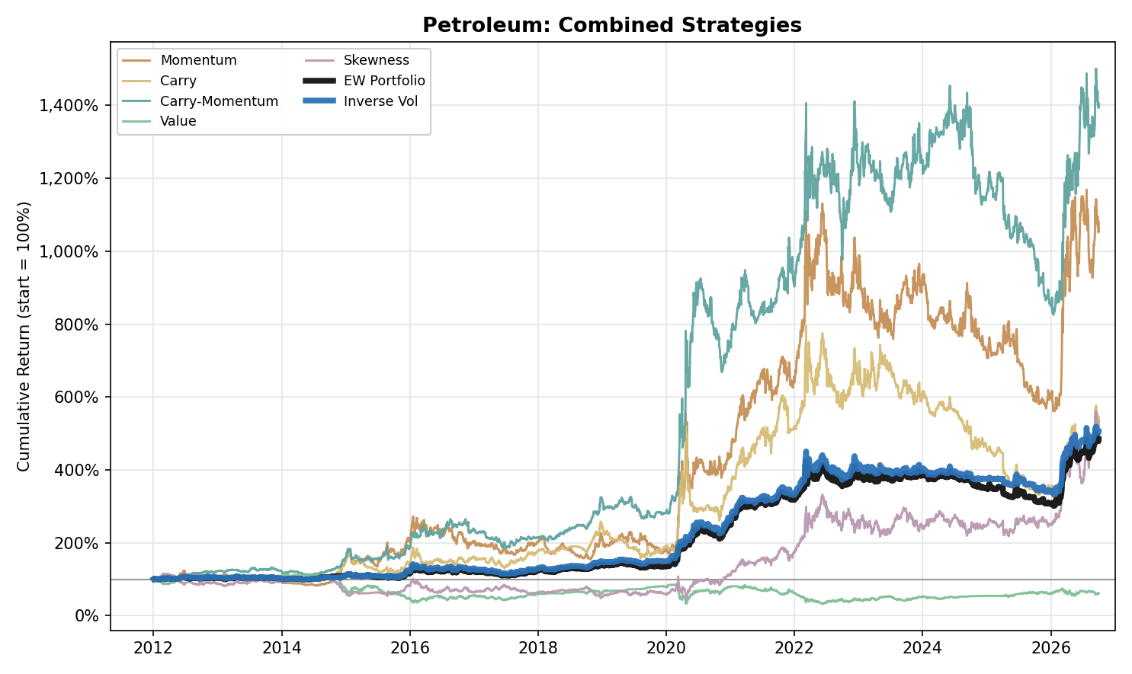
Figure 2. Petroleum: Combined Strategy Performance (Cumulative Return, 2012-2026)

Gas and Emissions
- Gas and Emissions combines four products: Henry Hub natural gas (NYMEX), TTF natural gas (ICE Endex, Europe), UK Gas (NBP, ICE Futures Europe) and EUA carbon allowances (ICE Endex). Henry Hub was part of Energy in earlier versions. Carry and Carry-Momentum use Henry Hub F1-F3 and F1-F13, TTF and UK Gas F1-F2 and F1-F13, and EUA F1-F2 and F1-F5 (EUA is a quarterly chain, so F5 is twelve months out). The bucket's data start in April 2008 (EUA's first Phase II day; Henry Hub, TTF and UK Gas start in January 2006) and results are reported from 1 January 2012.
- Gas and Emissions is a high-volatility bucket with a real but uneven edge: Equal Weight (Return +10.2%, Vol 16.5%, Max Drawdown -35.2%, IR +0.62) and Inverse Vol (Return +9.6%, Vol 16.0%, Max Drawdown -32.8%, IR +0.60). Both are positive in every period but concentrated in P2 (Equal Weight IR P1 +0.37, P2 +1.41, P3 +0.27; Inverse Vol P1 +0.40, P2 +1.38, P3 +0.23). Carry (IR +0.64) is the strongest sleeve, followed by Carry-Momentum (+0.45), Skewness (+0.30) and Momentum (+0.26); Value (IR -0.14) is the only negative one. Each sleeve has a volatility of 33.1% to 36.3%, and combining them halves it to 16.5% because the sleeves are far from perfectly correlated (pairwise correlations -0.41 to +0.44).
- The result is concentrated in the 2021-2022 gas crisis. The Equal Weight portfolio earned 42% of its full-sample log return in 2021 alone and 89% in 2020 to 2023. Excluding 1 July 2021 to 30 June 2023 its IR falls from +0.62 to +0.30, still positive, while that two-year window alone earns an IR of +2.03. In our series the TTF contract held by the strategy rose from EUR 19.84/MWh on 4 January 2021 to a peak of EUR 339.2 on 26 August 2022 and stood at EUR 72.36 on 30 September 2026; UK Gas rose from 59.45 to 640.36 pence per therm on the same dates and stood at 183.08.
- The edge is in European gas, not in US gas or carbon allowances. Over the five sleeves combined, TTF earns an IR of +0.90 and UK Gas +0.63, against -0.01 for Henry Hub and -0.14 for EUA. TTF and UK Gas are close to one bet (their combined returns correlate 0.77), while Henry Hub and EUA are uncorrelated with every other product (no pair above 0.06 in magnitude), which is why the bucket diversifies even though two of its four products carry the whole edge.
- Carry (Return +22.7%, Vol 35.3%, Max Drawdown -61.3%, IR +0.64) is the clearest source of the bucket's return: IR +0.56 in P1, +1.72 in P2 and +0.05 in P3, and +1.68 of log return in 2021, its best year. It is positive in TTF (+0.96), UK Gas (+0.46) and Henry Hub (+0.26) and slightly negative in EUA (-0.09). TTF and UK Gas Carry reach +2.59 and +2.77 in P2, then fade (TTF +0.50 in P3; UK Gas -0.36). The TTF F1-F13 slope explains why: it averaged +24.2% (backwardation) from July 2021 to December 2022, against -8.8% in 2012-2016 and -10.4% in 2017-2021 (contango). Carry-Momentum (Return +15.6%, Vol 34.9%, Max Drawdown -60.8%, IR +0.45) is positive in every period (IR +0.17, +1.15, +0.17).
- Momentum (Return +9.5%, Vol 36.3%, Max Drawdown -75.1%, IR +0.26) is a crisis strategy here: IR -0.29 in P1, +1.36 in P2 and -0.13 in P3. Calendar years 2020 and 2021 add 1.66 of log return against a full-sample total of 1.32, so the other thirteen years net to a loss. By product it is positive in TTF (+0.51) and UK Gas (+0.32), flat in Henry Hub (+0.02) and negative in EUA (-0.22).
- Value (Return -4.9%, Vol 34.1%, Max Drawdown -92.7%, IR -0.14) is the only negative core sleeve, and 2021 is its worst year (-0.76 of log return, the largest single-year loss of any sleeve in the bucket). Its P2 IR is -0.84: TTF (-0.65), UK Gas (-0.53) and EUA (-0.82) lost, consistent with Value being short markets that kept rising above their five-year averages, while Henry Hub was flat (+0.08). In P3 the sign reverses in the three of them (TTF +0.45, UK Gas +0.66, EUA +0.43; Henry Hub -0.22) and the bucket's P3 IR is +0.48. Value is the least correlated sleeve with the bucket's EW PORT (+0.13) and correlates -0.41 with Momentum and -0.36 with Skewness.
- Skewness (Return +9.9%, Vol 33.1%, Max Drawdown -61.2%, IR +0.30) is positive in every period (IR +0.67, +0.30, +0.13) and, unlike oil, is mostly short in European gas: the sleeve is long on only 34% of TTF days and 38% of UK Gas days, and the short leg earns +3.45 of log return in TTF against +1.54 for the long leg, and +3.68 against -0.21 in UK Gas. It is positive in TTF (+0.64), UK Gas (+0.39) and EUA (+0.07) and negative in Henry Hub (-0.39), where the long leg loses 3.61. Adding it lifts the bucket's Equal Weight IR from +0.49 to +0.62 (Inverse Vol +0.48 to +0.60), with P1 rising from +0.12 to +0.37 and P3 from +0.20 to +0.27.
- The two portfolio constructions are close. Equal Weight is ahead on return and IR: it returns +10.2% against +9.6% for Inverse Vol, with an IR of +0.62 against +0.60. Inverse Vol has the lower volatility (16.0% against 16.5%) and the shallower maximum drawdown (-32.8% against -35.2%); its Equal Weight maximum drawdown of -35.2% is, with Precious Metals (-35.2%), the third deepest of the seven buckets, behind Softs (-40.6%) and Agriculture (-38.5%).
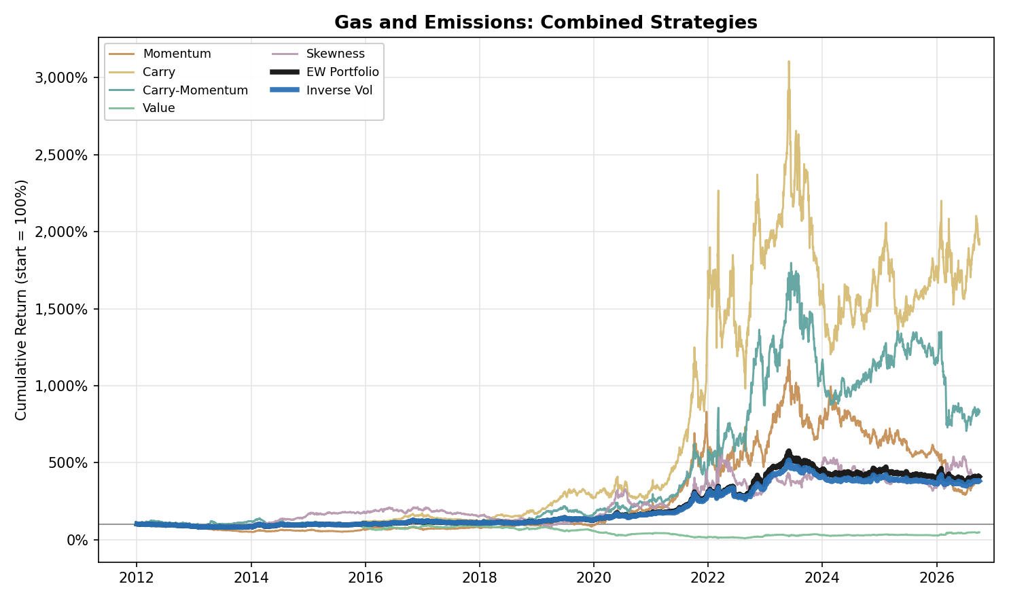
Figure 3. Gas and Emissions: Combined Strategy Performance (Cumulative Return, 2012-2026)

Precious Metals

No core signal earns a positive full-sample IR in Precious Metals: Momentum (−0.22; return −4.6%, volatility 20.7%, maximum drawdown −73.2%), Carry (−0.07), Carry-Momentum (−0.23) and Value (−0.05) are all negative. A common explanation is that Precious Metals are priced mainly off macro drivers, above all real yields (the weekly correlation of gold returns with changes in the 10-year real yield is −0.39 over the sample, −0.64 in P2 and −0.24 in P3), currency-debasement expectations and tail-risk demand, and not off their own recent price action, so that trend-following has little to extract. Momentum is flat in P1 (0.06) and negative in P2 (−0.46) and P3 (−0.25). The term structure is similarly uninformative. Under the theory of storage, the curve of a metal held largely as a financial asset reflects financing costs and not inventory scarcity, and this is consistent with the contango observed throughout the sample. The contango deepened in P3 as real yields rose (the 10-year real yield averaged 1.60% in P3 against 0.03% in P2, and the Gold F1–F7 slope averaged −4.6% against −1.8%), which coincides with the P3 loss of Carry-Momentum (−0.75). The hedging pressure channel is also weak: gold producers hedge little, so there are few commercial hedgers paying a premium to transfer downside risk. Value is mixed across products (Platinum 0.08, Gold −0.22), with the loss in Gold concentrated in P3 (−0.56), when the rule shorted a metal trading more than 10% above its five-year average as gold rose from $1,662 to $4,341. Skewness is the only sleeve with a positive IR (0.09), and the result is small and directional: it is negative in P1 (−0.26), positive in P2 and P3 (0.25 and 0.22), and in P3 it comes from long positions held through the 2025 rally. Its correlation with Value (−0.62) is consistent with Value shorting the metals that Skewness holds long. Both portfolios are negative in every subperiod (Equal Weight IR −0.22, Inverse Vol −0.28), and adding Skewness reduces the loss without making it positive.

- Momentum (Return -4.6%, Vol 20.7%, Max Drawdown -73.2%, IR -0.22) is flat in P1 (IR +0.06) and negative in P2 (-0.46) and P3 (-0.25). Precious Metals are priced primarily off macro drivers, above all real yields (the weekly correlation of gold returns with changes in the 10-year real yield, FRED series DFII10, is -0.39 over the sample, -0.64 in P2 and -0.24 in P3), currency-debasement expectations and tail-risk demand, not off their own recent price action, so trend-following has nothing to extract. Gold Momentum earned its two best years in the 2013 sell-off, when gold fell 28% on Fed tapering and ETF outflows (a log return of +0.25), and in the 2025 rally (+0.36), and little otherwise.
- Carry (Return -1.2%, Vol 17.5%, Max Drawdown -41.4%, IR -0.07) and Carry-Momentum (Return -3.8%, Vol 16.1%, Max Drawdown -68.2%, IR -0.23) show no consistent edge: Carry is negative in P1 (IR -0.14) and P2 (-0.09) and flat in P3 (0.00), while Carry-Momentum is slightly negative in P1 (-0.08), positive in P2 (+0.31) and clearly negative in P3 (-0.75), consistent with the post-2022 higher-real-yield environment pushing Gold and Silver deeper into cost-of-carry contango: the 10-year real yield averaged 1.60% in P3 against 0.03% in P2, and Gold's F1-F7 curve averaged -4.6% in P3 against -1.8% in P2 and -0.6% in P1 (Silver F1-F6 -4.5%, -2.3% and -1.1%).
- The long tenor pair does not change that conclusion. Carry IR: previous single pair (F1-F3) -0.16, short pair F1-F2 -0.25, long pair alone -0.17, two-pair sum -0.07. Carry-Momentum IR: previous single pair -0.31, short pair -0.23, long pair alone +0.06, two-pair sum -0.23.
- Value (Return -0.8%, Vol 17.8%, Max Drawdown -53.9%, IR -0.05) carries no full-sample edge, and the pattern is mixed at the product level: Platinum is the only metal with a positive signal (IR +0.08), Silver (-0.03) and Palladium (-0.02) are flat, and Gold (-0.22) is negative. Gold's loss is a P3 loss (-0.56): Value shorts a metal that trades more than 10% above its five-year average, and gold rose from $1,662 at the end of September 2022 to $4,341 at the end of 2025, with central banks buying 863 tonnes in 2025 against a 2010-2021 annual average of 473 tonnes (World Gold Council). Gold's Value position lost 0.45 in log return in 2025 alone. Value is measured on the F2 contract here (the previous version used F3), following the 1 November 2026 change to the Precious Metals and Agriculture configuration.
- Skewness (Return +1.8%, Vol 20.4%, Max Drawdown -40.4%, IR +0.09) is the only sleeve in this asset class with a positive full-sample IR, and it is small. It is negative in P1 (IR -0.26) and positive in P2 (+0.25) and P3 (+0.22). Silver is the best metal (IR +0.13; Gold +0.01, Platinum +0.06, Palladium +0.02). The P3 result comes from long positions: the sleeve was long on 71% of P3 days in Gold and 58% in Silver, and the long legs earned +0.47 and +0.84 in log return, concentrated in 2025 (sleeve log return Gold +0.45, Silver +0.83), when gold rose to $4,341 by the end of the year, and for Silver also in 2026 (+0.45 to 30 September), after a loss of 0.31 in 2022. It correlates at -0.62 with Value, the strongest negative pairing in the asset class, consistent with Value shorting the metals that have rallied while Skewness stays long them, and at +0.20 with Carry.
- Portfolio construction: Equal Weight (Return -1.8%, Vol 7.8%, Max Drawdown -35.2%, IR -0.22) and Inverse Vol (Return -2.2%, Vol 7.7%, Max Drawdown -38.5%, IR -0.28) are both net negative full-sample and in every period (P1 -0.22 / -0.40, P2 -0.03 / -0.10, P3 -0.38 / -0.36). Skewness trims the loss (Equal Weight -0.29 to -0.22, Inverse Vol -0.34 to -0.28) but does not turn it positive. Precious Metals is, with Agriculture, one of the two buckets where every core strategy is net negative full-sample, and with Agriculture and Softs one of the three buckets where neither construction earns a positive IR.
- Individual-metal decomposition: Momentum has no edge in any metal (Gold +0.04, Silver -0.04, Platinum -0.14, Palladium -0.36). Carry is near zero or slightly positive in Gold (+0.03), Silver (+0.18) and Platinum (+0.07); its negative blended IR comes from Palladium (-0.32), which is also the weakest metal for Momentum (-0.36) and Carry-Momentum (-0.28). Value's only positive edge sits in Platinum (IR +0.08).
- Fundamentally, gold producers hedge little (the global producer hedge book was 218 tonnes in Q3 2017 and under 200 tonnes by the end of 2024, 182 tonnes on the World Gold Council's first estimate and about 194 tonnes after later revisions), so there are few commercial hedgers paying an insurance premium to transfer downside risk to financial counterparties; without that premium, Momentum has no structural engine to harvest here.
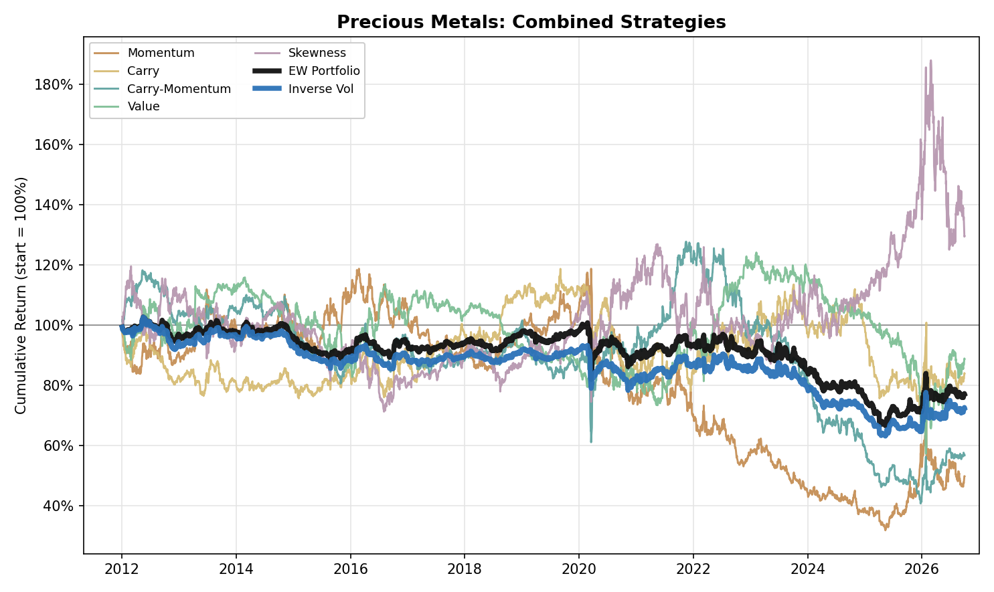
Figure 4. Precious Metals: Combined Strategy Performance (Cumulative Return, 2012-2026)

NGL
- NGL (five products: Ethane, Propane, Butane, Naphtha and Natural Gasoline; Isobutane, the least liquid product in the data set, is excluded) is the strongest bucket in the research: Equal Weight (Return +15.5%, Vol 11.5%, Max Drawdown -19.5%, IR +1.35) and Inverse Vol (Return +15.5%, Vol 11.5%, Max Drawdown -18.1%, IR +1.35), the best full-sample IR of any bucket under both constructions. At the individual-strategy level, Momentum (IR +0.87), Carry (IR +0.95) and Carry-Momentum (IR +1.02) are positive in every one of the three periods. Value (Return +2.2%, Vol 26.3%, Max Drawdown -68.6%, IR +0.08) is an exception: net positive full-sample but negative in P1 (-0.42), flat in P2 (0.00) and strongly positive in P3 (+0.99). Skewness (Return +6.0%, Vol 27.5%, Max Drawdown -64.5%, IR +0.22) is the other: negative in P1 (-0.55), strongly positive in P2 (+0.89) and weakly positive in P3 (+0.17).
- NGL's portfolios are strong in every period rather than in one: Equal Weight IR is P1 +0.66, P2 +2.11, P3 +1.15 and Inverse Vol P1 +0.65, P2 +1.97, P3 +1.31. Both are well ahead of every other bucket, whose best full-sample Equal Weight IR is +0.84 (Petroleum). Skewness shifts the profile within the periods: P1 falls from +0.95 to +0.66 for Equal Weight and P2 rises from +1.67 to +2.11, while the full-sample IR changes little (+1.28 to +1.35; Inverse Vol +1.28 to +1.35) and volatility falls (14.2% to 11.5%). The macro backdrop is the US export build-out: in 2012 Mont Belvieu propane traded at an average $0.89/gal discount to international prices because export terminals were at capacity (EIA), and US propane exports averaged a record 1.8 million b/d in 2024 (EIA) and reached a record 2.1 million b/d in April 2026 (EIA; exports first topped 2 million b/d in November 2024), while ethane exports reached 492,000 b/d in 2024 against 65,000 b/d in 2015 and normal butane 491,000 b/d against 97,000 (OPIS, citing EIA).
- Naphtha (CIF NWE average-price swap, USD per tonne) strengthens the bucket. On the three Mont Belvieu products alone it earned an Equal Weight IR of +1.20 and an Inverse Vol IR of +1.12; with Naphtha, as a four-product bucket, they were +1.43 and +1.41, volatility fell from 13.0% to 11.8% and the Equal Weight maximum drawdown from -23.2% to -20.4%. On its own, Naphtha's five sleeves combined earn an IR of +1.21, the highest of the five products (Butane +1.13, Propane +0.99, Natural Gasoline +0.62, Ethane +0.54). It is a different bet from the Mont Belvieu complex: its combined returns correlate 0.07 to 0.36 with the three Mont Belvieu products (Ethane 0.07) and 0.61 with the Petroleum bucket, consistent with a product priced off crude. Carry and Carry-Momentum use the F2-F4 pair only for Naphtha, as its F14 is rarely quoted. Carry (IR +0.72, +0.73, +1.00 in P1 to P3), Carry-Momentum (+0.41, +1.41, +0.93) and Skewness (+0.31, +0.34, +0.53) are positive in every period; Naphtha's Skewness is positive in P1, where it is negative for every Mont Belvieu product and for Natural Gasoline. The capacity caveat is material: Naphtha's time to trade one sigma of risk is 9.4 days on the Bloomberg volume series, a partial view of the swap market, the longest in the bucket and above Ethane (2.9) (see the liquidity section).
- Natural Gasoline (the CME Mont Belvieu 5-decimal OPIS swap, Bloomberg MMB, USD per gallon, added to the bucket on 10 November 2026) is the fifth product and it does not strengthen the bucket. With it the Equal Weight IR is +1.35 and the Inverse Vol IR +1.35, against +1.43 and +1.41 for the four products without it; Equal Weight IR falls in every period (P1 from +0.84 to +0.66, P2 from +2.13 to +2.11, P3 from +1.23 to +1.15), while the Equal Weight volatility (11.8% to 11.5%) and maximum drawdown (-20.4% to -19.5%) are lower. The reason is the product itself: its five sleeves combined earn an IR of +0.62, the second lowest of the five (Ethane +0.54), because Momentum (+0.04) and Carry (+0.21; -0.19 in P1, +0.48 in P2, +0.28 in P3) are close to zero. Carry-Momentum is its one strong sleeve (+0.81, positive in every period: +0.60, +1.21, +0.59); Value (+0.06) and Skewness (+0.26) are small. It uses the same Carry pairs as the Mont Belvieu products (F2-F4 and F2-F14). Its combined returns correlate 0.65 with Naphtha and 0.63 with the Petroleum bucket but only 0.09 to 0.37 with the three Mont Belvieu products (Ethane 0.09, Propane 0.30, Butane 0.37), so in these results it behaves more like Naphtha than like the other Mont Belvieu swaps. It is far more liquid than Naphtha and Ethane: its time to trade one sigma of risk is 1.25 days, with about 827 lots a day on a 12-month strip and a print on 99% of days (CME volume; see the liquidity section).
- Carry (Return +23.3%, Vol 24.5%, Max Drawdown -47.4%, IR +0.95) is the clearest embodiment of NGL's seasonal mechanics: predictable weather- and industrial-driven demand cycles push futures curves from contango in low-demand build periods into steep backwardation as inventories drain in peak season. In the data the F2-F4 slope, averaged over the five products, is +2.7% (backwardation) in December to March and -1.1% (contango) in June to September. Carry is positive in every period (IR +0.62 to +1.19), capturing that swing.
- The two portfolio constructions are essentially the same: Equal Weight returns +15.5% against +15.5% for Inverse Vol, with an IR of +1.35 against +1.35. Inverse Vol has the slightly lower volatility (11.5% against 11.5%) and the shallower maximum drawdown (-18.1% against -19.5%).
- The P3 Value result (+0.99) is not a one-year event: the sleeve earns a positive log return in each of 2022 to 2026, and 2026 is its best year of the period (+0.27, against +0.10 in 2025). It is led by Propane (+1.47), Butane (+1.02) and Naphtha (+0.94), with Natural Gasoline at +0.59. The war that began on 28 February 2026 and the closure of the Strait of Hormuz disrupted around 30% of global LPG supply (Veson Nautical estimate) and sent US LPG exports to a record 3.3 million b/d in April 2026 (S&P Global); in our series the Propane contract held by the strategy (rolled on the fifth trading day of its expiry month) rose from $0.67/gal on 27 February to $0.90/gal on 27 March, and the Naphtha contract held rose from $588/t to $942/t over the same four weeks.
- Skewness is a single-regime result in the Mont Belvieu products. It is negative in all three in P1 (IR -0.26 to -0.80) and in Natural Gasoline (-0.20), and positive in all five products in P2 (IR +0.16 to +1.82); by calendar year the sleeve loses 0.44 in 2012 and earns +1.02 in 2020 and +0.52 in 2021, the crash and recovery of 2020-2021: it turned long on 11 March 2020 in Propane and Butane, earning +1.51 in Propane and +1.46 in Butane from May 2020 to December 2021, then stayed long (94% or more of P3 days in every product); it adds +0.53 in 2026. It correlates at -0.22 with Momentum and -0.27 with Carry, the most negative pairings in any bucket for those two, and at +0.15 with Value.
- Individual-product decomposition: Momentum is positive in all five products (IR +0.04 to +1.12; Natural Gasoline is the weakest at +0.04), Carry (IR +0.21 to +0.97) and Carry-Momentum (IR +0.16 to +0.92) likewise. Value's modest full-sample edge is concentrated in Butane and Naphtha (IR +0.24 / +0.17), while Ethane, Propane and Natural Gasoline show little or none (IR -0.10 / +0.01 / +0.06); the period inconsistency above is clearest in Propane (IR -0.34 in P1, -0.42 in P2, +1.47 in P3). Skewness is positive in Naphtha (+0.38), Ethane (+0.27) and Natural Gasoline (+0.26) and slightly negative in Propane (-0.08) and Butane (-0.07).
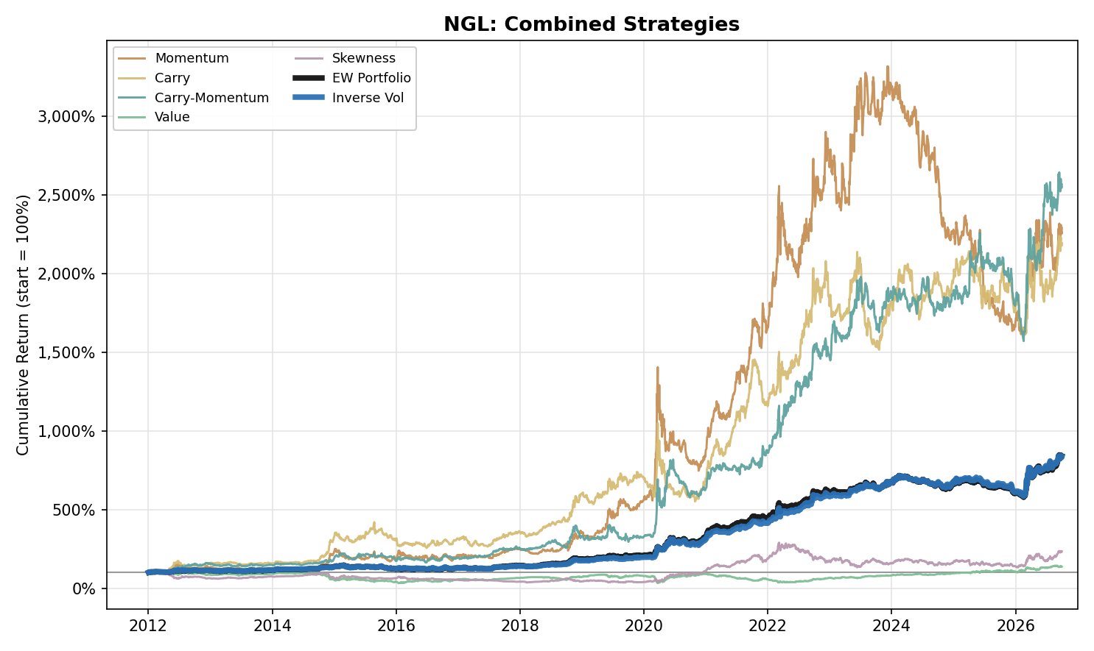
Figure 5. NGL: Combined Strategy Performance (Cumulative Return, 2012-2026)

Agriculture

Agriculture (Corn, Wheat, Soybean and Live Cattle) shows no premium in any of the four core sleeves. Momentum (IR −0.28), Carry (−0.34), Carry-Momentum (−0.71) and Value (−0.21) are negative over the full sample and in every subperiod. The curve signals lose most in P2 for Carry (−0.70) and in P3 for Carry-Momentum (−1.06); P3 opens with the 2022 price spike in grains and its reversal. Live Cattle illustrates the weakness of the curve signals: it is the weakest product in both Carry (−0.59) and Carry-Momentum (−0.63). Signals built on trend and curve slope respond to such moves with a lag and are exposed to sharp reversals. Value is negative in every subperiod, with P1 the worst (−0.44). Skewness is the only sleeve with a positive full-sample IR (0.45) and is positive in all four products, but the result is uneven across subperiods (P1 0.36, P2 −0.29, P3 1.31) and is concentrated in P3, when spike-prone returns in Wheat kept the sleeve short on 86% of days and the short leg earned 0.60 in log return as prices fell from their 2022 peak. The gains therefore appear to reflect the reversal of a single episode and not a stable premium. As a consequence, the Equal Weight (return −3.0%, volatility 5.8%, maximum drawdown −38.5%, IR −0.52) and Inverse Vol (return −2.7%, volatility 5.4%, maximum drawdown −34.1%, IR −0.50) portfolios are negative in every subperiod, with P2 the main drag (−0.83 and −0.75).

- Agriculture (four products: Corn, Wheat, Soybean and Live Cattle; Sugar and Coffee, previously part of it, are now in Softs and Soybean Oil is dropped) has no edge in any of the four core sleeves: Momentum (-0.28), Carry (-0.34), Carry-Momentum (-0.71) and Value (-0.21) are net negative full-sample, and Equal Weight (Return -3.0%, Vol 5.8%, Max Drawdown -38.5%, IR -0.52) and Inverse Vol (Return -2.7%, Vol 5.4%, Max Drawdown -34.1%, IR -0.50) follow. Skewness (Return +5.1%, Vol 11.4%, Max Drawdown -33.3%, IR +0.45) is the only sleeve with a positive full-sample IR. Together with Precious Metals and Softs it is one of three buckets where neither portfolio construction earns a positive IR. Live Cattle (CME, 40,000 lb, listed in six bimonthly contract months) is new to the bucket; Carry and Carry-Momentum use F1-F2 plus F1-F6 for Corn and Wheat and F1-F2 plus F1-F7 for Soybean and Live Cattle.
- Momentum (Return -3.8%, Vol 13.5%, Max Drawdown -52.5%, IR -0.28) is negative in every period (P1 -0.36, P2 -0.14, P3 -0.34). By product it is negative in Corn (-0.27), Wheat (-0.23) and Soybean (-0.10) and flat in Live Cattle (+0.01).
- Carry (Return -4.2%, Vol 12.5%, Max Drawdown -60.1%, IR -0.34) and Carry-Momentum (Return -8.9%, Vol 12.5%, Max Drawdown -74.8%, IR -0.71) are negative in every period (Carry P1 -0.21, P2 -0.70, P3 -0.08; Carry-Momentum -0.44, -0.63, -1.06), Carry-Momentum worst in P3 and Carry worst in P2. Live Cattle is the weakest product in both (Carry -0.59, Carry-Momentum -0.63), with a Carry IR of -0.53 in P1 and -1.07 in P2; Wheat is the second weakest in Carry-Momentum (-0.52).
- The long tenor pair does not help in Agriculture. Carry IR: short pair alone (F1-F2) -0.10, long pair alone -0.31, two-pair sum -0.34. Carry-Momentum IR: short pair alone -0.32, long pair alone -0.65, two-pair sum -0.71. The two-pair sum, which the bucket uses, is the weakest variant for both sleeves and no variant earns a positive IR.
- Value (Return -2.7%, Vol 12.7%, Max Drawdown -48.3%, IR -0.21) is negative in every period: IR -0.44 in P1, -0.08 in P2 and -0.09 in P3. Wheat is the only product with a positive Value IR (+0.17: -0.24 in P1, +0.25 in P2, +0.47 in P3). Corn is the weakest (-0.36; -0.54 in P1 and -0.43 in P2) and loses in every year from 2012 to 2016 (log returns of -0.13, -0.16, -0.07, -0.19, -0.12), starting with the 2012 US drought that pushed corn to a record, with USDA projecting record season-average prices of $7.50 to $8.90 per bushel in August 2012; Live Cattle loses most in P3 (IR -0.86). Value shorts a market that trades more than 10% above its five-year average, measured on the F2 contract (the previous version used F3), following the 1 November 2026 change to the Precious Metals and Agriculture configuration.
- Skewness (Return +5.1%, Vol 11.4%, Max Drawdown -33.3%, IR +0.45) is the one positive sleeve: IR +0.36 in P1, -0.29 in P2 and +1.31 in P3. It is positive in all four products (Soybean +0.35, Corn +0.26, Wheat +0.22, Live Cattle +0.09). The clearest case is Wheat: its returns are spike-prone (the 2012 drought, the 2022 invasion of Ukraine), so its trailing-year skewness is positive most of the time and the sleeve is short on 86% of days; that short leg earns +1.05 in log return over the sample, including +0.60 in P3 as Wheat fell from $14.25 on 7 March 2022 to $6.76. In 2022 Corn and Soybean add +0.50 and +0.37 in log return, and Wheat adds +0.36 in 2023 as it fell. It correlates at -0.07 with Momentum, -0.06 with Carry, -0.12 with Carry-Momentum and -0.03 with Value.
- Portfolio construction: Equal Weight is negative in every period (P1 -0.54, P2 -0.83, P3 -0.23), as is Inverse Vol (P1 -0.70, P2 -0.75, P3 -0.12); both are worst in P2 and least negative in P3. Skewness trims the loss (full-sample Equal Weight -0.70 to -0.52, Inverse Vol -0.70 to -0.50; P1 Equal Weight -0.70 to -0.54, P3 -0.68 to -0.23). P3 opens with the Russia-Ukraine price spike and its reversal: Wheat peaked at $14.25/bu on 7 March 2022 and was $6.76 by 30 September 2026, and Corn went from $8.18 on 29 April 2022 to $5.01, while the FAO food price index peaked in March 2022 (159.3 points, the highest since 1990) and its 2023 average was 13.7% below 2022. Sharp spikes followed by reversals are the pattern signals built on trend and curve slope handle worst.
- Individual-product decomposition: no core sleeve works across the four products. The best single core product-sleeve result is Wheat Value (IR +0.17) and the three weakest are Live Cattle Carry-Momentum (-0.63), Live Cattle Carry (-0.59) and Wheat Carry-Momentum (-0.52); the best result overall is Skewness in Soybean (+0.35).
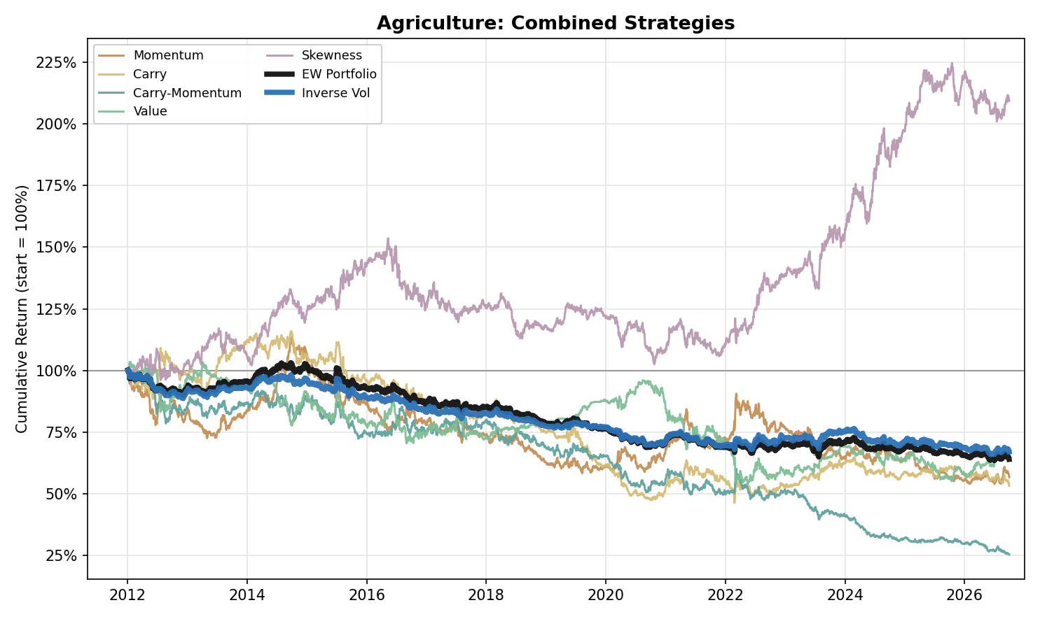
Figure 6. Agriculture: Combined Strategy Performance (Cumulative Return, 2012-2026)

Softs

Softs (Sugar, Cocoa, Coffee and Cotton) has one positive sleeve, Value (IR 0.13), while Momentum (−0.17), Carry (−0.20), Carry-Momentum (−0.20) and Skewness (−0.35) are negative over the full sample. Carry and Carry-Momentum are positive only in P2 (0.05 and 0.37) and fall to −0.38 and −0.66 in P3. Coffee illustrates the mechanism: Carry-Momentum earns an IR of 0.88 in P2, when the Brazilian frosts of July 2021 drove prices higher, and −0.66 in P3, after the record price of February 2025 and the decline that followed. Value earns 0.62 in P1 and 0.17 in P2 but −0.22 in P3, where the loss comes from 2024 (the sleeve returns −0.49 in log return that year), when the front-month price of Cocoa in our series reached $12,565 per tonne on 18 December 2024. Skewness is negative in every subperiod (P1 −0.23, P2 −0.40, P3 −0.42) and lowers the portfolio result. As a consequence, the Equal Weight (return −2.5%, volatility 6.9%, maximum drawdown −40.6%, IR −0.36) and Inverse Vol (return −2.1%, volatility 6.8%, maximum drawdown −38.9%, IR −0.31) portfolios are negative, marginally positive only in P2 (0.06 and 0.14), with P3 the main drag (−0.80 and −0.72).

- Softs (four ICE US products: Sugar No.11, Cocoa, Coffee C and Cotton No.2) is a new bucket, split out of the previous Agriculture bucket (Sugar and Coffee) with Cocoa and Cotton added. Value is its only positive sleeve (Return +1.9%, Vol 14.1%, Max Drawdown -51.9%, IR +0.13); Momentum (-0.17), Carry (-0.20), Carry-Momentum (-0.20) and Skewness (-0.35) are net negative full-sample, and Equal Weight (Return -2.5%, Vol 6.9%, Max Drawdown -40.6%, IR -0.36) and Inverse Vol (Return -2.1%, Vol 6.8%, Max Drawdown -38.9%, IR -0.31) follow. Together with Precious Metals and Agriculture it is one of three buckets where neither portfolio construction earns a positive IR, and with Metals one of two where Skewness is negative full-sample. Carry and Carry-Momentum use F1-F2 plus F1-F6 for all four products.
- Momentum (Return -2.7%, Vol 15.9%, Max Drawdown -55.0%, IR -0.17) is clearly negative in P1 (IR -0.46) and close to zero in P2 (-0.04) and P3 (-0.05). Coffee is the only product with a positive full-sample IR (+0.11); Sugar (-0.07), Cocoa (-0.16) and Cotton (-0.28), the weakest, are negative.
- Carry (Return -3.1%, Vol 15.6%, Max Drawdown -50.3%, IR -0.20) and Carry-Momentum (Return -3.0%, Vol 15.5%, Max Drawdown -60.2%, IR -0.20) are negative in P1 (Carry -0.24, Carry-Momentum -0.15), positive in P2 (+0.05 / +0.37) and negative in P3 (-0.38 / -0.66). Coffee is the swing: its Carry IR is +0.62 in P1 and +0.58 in P2 and -0.63 in P3, and its Carry-Momentum IR is +0.88 in P2, when the July 2021 Brazilian frosts lifted arabica by 34% in a week in our series (19 to 26 July) to its highest front-month price since October 2014 (Reuters, Bloomberg), and -0.66 in P3, after the price reached its high of $4.39/lb in our series on 13 February 2025 (our series is the front-month, March, contract; the most active contract set its record at about $4.30 that month) and fell back to $2.91/lb by 30 September 2026 in our series. Without Coffee, both sleeves are negative in P2. Cotton is the weakest product in both sleeves (Carry -0.33, Carry-Momentum -0.52) and is negative in every period.
- The long tenor pair matters differently for the two sleeves. Carry IR: short pair alone (F1-F2) -0.51, long pair alone -0.07, two-pair sum -0.20. Carry-Momentum IR: short pair alone -0.08, long pair alone -0.16, two-pair sum -0.20. The sum improves on the short pair for Carry but not for Carry-Momentum, where it is the weakest variant, and no variant earns a positive IR.
- Value (Return +1.9%, Vol 14.1%, Max Drawdown -51.9%, IR +0.13) is the one positive sleeve: IR +0.62 in P1, +0.17 in P2 and -0.22 in P3. By product it is positive in Cotton (+0.21) and Cocoa (+0.16), flat in Coffee (0.00) and negative in Sugar (-0.07). Cocoa earns +0.78 in P1 and +0.68 in P2 and loses in P3 (-0.27); Cotton earns +0.45 in P3 and Coffee +0.53 in P1. The P3 loss comes from 2024 and the cocoa rally: the front-month price in our series reached $12,565/MT on 18 December 2024, Value is short a market that trades more than 10% above its five-year average, and the sleeve loses 0.49 in log return in 2024 (Cocoa -1.49), its worst year; it recovers in 2025 and 2026 as Cocoa falls back to $5,367/MT by 30 September 2026 (Cocoa +0.65 in 2025 and +0.45 in 2026). Value is measured on the F2 contract, as in Precious Metals and Agriculture.
- Skewness (Return -5.3%, Vol 14.9%, Max Drawdown -64.7%, IR -0.35) is the only sleeve that is negative in every period (IR -0.23 in P1, -0.40 in P2, -0.42 in P3) and it is negative in all four products, worst in Coffee (-0.29) and Cocoa (-0.20), near zero in Sugar (-0.08) and Cotton (-0.07). In Cocoa it earns +0.90 in log return in 2024, as the price rose, then loses 0.60 in 2025 and 0.58 in 2026 as it fell back; its short leg loses 1.37 over the sample, 0.86 of it in P3. In Coffee, where the 2021 frost and the 2025 record were followed by sharp reversals, the signal loses on both legs (long leg -0.72, short leg -0.75; -0.49 in 2021 and -0.56 in 2024). In Sugar the sleeve is short on 71% of days: the short leg earns +0.27 and the long leg loses 0.53. It correlates at -0.14 with Momentum, -0.16 with Carry, -0.06 with Carry-Momentum and -0.07 with Value.
- Portfolio construction: Equal Weight is negative in P1 (-0.25), marginally positive in P2 (+0.06) and clearly negative in P3 (-0.80); Inverse Vol is -0.24, +0.14 and -0.72. Skewness lowers the result here, as it does in Metals and in no other bucket: the Equal Weight IR is -0.21 without it and -0.36 with it (Inverse Vol -0.17 and -0.31), P2 falls from +0.24 to +0.06 and P3 from -0.61 to -0.80.
- Individual-product decomposition: Coffee is the only product with a positive IR in Momentum (+0.11), Carry (+0.11) and Carry-Momentum (+0.09), and all three are small. The best single core product-sleeve result is Cotton Value (IR +0.21) and the three weakest are Cotton Carry-Momentum (-0.52), Cotton Carry (-0.33) and Cotton Momentum (-0.28); Sugar is within 0.08 of zero in all five sleeves.
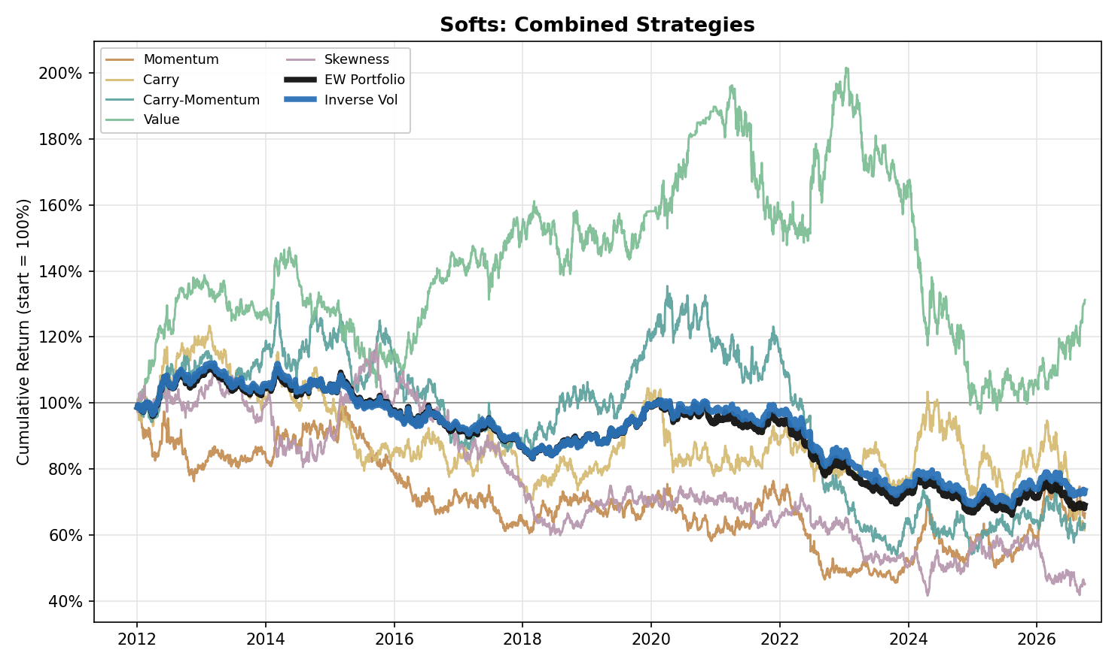
Figure 7. Softs: Combined Strategy Performance (Cumulative Return, 2012-2026)

US Power (Standalone)
- US Power is a standalone bucket and is not part of the cross-commodity book. The series are ICE monthly real-time power futures (USD per MWh), peak and off-peak, on the PJM Western Hub, ERCOT North 345KV and MISO Indiana Hub. The data files hold ten series: the four CME ones start in 2026 and carry no volume or open interest, so six are usable, and the five whose Calendar-2025 time to trade one sigma of risk is under 5 days are included (PJM Peak 0.10, ERCOT Peak 0.36, PJM OffPeak 0.47, ERCOT OffPeak 4.7, MISO Peak 4.7 days); MISO OffPeak, at 9.9 days, is excluded. The data start on 2 January 2015 and Value needs two years of F3, so results run from 2017 and there is no P1; the periods are P2 (2017-2021), P3 (2022-2026) and the full window. Every delivery month is listed and its last trade date falls in the delivery month, so the generic F1 is the contract delivering now. The usual roll (the fifth trading day of the expiry month) therefore moves into the next month on the fifth trading day of the delivery month, and the position is in the partly settled delivery-month contract for its first four or five trading days. Carry and Carry-Momentum use F1-F2 and F1-F13.
- US Power earns a weak positive edge at very high volatility: Equal Weight (Return +8.7%, Vol 29.4%, Max Drawdown -47.1%, IR +0.30) and Inverse Vol (Return +8.7%, Vol 28.1%, Max Drawdown -44.7%, IR +0.31). The result sits in P2: Equal Weight IR is +0.88 in P2 and -0.03 in P3 (Inverse Vol +0.78 and +0.05), and 2026 to 30 September is negative under both constructions (Equal Weight -0.27, Inverse Vol -0.53). Each sleeve has a volatility of 51.7% to 57.8%; combining them brings it to 29.4%, still the highest of any bucket's portfolio, so the IRs should be read together with the drawdowns, and the Equal Weight maximum drawdown of -47.1% is deeper than in any of the seven buckets.
- Value (Return +22.4%, Vol 57.8%, Max Drawdown -75.9%, IR +0.39) is the best sleeve and, with Momentum, one of only two positive in both periods (P2 +0.84, P3 +0.17); Carry (Return +19.9%, Vol 55.9%, Max Drawdown -88.9%, IR +0.36) follows but is a P2 result (P2 +2.20, P3 -0.40); Momentum (IR +0.20; P2 +0.09, P3 +0.29) and Skewness (IR +0.02) add little; Carry-Momentum (Return -7.6%, Vol 54.7%, Max Drawdown -88.2%, IR -0.14) is the only negative sleeve (P2 +0.22, P3 -0.34).
- The weakest year is 2022: the Equal Weight portfolio loses 0.38 of log return because Carry loses 1.85 (the largest sleeve-year in the bucket) and Carry-Momentum 0.89 and Momentum 0.28, while Value earns +0.86 and Skewness +0.26. The other very large sleeve-year is Skewness in 2024 (+1.63), against -0.87 in 2019 and -0.75 in 2023, which is why its full-sample IR is close to zero (+0.02).
- The five products differ materially in return, risk and capacity. Over the five sleeves combined, ERCOT Peak earns the best IR (+0.45) at a volatility of 66.9% and a maximum drawdown of -84.7%, followed by MISO Peak (+0.23), PJM Peak (+0.19) and PJM OffPeak (+0.10); ERCOT OffPeak is negative (-0.06). The products form two clusters: PJM Peak correlates 0.67 with MISO Peak and 0.62 with PJM OffPeak, and the two ERCOT series 0.47 with each other, while ERCOT against PJM and MISO is at most 0.14. The capacity constraint is tightest for ERCOT OffPeak and MISO Peak (4.7 days each to trade one sigma of risk).
- Carry's P2 result of +2.20 comes from every product (P2 IR +0.29 to +3.84, with ERCOT Peak at +3.84); in P3 it is negative in four of the five (only MISO Peak is positive, +0.11). Over the full window it is positive in ERCOT Peak (+0.67), MISO Peak (+0.37), PJM OffPeak (+0.20) and PJM Peak (+0.08) and negative in ERCOT OffPeak (-0.14).
- Value is positive in every product (IR +0.18 to +0.36). It is also the main diversifier inside the bucket after Skewness: it correlates -0.15 with Momentum and -0.21 with Skewness and +0.31 with the bucket's Equal Weight portfolio (Skewness +0.10), while Carry and Carry-Momentum correlate +0.80 and +0.80 with it and +0.67 with each other.
- Skewness splits by product: negative in PJM Peak (-0.44) and PJM OffPeak (-0.42) and strongly positive in ERCOT OffPeak (+0.88; P3 +1.97). It is negative in P2 (-0.52) and positive in P3 (+0.41). Adding it lifts the portfolio's IR from +0.28 to +0.30 for Equal Weight and from +0.25 to +0.31 for Inverse Vol.
- The two portfolio constructions are close: Inverse Vol has the slightly higher IR (+0.31 against +0.30), the lower volatility (28.1% against 29.4%) and the shallower maximum drawdown (-44.7% against -47.1%) for the same return (+8.7%).
- As a stream, US Power is close to uncorrelated with everything else in the research: its Equal Weight portfolio correlates -0.02 to +0.05 with the seven buckets' Equal Weight portfolios over 2017 to 2026 and 0.00 with equity, +0.02 with the Commodity Index and 0.00 with gold, but at an IR of +0.30 and a volatility of 29.4% it is a weak stand-alone return stream.
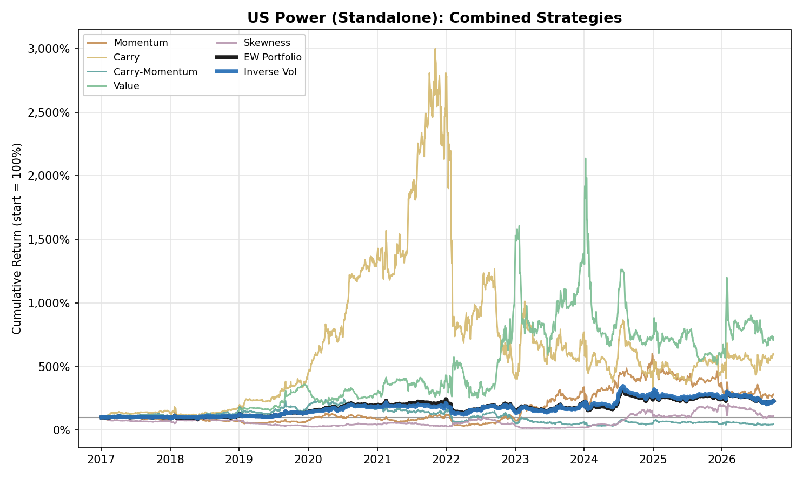
Figure 8. US Power (Standalone): Combined Strategy Performance (Cumulative Return, 2017-2026)

Correlation Analysis

Within-Asset-Class Correlation
- Value is the least correlated sleeve with its own EW PORT in every bucket, correlating at -0.07 in Metals, -0.23 in Petroleum, +0.13 in Gas and Emissions, 0.00 in NGL, -0.30 in Precious Metals, +0.12 in Agriculture and +0.05 in Softs. Skewness is the second least correlated in every bucket (+0.36 in Metals, +0.27 in Petroleum, +0.16 in Gas and Emissions, +0.28 in NGL, +0.40 in Precious Metals, +0.27 in Agriculture and +0.24 in Softs), so the two sleeves with the weakest links to the portfolio are the two that are not built on trend or curve slope, which is consistent with, not a test of, their acting as diversifiers. In Gas and Emissions, Agriculture and Softs, where Value is positively correlated with the portfolio (in NGL the correlation is zero), it is still the lowest of the five.
- Momentum and Carry are the most correlated pair of base strategies in Petroleum (+0.69) and NGL (+0.70), consistent with a common driver behind the two signals (not tested here). Metals, Gas and Emissions and Precious Metals break this pattern: in all three, Carry and Carry-Momentum are the closest pair (+0.41 in Metals, +0.44 in Gas and Emissions, +0.50 in Precious Metals), and in Agriculture and Softs it is Momentum and Carry-Momentum (+0.39 and +0.40). Value is negatively correlated with Momentum in all seven buckets (-0.50 in Metals, -0.52 in Petroleum, -0.41 in Gas and Emissions, -0.51 in NGL, -0.41 in Precious Metals, -0.29 in Agriculture and -0.34 in Softs).
- Skewness pairs differently by bucket. With Value it is negative in six buckets and strongest in Precious Metals (-0.20 in Metals, -0.11 in Petroleum, -0.36 in Gas and Emissions, +0.15 in NGL, -0.62 in Precious Metals, -0.03 in Agriculture and -0.07 in Softs); in NGL it is the exception. With Momentum and Carry it is near zero (no reading above 0.20 in magnitude) except in NGL, where it is -0.22 and -0.27.
- Inverse Vol tracks its own EW PORT closely everywhere, correlating between 0.95 and 0.99 across all seven buckets, expected since both portfolios are built from the same five sleeves and differ only in how they are weighted.

Cross-Commodity Correlation
- Petroleum and NGL are the most correlated cross-bucket pair for all seven series types tracked: Momentum (0.69), Carry (0.45), Carry-Momentum (0.44), Value (0.74), Skewness (0.76), EW PORT (0.56) and Inverse Vol (0.53), consistent with both trading the same hydrocarbon complex (the Naphtha swap, priced off crude, is part of NGL).
- Gas and Emissions is close to uncorrelated with everything except the hydrocarbon buckets: its EW PORT correlation is 0.16 with NGL and 0.13 with Petroleum, and 0.00 with Metals, -0.04 with Precious Metals, 0.03 with Agriculture and -0.02 with Softs. Metals-Precious Metals is the second most correlated pair for Momentum (0.22), Value (0.26) and Skewness (0.15) and fourth for EW PORT (0.12); for Carry the second place is Petroleum-Gas and Emissions (0.14) and for Carry-Momentum Gas and Emissions-NGL (0.07), narrowly ahead of Petroleum-Agriculture (0.06).
- Carry-Momentum has the lowest cross-bucket correlations of the seven series: its correlations to the same strategy in other buckets average just 0.05 in magnitude (Carry 0.07; the other five range 0.07 to 0.15), and 20 of its twenty-one pairwise readings are below 0.10, the exception being Petroleum-NGL (0.44).

Portfolio Construction Implication
- The Cross-Pair tab shows all twenty-one bucket pairs. Under the EW PORT measure, Petroleum-NGL (0.56) is by far the most correlated pair; the next three are Gas and Emissions-NGL (0.16), Petroleum-Gas and Emissions (0.13) and Metals-Precious Metals (0.12), and every other pair is at or below 0.08 in magnitude. The table below sets each pair's EW PORT correlation beside its full-sample IR under Equal Weight and Inverse Vol.
Pair | EW PORT correlation | Equal Weight IR | Inverse Vol IR
Petroleum-NGL | 0.56 | +1.21 | +1.29
Gas and Emissions-NGL | 0.16 | +1.20 | +1.32
Metals-NGL | 0.07 | +1.12 | +0.97
Petroleum-Gas and Emissions | 0.13 | +0.96 | +0.94
NGL-Precious Metals | 0.02 | +0.93 | +0.76
NGL-Softs | 0.02 | +0.91 | +0.72
NGL-Agriculture | 0.05 | +0.89 | +0.54
Metals-Petroleum | 0.07 | +0.73 | +0.60
Petroleum-Precious Metals | 0.03 | +0.58 | +0.50
Petroleum-Softs | -0.01 | +0.56 | +0.29
Metals-Gas and Emissions | 0.00 | +0.55 | +0.50
Petroleum-Agriculture | 0.06 | +0.52 | +0.18
Gas and Emissions-Precious Metals | -0.04 | +0.45 | +0.17
Gas and Emissions-Softs | -0.02 | +0.41 | +0.15
Gas and Emissions-Agriculture | 0.03 | +0.38 | +0.12
Metals-Precious Metals | 0.12 | -0.20 | -0.14
Metals-Softs | 0.01 | -0.31 | -0.27
Precious Metals-Softs | 0.06 | -0.39 | -0.50
Metals-Agriculture | 0.01 | -0.41 | -0.32
Precious Metals-Agriculture | 0.02 | -0.48 | -0.59
Agriculture-Softs | 0.00 | -0.60 | -0.62

- Correlation and standalone performance are separate questions. Held on its own, Petroleum-NGL, the most correlated pair, produces the highest full-sample Equal Weight IR of the twenty-one pairs (+1.21) and the second highest under Inverse Vol (+1.29, behind Gas and Emissions-NGL at +1.32), while Agriculture-Softs produces the lowest under both (Equal Weight -0.60, Inverse Vol -0.62). Two individually strong books can still make a poor diversification pairing simply because they move together.

Cross-Commodity Portfolio
- Diversifying each individual strategy across all seven buckets first (equal-weighted), then combining strategies, lifts every strategy above its worst individual bucket showing: Momentum (Return +4.5%, Vol 12.2%, Max Drawdown -35.3%, IR +0.37), Carry (Return +6.9%, Vol 10.0%, Max Drawdown -26.9%, IR +0.68), Carry-Momentum (Return +5.5%, Vol 9.3%, Max Drawdown -29.2%, IR +0.59), Value (Return -0.6%, Vol 11.7%, Max Drawdown -52.6%, IR -0.05) and Skewness (Return +4.0%, Vol 10.9%, Max Drawdown -33.3%, IR +0.37). The worst bucket IRs for the same strategies are -0.33, -0.34, -0.71, -0.21, -0.35.
- At the top level, combining those five cross-commodity strategies gives Equal Weight (Return +4.0%, Vol 4.8%, Max Drawdown -15.0%, IR +0.84) and Inverse Vol (Return +4.4%, Vol 4.8%, Max Drawdown -13.9%, IR +0.90). Inverse Vol is the stronger construction, with the higher return and IR and the shallower drawdown at nearly the same volatility.
- The cross-commodity book is positive in every one of the three periods under both constructions (Equal Weight P1 +0.41, P2 +1.87, P3 +0.33; Inverse Vol P1 +0.66, P2 +1.82, P3 +0.36). Among the single buckets only Petroleum, Gas and Emissions and NGL do the same, and all three do so at more than twice the cross-commodity volatility (Equal Weight 13.4%, 16.5% and 11.5% against 4.8%).
- The weakest period for the cross-commodity book is P3 (Equal Weight IR +0.33, Inverse Vol +0.36), still positive but a fraction of the strength shown in P2. Within the strategies, P3 is the period in which Momentum (-0.11) and Carry-Momentum (-0.12) turn negative and Carry is barely positive (+0.10); Skewness (+0.53) and Value (+0.46) are the best sleeves. In P1 Value (-0.28) and Skewness (-0.26) are the only negative ones.
- Skewness changes the book in three ways. It lifts the full-sample IR (Equal Weight +0.68 to +0.84, Inverse Vol +0.76 to +0.90) and cuts volatility (Equal Weight 6.0% to 4.8%) and maximum drawdown (-20.6% to -15.0%); it moves the IR from P1 to P3 (Equal Weight P1 +0.51 to +0.41, P3 +0.13 to +0.33); and it adds commodity beta (see the benchmark correlations below).
- Combining in the opposite order, each bucket's five sleeves first and then the seven bucket portfolios, gives the identical Equal Weight result (IR +0.84); the three other weighting combinations give IRs of +0.53, +0.90 and +0.53 (sleeves Equal Weight / across Inverse Vol; sleeves Inverse Vol / across Equal Weight; Inverse Vol at both stages).
- Across all twenty-one bucket pairings, Petroleum-NGL is the best-performing combination under Equal Weight (IR +1.21, Inverse Vol +1.29) even though it is the most correlated pair, and Gas and Emissions-NGL is the best under Inverse Vol (Inverse Vol +1.32, Equal Weight +1.20); both beat the seven-bucket book on IR under both constructions (Equal Weight +0.84, Inverse Vol +0.90) at 11.0% and 10.8% Equal Weight volatility against 4.8%. Seven pairs beat the book under Equal Weight and four under Inverse Vol, every one of them containing NGL, Petroleum or Gas and Emissions. The only pairs with a negative full-sample IR under either construction are the six built from Metals, Precious Metals, Agriculture and Softs alone: Metals-Precious Metals (-0.20 / -0.14); Metals-Agriculture (-0.41 / -0.32); Metals-Softs (-0.31 / -0.27); Precious Metals-Agriculture (-0.48 / -0.59); Precious Metals-Softs (-0.39 / -0.50); Agriculture-Softs (-0.60 / -0.62), and each is clearly negative in P3 under both constructions (Equal Weight -0.47, -0.42, -0.86, -0.44, -0.77, -0.77; Inverse Vol -0.41, -0.28, -0.82, -0.48, -0.85, -0.62).
- Benchmarked against traditional assets, the five-sleeve cross-commodity book still diversifies equity and bonds but is not free of commodity beta: it correlates negatively with Equity (Equal Weight -0.09, Inverse Vol -0.10) and with a traditional 60/40 portfolio (-0.10, -0.11), stays close to zero against Fixed Income (-0.06, -0.05) and Gold (+0.02, +0.02), but is positively correlated with a passive Commodity Index (+0.18, +0.15; -0.01 and -0.02 without Skewness). The change comes from Skewness, which correlates +0.41 with the Commodity Index, +0.16 with Equity and +0.14 with Gold.
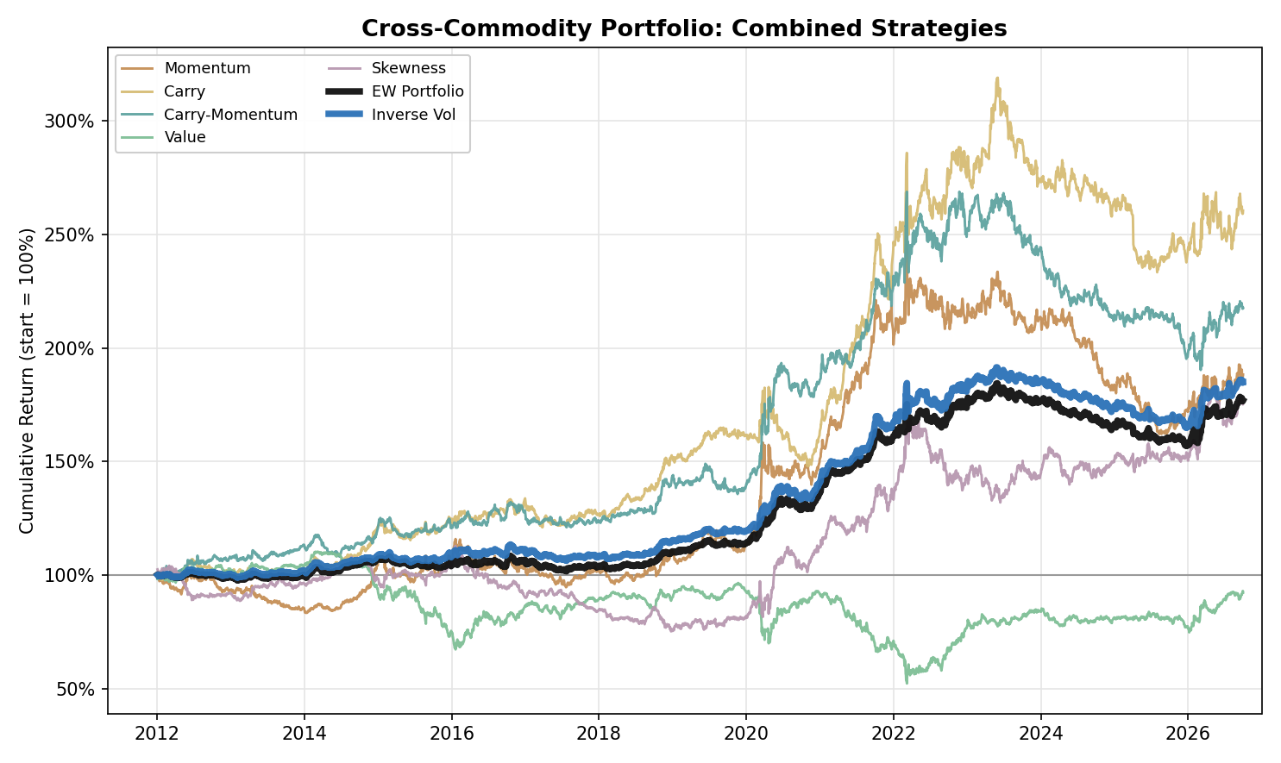
Figure 9. Cross-Commodity Portfolio: Combined Strategy Performance (Cumulative Return, 2012-2026)

Liquidity and Tradable Capacity: Dollar Risk Turnover, Calendar 2025
Definition. Market liquidity is operationalised as dollar risk turnover: the amount of one-standard-deviation daily price risk that a market transacts per trading day. For product i it is the product of average daily volume, the dollar value of one contract at the average price, and the volatility of daily returns. Raw volume is not comparable across contracts that differ in size, price level and volatility; expressing every market as dollars of risk traded per day ranks WTI, Gold, Corn and Propane on one scale.
Purpose. The return analysis done here leaves one capacity question open: whether a position taken at a given risk budget could be executed in each market without dominating its flow. The metric answers it directly, and is used to test how liquid is each product across all the buckets. It is a descriptive, one-year cross-sectional snapshot. Data for only 2025 are used: volume, prices and volatility all cover 1 January to 31 December 2025.
$c_{i} = m_{i} · {\overline{P}}_{i} · σ_{i}$ (1)
${ADV}_{i} = \frac{1}{T_{i}}\sum_{t = 1}^{T_{i}}{\sum_{j ∈ S_{i}}{V_{i,j,t}}}$ (2)
$x_{i} = {ADV}_{i} · c_{i}$ (3)
$L_{i} = \frac{K}{x_{i}}$ (4)
where, for product i:
• c_{i}: dollar one-sigma risk of a single contract (USD per contract).
• m_{i}: contract multiplier, the number of price units per lot from the exchange specification (for example 1,000 barrels for WTI, 100 troy ounces for Gold).
• P̄_{i}: mean 2025 unadjusted price of the contract actually held (F1 before the roll day, F2 after), in USD per unit; EUR-quoted EUA and TTF are converted at 1.1300 USD/EUR, the 2025 mean of the ECB daily reference rate.
• σ_{i}: sample standard deviation of the daily log returns of the roll-adjusted series over 2025.
• T_{i}: number of 2025 trading days of the product's own exchange calendar (251 to 258).
• S_{i}: the strip of tenors spanning twelve months: F1–F12 for monthly chains, shorter for quarterly or sparse chains (Gold F1–F6, Silver F1–F5, EUA F1–F4).
• V_{i,j,t}: volume in lots of tenor j on day t; a day with no print counts as zero, and open interest is never substituted for volume.
• ADV_{i}, x_{i}: average daily volume in lots, and dollar risk turnover (USD of one-sigma risk traded per day, reported in USD millions).
• K, L_{i}: reference position of USD 1 million of one-sigma daily risk, and L, its size as a multiple of one day of the market's risk turnover (L = 0.05 is five per cent of a day; L = 3 is three days of the entire market's flow). The ranking by x does not depend on K.
Results across 36 products. Dollar risk turnover ranges from USD 1,324.9 million per day for Brent, the most liquid, to USD 0.101 million for MISO OffPeak, the least liquid and the series excluded from the Power bucket on that ground, a span of four orders of magnitude. Naphtha (USD 0.107 million) is the least liquid product inside the seven research buckets. Within buckets, the spread between the most and least liquid products is narrow in Agriculture (3.1-fold; Soybean 157.1 to Wheat 51.1), Petroleum (5.2-fold; Brent 1,324.9 to RBOB 256.1) and Softs (7.2-fold; Coffee 112.0 to Cotton 15.5), intermediate in Metals (12.7-fold; Copper 244.8 to Lead 19.3) and in Gas and Emissions (21.3-fold; Henry Hub 668.3 to UK Gas 31.4), and wide in Precious Metals (47.7-fold; Gold 1,141.2 to Palladium 23.9). NGL is the outlier, with a spread of 45.4-fold (Propane 4.85 to Naphtha 0.107) and a level far below the other buckets: Propane, the most liquid NGL product, trades about 31% of the risk turnover of Cotton (15.5), the least liquid product outside NGL and US Power, and Natural Gasoline (0.80) sits between Butane (1.81) and Ethane (0.35). The US Power series lie between the two groups: PJM Peak (9.96) trades about 64% of the risk turnover of Cotton, ERCOT Peak and PJM OffPeak 2.80 and 2.12, and ERCOT OffPeak and MISO Peak 0.21 and 0.21, below Ethane (0.35); the spread across the five series is 46.8-fold. In terms of the reference position, a USD 1 million one-sigma position equals at most 0.06 days of market risk turnover in any product outside NGL and US Power, against 0.10, 0.36, 0.47, 4.7 and 4.7 days in PJM Peak, ERCOT Peak, PJM OffPeak, ERCOT OffPeak and MISO Peak, and 0.21 days in Propane, 1.25 in Natural Gasoline, 2.9 in Ethane and 9.4 in Naphtha. Naphtha averages 12 lots per day on the Bloomberg series and prints on 55% of days, so it cannot absorb a position of meaningful size. Isobutane, outside the table, is the least liquid of the 40 products measured: its 12-month strip averages 10 lots per day and prints on 13% of days, so a USD 1 million one-sigma position equals 156 days of its risk turnover. It is removed from every bucket, portfolio and table of this report for that reason. The same capacity limit applies to the remaining thin series. Returns in NGL and US Power may not be capturable at a scale comparable to that of the other buckets: ERCOT OffPeak and MISO Peak need 4.7 days of market turnover per USD 1 million of one-sigma risk. NGL volumes refer to CME only, and Naphtha volume is the Bloomberg series, a partial view of the swap market, so both are lower bounds. The product-level results are reported in Table A35.

Appendix: Period-Level Detail
Table A1. Metals: Strategy Information Ratios by Period
 | Full | 2012-16 | 2017-21 | 2022-26
Momentum | -0.33 | -0.43 | +0.05 | -0.58
Carry | +0.12 | +0.43 | +0.02 | -0.07
Carry-Momentum | -0.09 | +0.76 | -0.57 | -0.46
Value | +0.38 | +0.34 | +0.08 | +0.79
Skewness | -0.09 | -0.23 | +0.35 | -0.34

Table A2. Metals: Portfolio Construction Information Ratios by Period
 | Full | 2012-16 | 2017-21 | 2022-26
Equal Weight | -0.05 | +0.27 | -0.05 | -0.35
Inverse Vol | +0.07 | +0.48 | -0.02 | -0.19

Table A3. Metals: Individual-Metal Information Ratios, All Strategies (Full Sample)
 | Copper | Aluminium | Lead | Zinc
Momentum | -0.31 | +0.21 | -0.56 | -0.17
Carry | +0.13 | +0.26 | -0.19 | +0.11
Carry-Momentum | +0.05 | +0.03 | -0.24 | -0.02
Value | +0.10 | +0.16 | +0.42 | +0.38
Skewness | 0.00 | -0.03 | +0.03 | -0.17

Table A4. Petroleum: Strategy Information Ratios by Period
 | Full | 2012-16 | 2017-21 | 2022-26
Momentum | +0.53 | +0.57 | +0.66 | +0.36
Carry | +0.39 | +0.45 | +0.68 | +0.04
Carry-Momentum | +0.71 | +0.95 | +0.92 | +0.34
Value | -0.11 | -0.38 | +0.07 | -0.03
Skewness | +0.37 | -0.36 | +0.57 | +0.80

Table A5. Petroleum: Portfolio Construction Information Ratios by Period
 | Full | 2012-16 | 2017-21 | 2022-26
Equal Weight | +0.84 | +0.44 | +1.43 | +0.61
Inverse Vol | +0.89 | +0.52 | +1.50 | +0.62

Table A6. Petroleum: Individual-Product Information Ratios, All Strategies (Full Sample)
 | WTI | Brent | RBOB | Heating Oil
Momentum | +0.49 | +0.42 | +0.28 | +0.65
Carry | +0.16 | +0.27 | +0.32 | +0.58
Carry-Momentum | +0.85 | +0.48 | +0.35 | +0.32
Value | -0.07 | +0.02 | -0.12 | -0.23
Skewness | +0.32 | +0.39 | +0.32 | +0.24

Table A7. Gas and Emissions: Strategy Information Ratios by Period
 | Full | 2012-16 | 2017-21 | 2022-26
Momentum | +0.26 | -0.29 | +1.36 | -0.13
Carry | +0.64 | +0.56 | +1.72 | +0.05
Carry-Momentum | +0.45 | +0.17 | +1.15 | +0.17
Value | -0.14 | -0.11 | -0.84 | +0.48
Skewness | +0.30 | +0.67 | +0.30 | +0.13

Table A8. Gas and Emissions: Portfolio Construction Information Ratios by Period
 | Full | 2012-16 | 2017-21 | 2022-26
Equal Weight | +0.62 | +0.37 | +1.41 | +0.27
Inverse Vol | +0.60 | +0.40 | +1.38 | +0.23

Table A9. Gas and Emissions: Individual-Product Information Ratios, All Strategies (Full Sample)
 | Henry Hub | TTF | UK Gas | EUA
Momentum | +0.02 | +0.51 | +0.32 | -0.22
Carry | +0.26 | +0.96 | +0.46 | -0.09
Carry-Momentum | +0.28 | +0.40 | +0.24 | +0.15
Value | -0.11 | -0.08 | +0.02 | -0.23
Skewness | -0.39 | +0.64 | +0.39 | +0.07

Table A10. Precious Metals: Strategy Information Ratios by Period
 | Full | 2012-16 | 2017-21 | 2022-26
Momentum | -0.22 | +0.06 | -0.46 | -0.25
Carry | -0.07 | -0.14 | -0.09 | 0.00
Carry-Momentum | -0.23 | -0.08 | +0.31 | -0.75
Value | -0.05 | +0.01 | -0.05 | -0.08
Skewness | +0.09 | -0.26 | +0.25 | +0.22

Table A11. Precious Metals: Portfolio Construction Information Ratios by Period
 | Full | 2012-16 | 2017-21 | 2022-26
Equal Weight | -0.22 | -0.22 | -0.03 | -0.38
Inverse Vol | -0.28 | -0.40 | -0.10 | -0.36

Table A12. Precious Metals: Individual-Metal Information Ratios, All Strategies (Full Sample)
 | Gold | Silver | Platinum | Palladium
Momentum | +0.04 | -0.04 | -0.14 | -0.36
Carry | +0.03 | +0.18 | +0.07 | -0.32
Carry-Momentum | -0.12 | -0.06 | -0.01 | -0.28
Value | -0.22 | -0.03 | +0.08 | -0.02
Skewness | +0.01 | +0.13 | +0.06 | +0.02

Table A13. Precious Metals: Carry Tenor Pairs, Full-Sample Information Ratios
 | Previous single pair (F1-F3) | Short pair (F1-F2) | Long pair alone | Two-pair sum
Carry | -0.16 | -0.25 | -0.17 | -0.07
Carry-Momentum | -0.31 | -0.23 | +0.06 | -0.23

Table A14. NGL: Strategy Information Ratios by Period
 | Full | 2012-16 | 2017-21 | 2022-26
Momentum | +0.87 | +0.67 | +1.58 | +0.29
Carry | +0.95 | +1.19 | +1.05 | +0.62
Carry-Momentum | +1.02 | +0.74 | +1.16 | +1.20
Value | +0.08 | -0.42 | 0.00 | +0.99
Skewness | +0.22 | -0.55 | +0.89 | +0.17

Table A15. NGL: Portfolio Construction Information Ratios by Period
 | Full | 2012-16 | 2017-21 | 2022-26
Equal Weight | +1.35 | +0.66 | +2.11 | +1.15
Inverse Vol | +1.35 | +0.65 | +1.97 | +1.31

Table A16. NGL: Individual-Product Information Ratios, All Strategies (Full Sample)
 | Ethane | Propane | Butane | Naphtha | Natural Gasoline
Momentum | +0.82 | +0.67 | +1.12 | +0.52 | +0.04
Carry | +0.26 | +0.97 | +0.93 | +0.80 | +0.21
Carry-Momentum | +0.16 | +0.86 | +0.53 | +0.92 | +0.81
Value | -0.10 | +0.01 | +0.24 | +0.17 | +0.06
Skewness | +0.27 | -0.08 | -0.07 | +0.38 | +0.26

Table A17. Agriculture: Strategy Information Ratios by Period
 | Full | 2012-16 | 2017-21 | 2022-26
Momentum | -0.28 | -0.36 | -0.14 | -0.34
Carry | -0.34 | -0.21 | -0.70 | -0.08
Carry-Momentum | -0.71 | -0.44 | -0.63 | -1.06
Value | -0.21 | -0.44 | -0.08 | -0.09
Skewness | +0.45 | +0.36 | -0.29 | +1.31

Table A18. Agriculture: Portfolio Construction Information Ratios by Period
 | Full | 2012-16 | 2017-21 | 2022-26
Equal Weight | -0.52 | -0.54 | -0.83 | -0.23
Inverse Vol | -0.50 | -0.70 | -0.75 | -0.12

Table A19. Agriculture: Individual-Product Information Ratios, All Strategies (Full Sample)
 | Corn | Wheat | Soybean | Live Cattle
Momentum | -0.27 | -0.23 | -0.10 | +0.01
Carry | -0.12 | -0.07 | -0.13 | -0.59
Carry-Momentum | -0.20 | -0.52 | -0.26 | -0.63
Value | -0.36 | +0.17 | -0.18 | -0.29
Skewness | +0.26 | +0.22 | +0.35 | +0.09

Table A20. Agriculture: Carry Tenor Pairs, Full-Sample Information Ratios (long pair F1-F6 for Corn and Wheat, F1-F7 for Soybean and Live Cattle)
 | Short pair alone (F1-F2) | Long pair alone | Two-pair sum
Carry | -0.10 | -0.31 | -0.34
Carry-Momentum | -0.32 | -0.65 | -0.71

Table A21. Softs: Strategy Information Ratios by Period
 | Full | 2012-16 | 2017-21 | 2022-26
Momentum | -0.17 | -0.46 | -0.04 | -0.05
Carry | -0.20 | -0.24 | +0.05 | -0.38
Carry-Momentum | -0.20 | -0.15 | +0.37 | -0.66
Value | +0.13 | +0.62 | +0.17 | -0.22
Skewness | -0.35 | -0.23 | -0.40 | -0.42

Table A22. Softs: Portfolio Construction Information Ratios by Period
 | Full | 2012-16 | 2017-21 | 2022-26
Equal Weight | -0.36 | -0.25 | +0.06 | -0.80
Inverse Vol | -0.31 | -0.24 | +0.14 | -0.72

Table A23. Softs: Individual-Product Information Ratios, All Strategies (Full Sample)
 | Sugar | Cocoa | Coffee | Cotton
Momentum | -0.07 | -0.16 | +0.11 | -0.28
Carry | -0.06 | -0.16 | +0.11 | -0.33
Carry-Momentum | -0.02 | -0.03 | +0.09 | -0.52
Value | -0.07 | +0.16 | 0.00 | +0.21
Skewness | -0.08 | -0.20 | -0.29 | -0.07

Table A24. Softs: Carry Tenor Pairs, Full-Sample Information Ratios (long pair F1-F6 for all four products)
 | Short pair alone (F1-F2) | Long pair alone | Two-pair sum
Carry | -0.51 | -0.07 | -0.20
Carry-Momentum | -0.08 | -0.16 | -0.20

Table A25. US Power (Standalone): Strategy Information Ratios by Period (2017 onwards)
 | Full | 2017-21 | 2022-26
Momentum | +0.20 | +0.09 | +0.29
Carry | +0.36 | +2.20 | -0.40
Carry-Momentum | -0.14 | +0.22 | -0.34
Value | +0.39 | +0.84 | +0.17
Skewness | +0.02 | -0.52 | +0.41

Table A26. US Power (Standalone): Portfolio Construction Information Ratios by Period (2017 onwards)
 | Full | 2017-21 | 2022-26
Equal Weight | +0.30 | +0.88 | -0.03
Inverse Vol | +0.31 | +0.78 | +0.05

Table A27. US Power (Standalone): Individual-Product Information Ratios, All Strategies (Full Sample from 2017)
 | PJM Peak | PJM OffPeak | ERCOT Peak | ERCOT OffPeak | MISO Peak
Momentum | +0.43 | +0.08 | +0.36 | -0.20 | +0.01
Carry | +0.08 | +0.20 | +0.67 | -0.14 | +0.37
Carry-Momentum | +0.26 | +0.16 | -0.10 | -0.49 | +0.05
Value | +0.36 | +0.36 | +0.33 | +0.19 | +0.18
Skewness | -0.44 | -0.42 | +0.12 | +0.88 | +0.03

Table A28. Cross-Commodity Portfolio: Correlation vs Traditional Assets (2012 to 30 September 2026)
 | Equity | Fixed Income | Commodity Index | Gold | 60/40 Portfolio
Momentum | -0.21 | -0.05 | -0.07 | +0.01 | -0.21
Carry | -0.15 | -0.07 | +0.05 | -0.01 | -0.16
Carry-Momentum | -0.13 | -0.02 | -0.04 | +0.02 | -0.13
Value | +0.13 | +0.02 | +0.04 | -0.11 | +0.13
Skewness | +0.16 | 0.00 | +0.41 | +0.14 | +0.15
EW Portfolio | -0.09 | -0.06 | +0.18 | +0.02 | -0.10
Inverse Vol | -0.10 | -0.05 | +0.15 | +0.02 | -0.11

Table A29. Cross-Commodity Portfolio: Strategy Information Ratios by Period (all seven buckets)
 | Full | 2012-16 | 2017-21 | 2022-26
Momentum | +0.37 | +0.08 | +1.11 | -0.11
Carry | +0.68 | +0.92 | +1.25 | +0.10
Carry-Momentum | +0.59 | +0.79 | +1.28 | -0.12
Value | -0.05 | -0.28 | -0.33 | +0.46
Skewness | +0.37 | -0.26 | +0.66 | +0.53

Table A30. Cross-Commodity Portfolio: Construction Information Ratios by Period (all seven buckets)
 | Full | 2012-16 | 2017-21 | 2022-26
Equal Weight | +0.84 | +0.41 | +1.87 | +0.33
Inverse Vol | +0.90 | +0.66 | +1.82 | +0.36
Equal Weight (without Skewness) | +0.68 | +0.51 | +1.55 | +0.13
Inverse Vol (without Skewness) | +0.76 | +0.71 | +1.55 | +0.22

Table A31. Cross-Pair Portfolio: Full-Sample Information Ratios, All Twenty-One Bucket Pairs
 | Equal Weight | Inverse Vol
Metals-Petroleum | +0.73 | +0.60
Metals-Gas and Emissions | +0.55 | +0.50
Metals-NGL | +1.12 | +0.97
Metals-Precious Metals | -0.20 | -0.14
Metals-Agriculture | -0.41 | -0.32
Metals-Softs | -0.31 | -0.27
Petroleum-Gas and Emissions | +0.96 | +0.94
Petroleum-NGL | +1.21 | +1.29
Petroleum-Precious Metals | +0.58 | +0.50
Petroleum-Agriculture | +0.52 | +0.18
Petroleum-Softs | +0.56 | +0.29
Gas and Emissions-NGL | +1.20 | +1.32
Gas and Emissions-Precious Metals | +0.45 | +0.17
Gas and Emissions-Agriculture | +0.38 | +0.12
Gas and Emissions-Softs | +0.41 | +0.15
NGL-Precious Metals | +0.93 | +0.76
NGL-Agriculture | +0.89 | +0.54
NGL-Softs | +0.91 | +0.72
Precious Metals-Agriculture | -0.48 | -0.59
Precious Metals-Softs | -0.39 | -0.50
Agriculture-Softs | -0.60 | -0.62

Table A32. Skewness: Share of Days Long and Log Return of the Long and Short Legs, by Product (Full Sample, Gross of Costs)
Product | Days long | Long-leg log return | Short-leg log return | IR (net)
Metals: Copper | 55% | +0.30 | -0.24 | 0.00
Metals: Aluminium | 24% | -0.10 | +0.06 | -0.03
Metals: Lead | 47% | -0.18 | +0.33 | +0.03
Metals: Zinc | 48% | +0.10 | -0.62 | -0.17
Petroleum: WTI | 73% | +0.89 | +1.06 | +0.32
Petroleum: Brent | 70% | +1.27 | +0.74 | +0.39
Petroleum: RBOB | 73% | +1.44 | +0.25 | +0.32
Petroleum: Heating Oil | 67% | +1.24 | 0.00 | +0.24
Gas and Emissions: Henry Hub | 56% | -3.61 | +0.35 | -0.39
Gas and Emissions: TTF | 34% | +1.54 | +3.45 | +0.64
Gas and Emissions: UK Gas | 38% | -0.21 | +3.68 | +0.39
Gas and Emissions: EUA | 61% | +1.40 | -0.86 | +0.07
Precious Metals: Gold | 57% | +0.37 | -0.31 | +0.01
Precious Metals: Silver | 75% | +0.54 | +0.12 | +0.13
Precious Metals: Platinum | 68% | +0.12 | +0.20 | +0.06
Precious Metals: Palladium | 73% | +0.31 | -0.18 | +0.02
NGL: Ethane | 80% | -0.34 | +2.04 | +0.27
NGL: Propane | 79% | -0.36 | -0.04 | -0.08
NGL: Butane | 78% | +0.48 | -0.77 | -0.07
NGL: Naphtha | 78% | +1.62 | +0.45 | +0.38
NGL: Natural Gasoline | 74% | +0.95 | +0.54 | +0.26
Agriculture: Corn | 65% | +0.38 | +0.52 | +0.26
Agriculture: Wheat | 14% | -0.11 | +1.05 | +0.22
Agriculture: Soybean | 60% | +0.95 | +0.09 | +0.35
Agriculture: Live Cattle | 44% | +0.43 | -0.17 | +0.09
Softs: Sugar | 29% | -0.53 | +0.27 | -0.08
Softs: Cocoa | 47% | +0.31 | -1.37 | -0.20
Softs: Coffee | 44% | -0.72 | -0.75 | -0.29
Softs: Cotton | 49% | -0.27 | +0.07 | -0.07

Table A33. Effect of Adding Skewness: Full-Sample Portfolio Information Ratios with Four and Five Sleeves
 | Equal Weight, 4 sleeves | Equal Weight, 5 sleeves | Inverse Vol, 4 sleeves | Inverse Vol, 5 sleeves
Metals | -0.02 | -0.05 | +0.14 | +0.07
Petroleum | +0.67 | +0.84 | +0.71 | +0.89
Gas and Emissions | +0.49 | +0.62 | +0.48 | +0.60
Precious Metals | -0.29 | -0.22 | -0.34 | -0.28
NGL | +1.28 | +1.35 | +1.28 | +1.35
Agriculture | -0.70 | -0.52 | -0.70 | -0.50
Softs | -0.21 | -0.36 | -0.17 | -0.31
Cross-commodity (seven buckets) | +0.68 | +0.84 | +0.76 | +0.90

Table A34. Skewness: Correlation with the Other Sleeves and with the Equal Weight Portfolio, within Each Bucket
 | Momentum | Carry | Carry-Momentum | Value | EW PORT
Metals | +0.01 | +0.06 | -0.03 | -0.20 | +0.36
Petroleum | -0.16 | -0.05 | -0.16 | -0.11 | +0.27
Gas and Emissions | +0.07 | -0.10 | -0.18 | -0.36 | +0.16
Precious Metals | +0.03 | +0.20 | +0.12 | -0.62 | +0.40
NGL | -0.22 | -0.27 | -0.12 | +0.15 | +0.28
Agriculture | -0.07 | -0.06 | -0.12 | -0.03 | +0.27
Softs | -0.14 | -0.16 | -0.06 | -0.07 | +0.24

Appendix: Equity-Curve Charts
Individual equity curves underlying the combined-strategy figures above, decomposed by instrument for each strategy within each bucket and for the standalone US Power bucket (from 2017), and by bucket pair, one chart per construction method, for the Cross-Pair Portfolios (all twenty-one pairs). Skewness charts are included for every bucket.

Metals
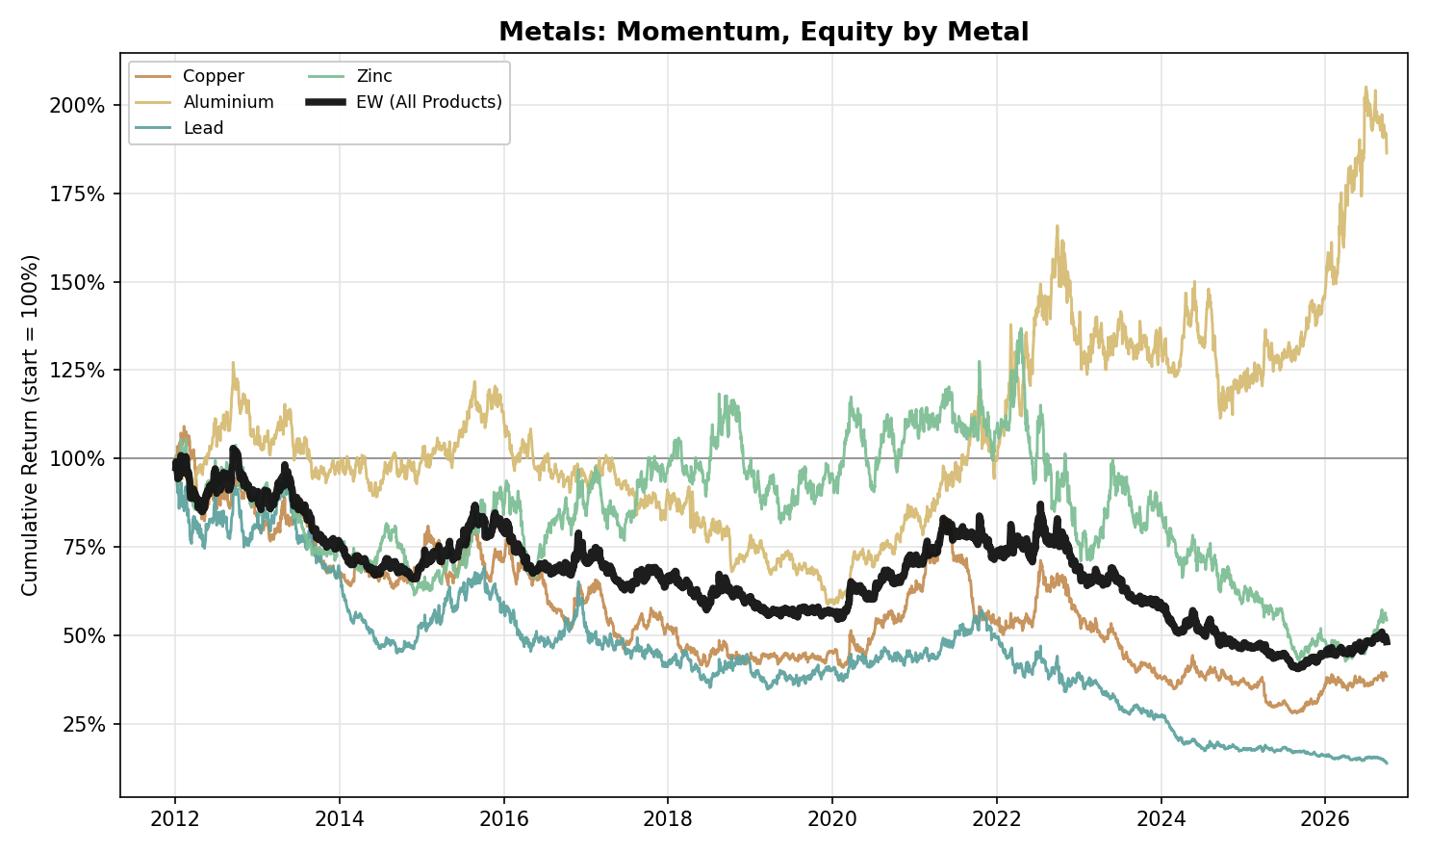
Figure A1. Metals, Momentum: Equity Curve by Metal (2012-2026)
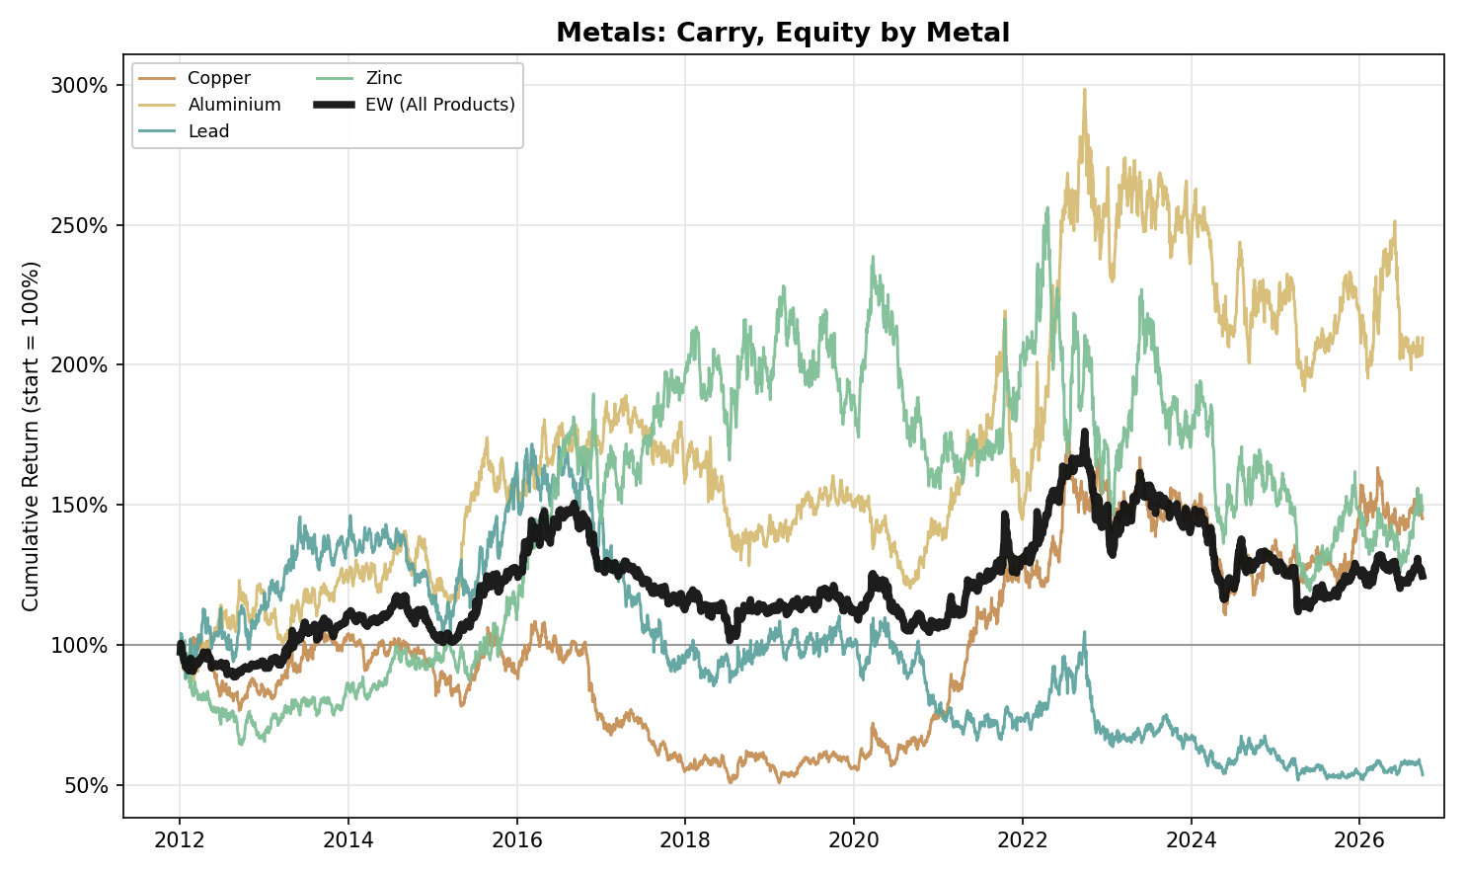
Figure A2. Metals, Carry: Equity Curve by Metal (2012-2026)
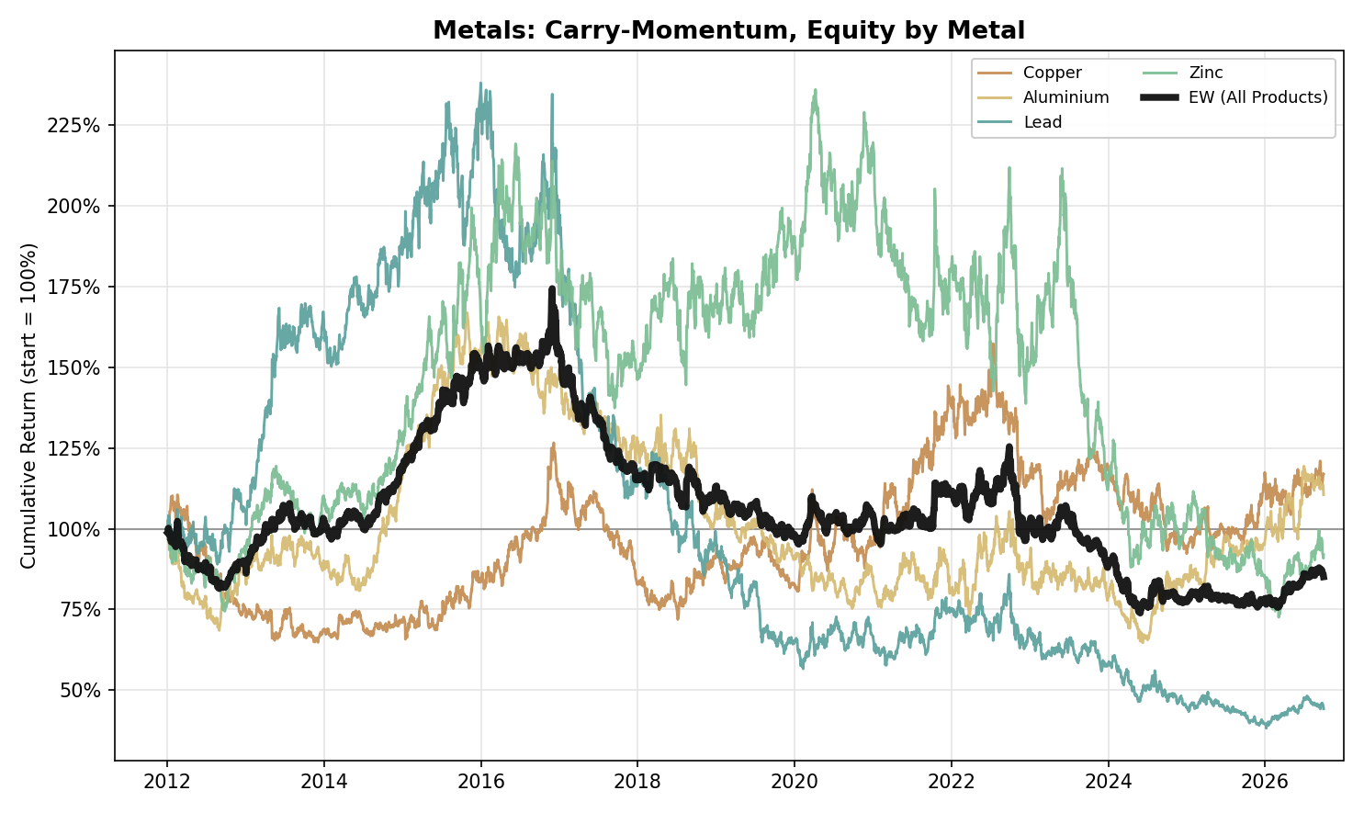
Figure A3. Metals, Carry-Momentum: Equity Curve by Metal (2012-2026)
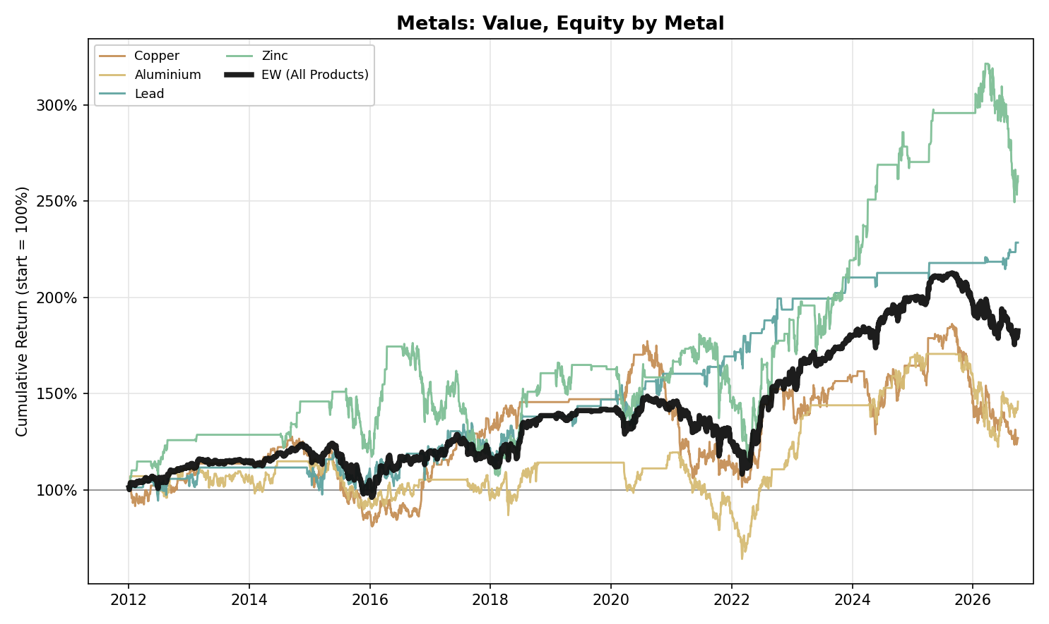
Figure A4. Metals, Value: Equity Curve by Metal (2012-2026)
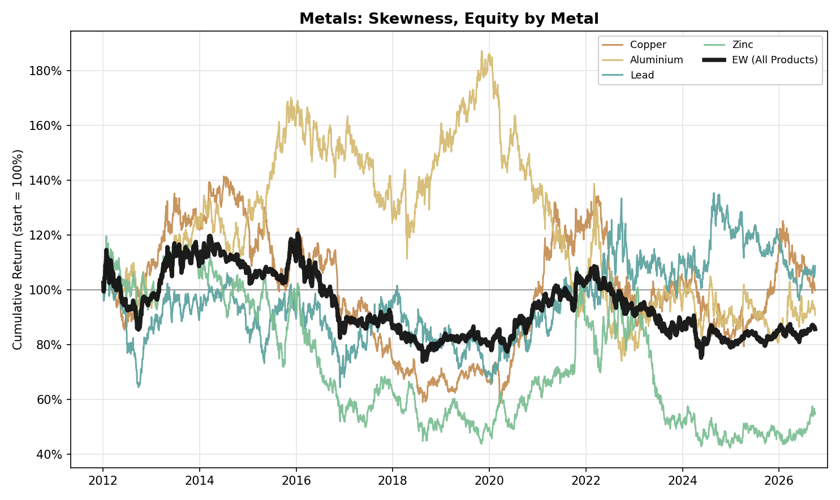
Figure A5. Metals, Skewness: Equity Curve by Metal (2012-2026)

Petroleum
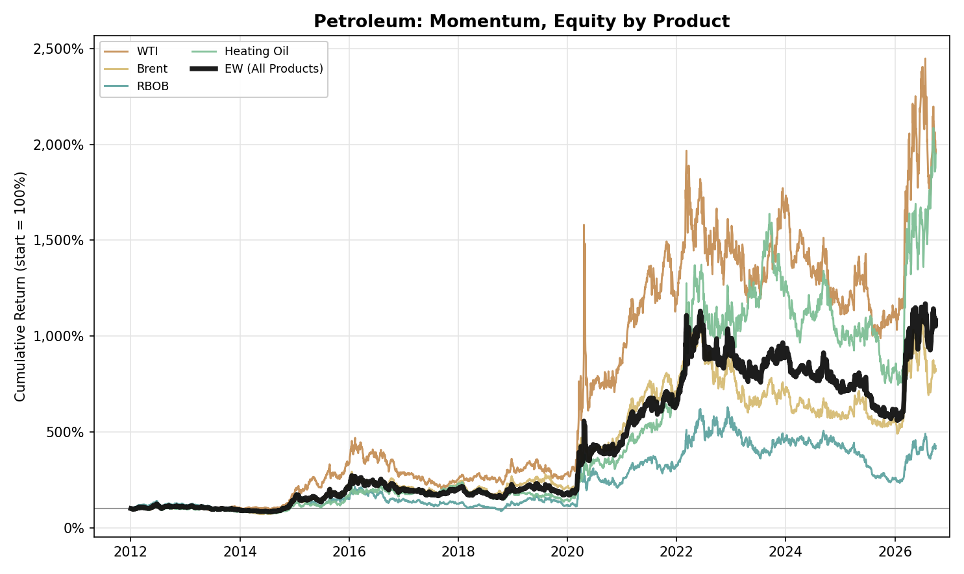
Figure A6. Petroleum, Momentum: Equity Curve by Product (2012-2026)
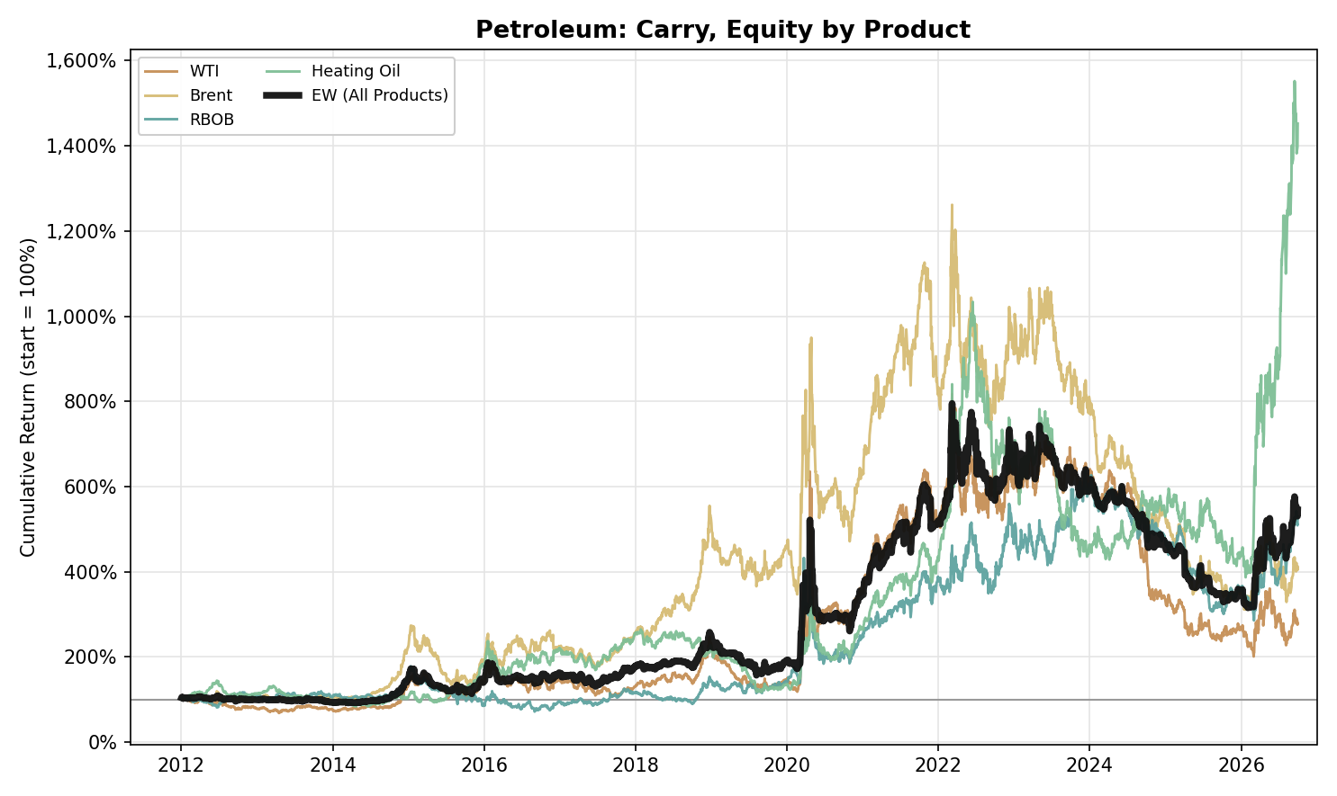
Figure A7. Petroleum, Carry: Equity Curve by Product (2012-2026)
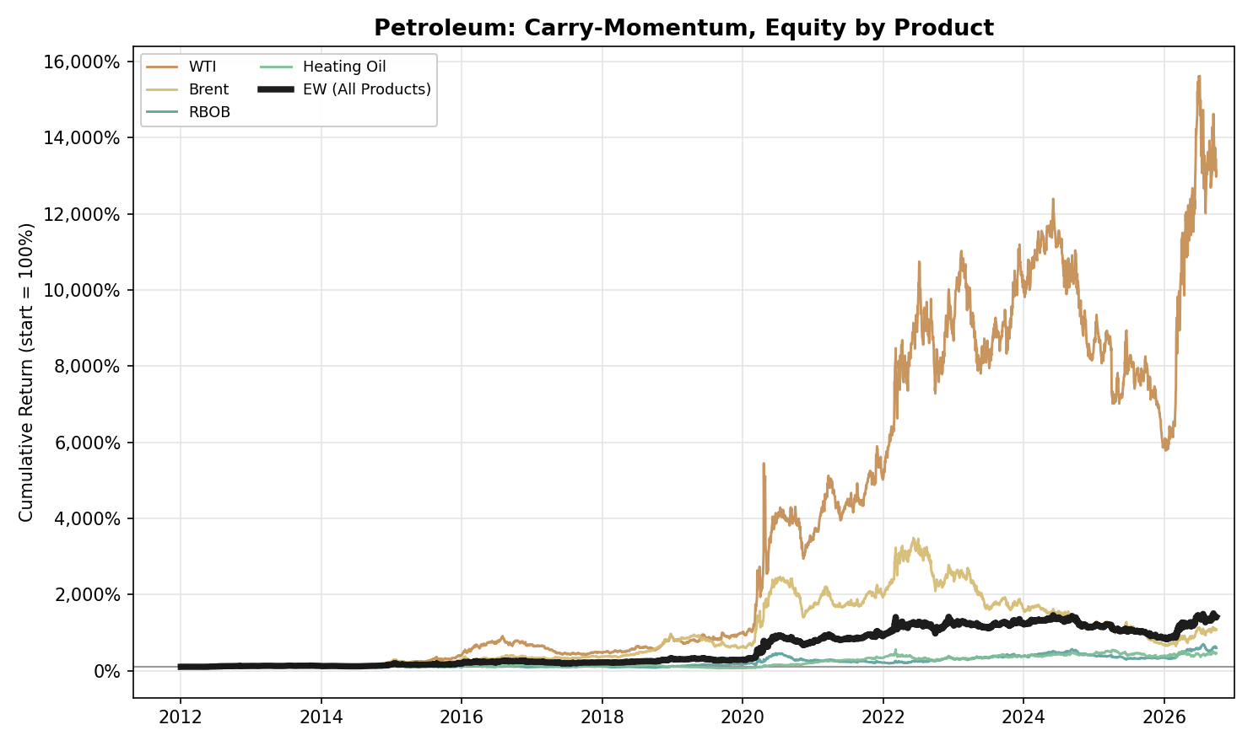
Figure A8. Petroleum, Carry-Momentum: Equity Curve by Product (2012-2026)
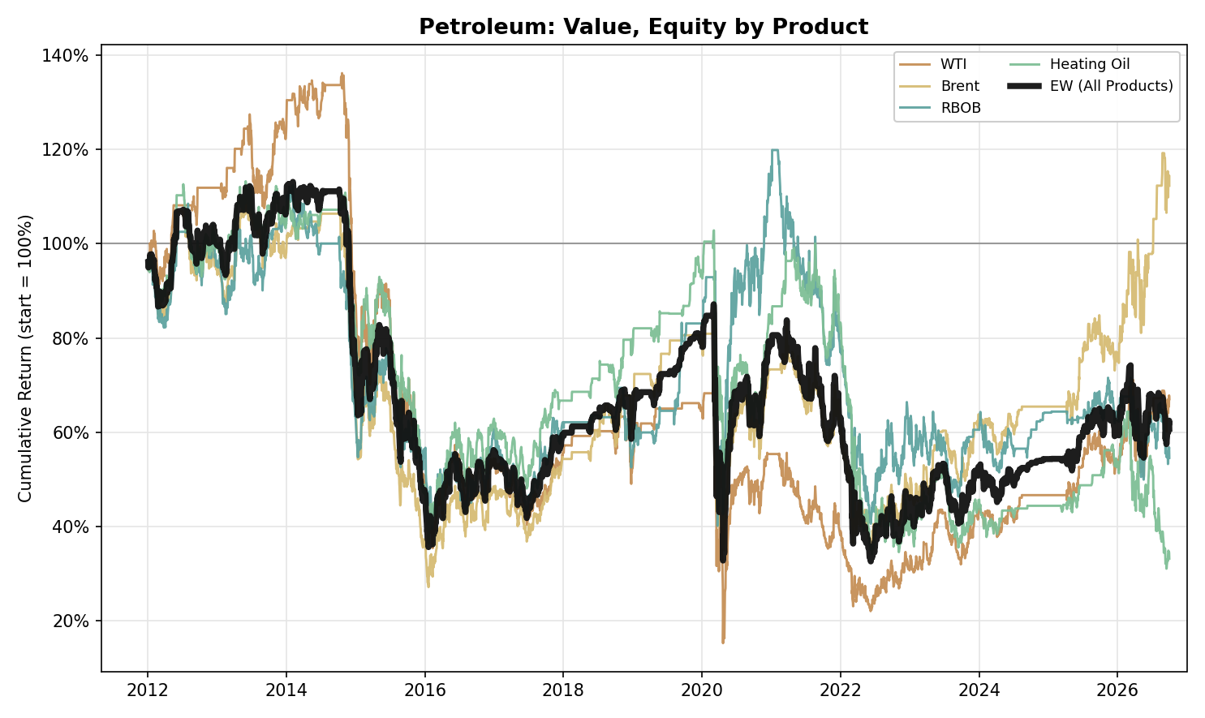
Figure A9. Petroleum, Value: Equity Curve by Product (2012-2026)
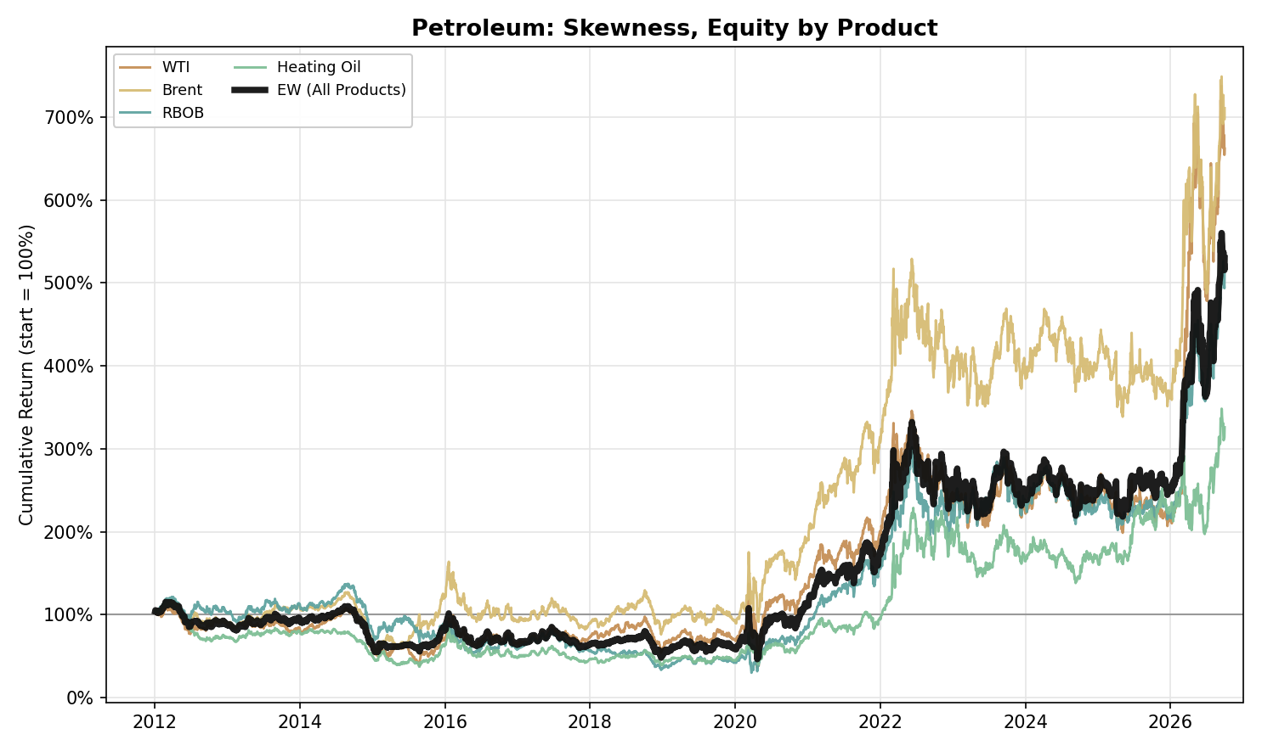
Figure A10. Petroleum, Skewness: Equity Curve by Product (2012-2026)

Gas and Emissions
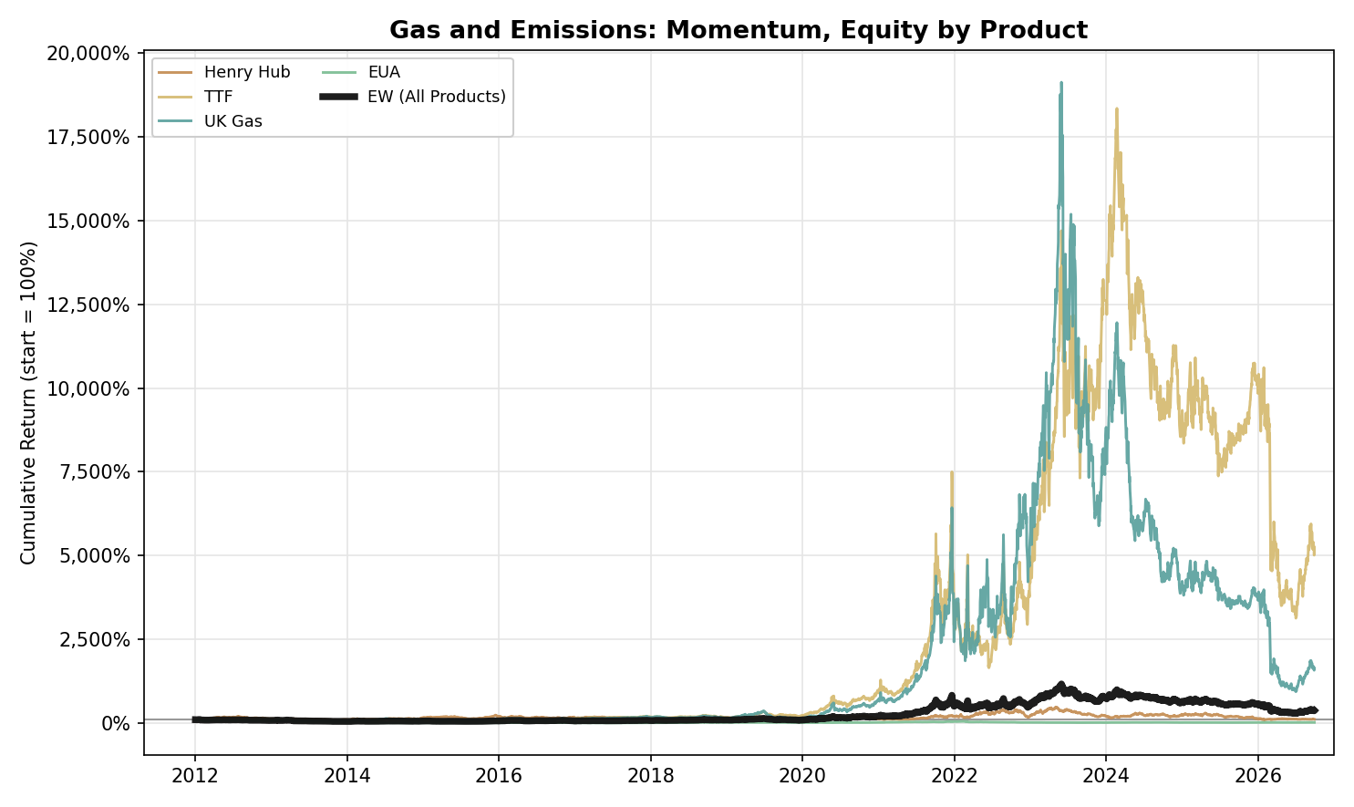
Figure A11. Gas and Emissions, Momentum: Equity Curve by Product (2012-2026)
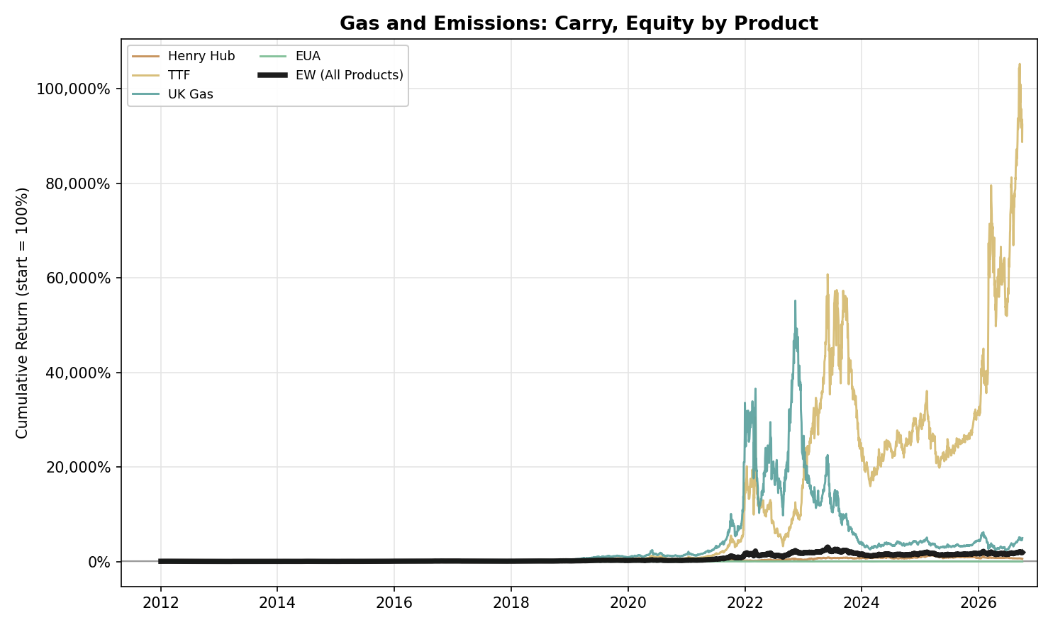
Figure A12. Gas and Emissions, Carry: Equity Curve by Product (2012-2026)
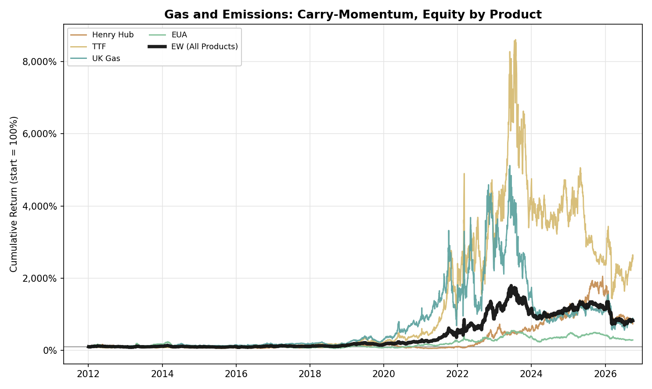
Figure A13. Gas and Emissions, Carry-Momentum: Equity Curve by Product (2012-2026)
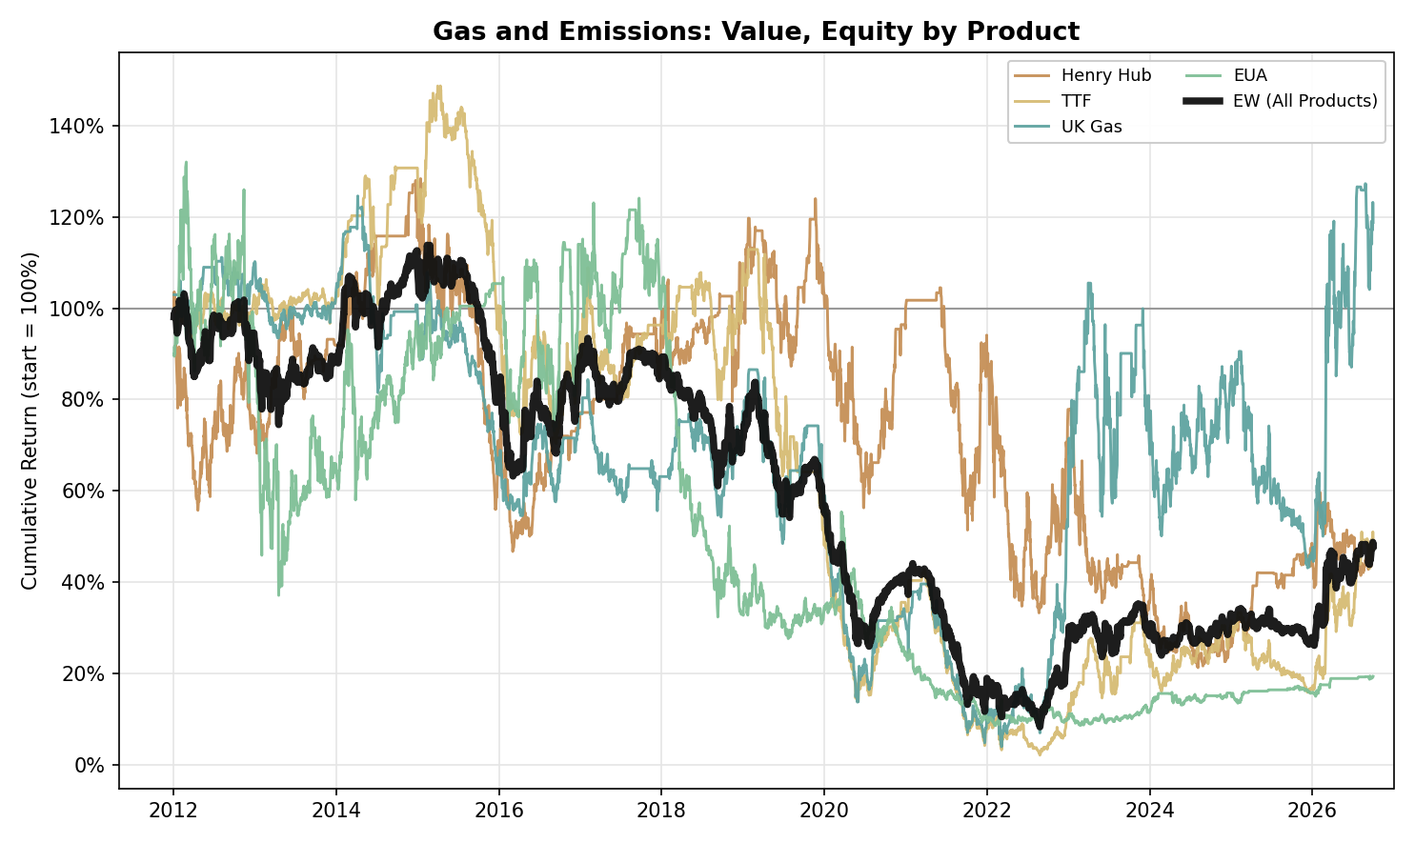
Figure A14. Gas and Emissions, Value: Equity Curve by Product (2012-2026)
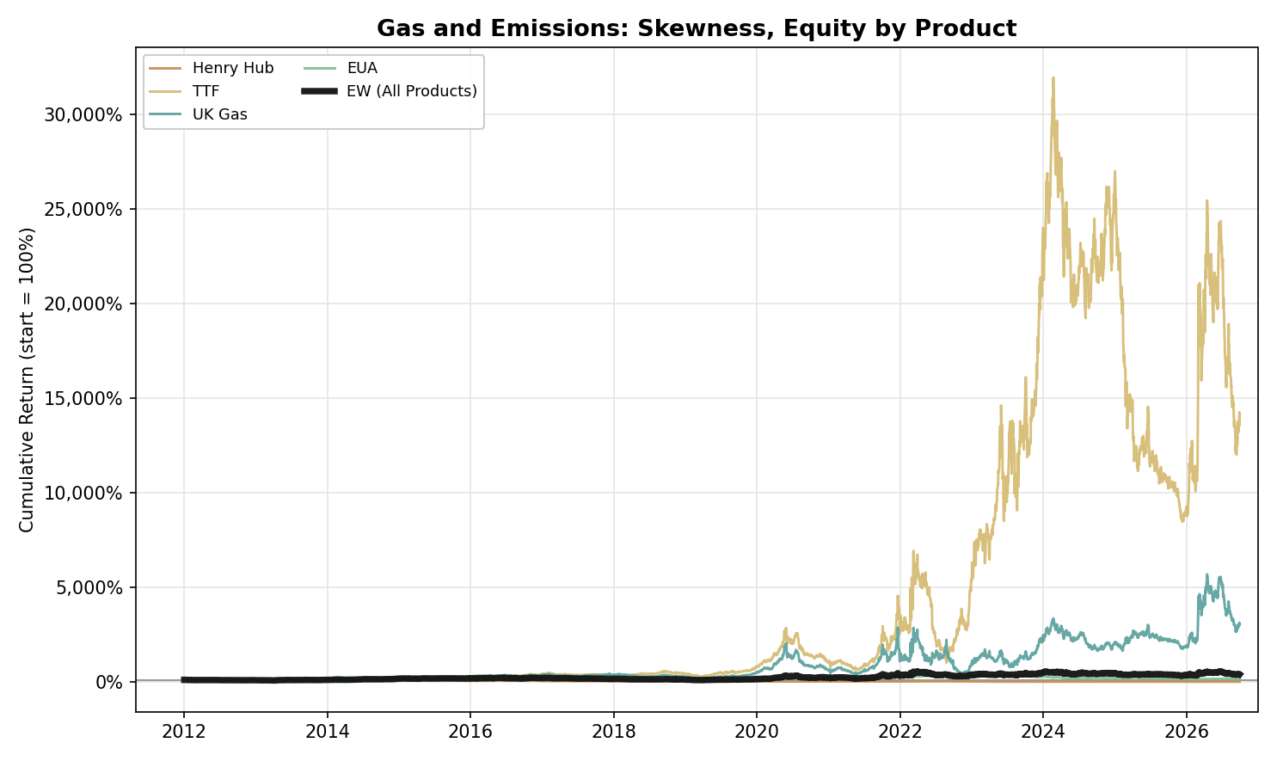
Figure A15. Gas and Emissions, Skewness: Equity Curve by Product (2012-2026)

Precious Metals
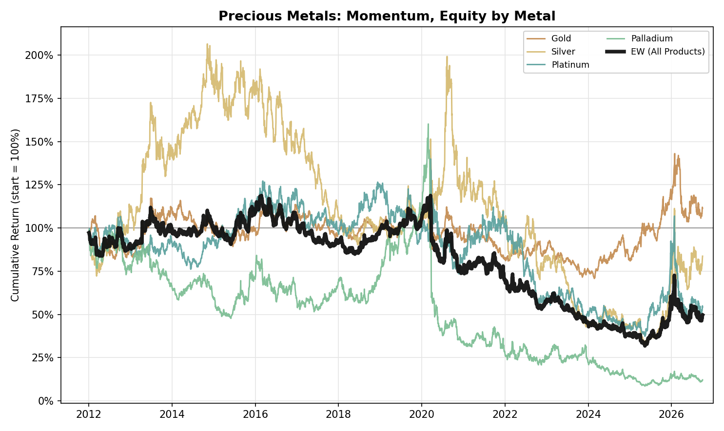
Figure A16. Precious Metals, Momentum: Equity Curve by Metal (2012-2026)
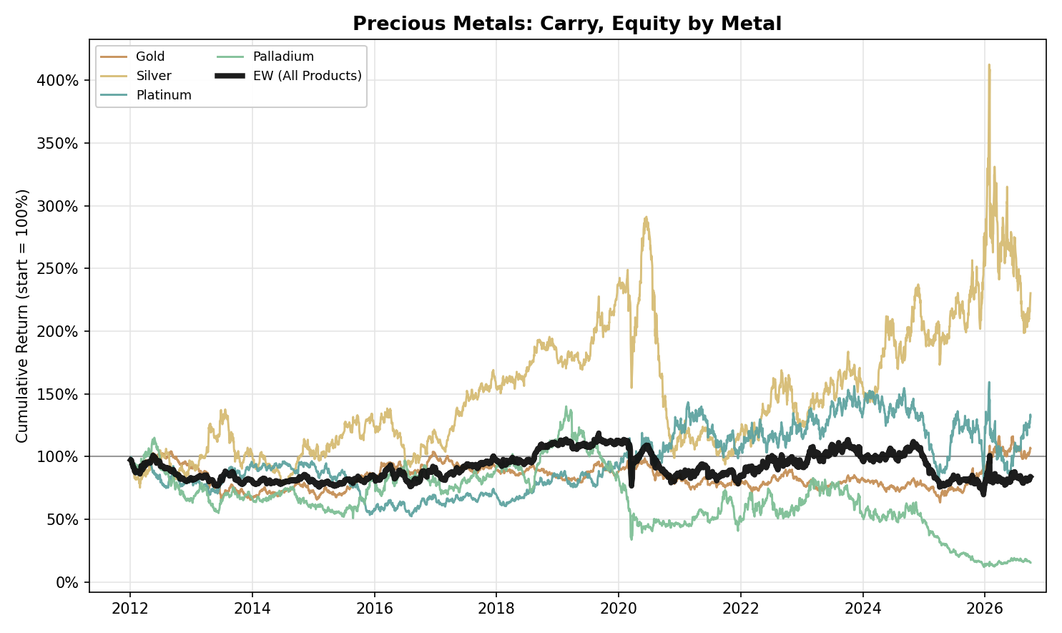
Figure A17. Precious Metals, Carry: Equity Curve by Metal (2012-2026)
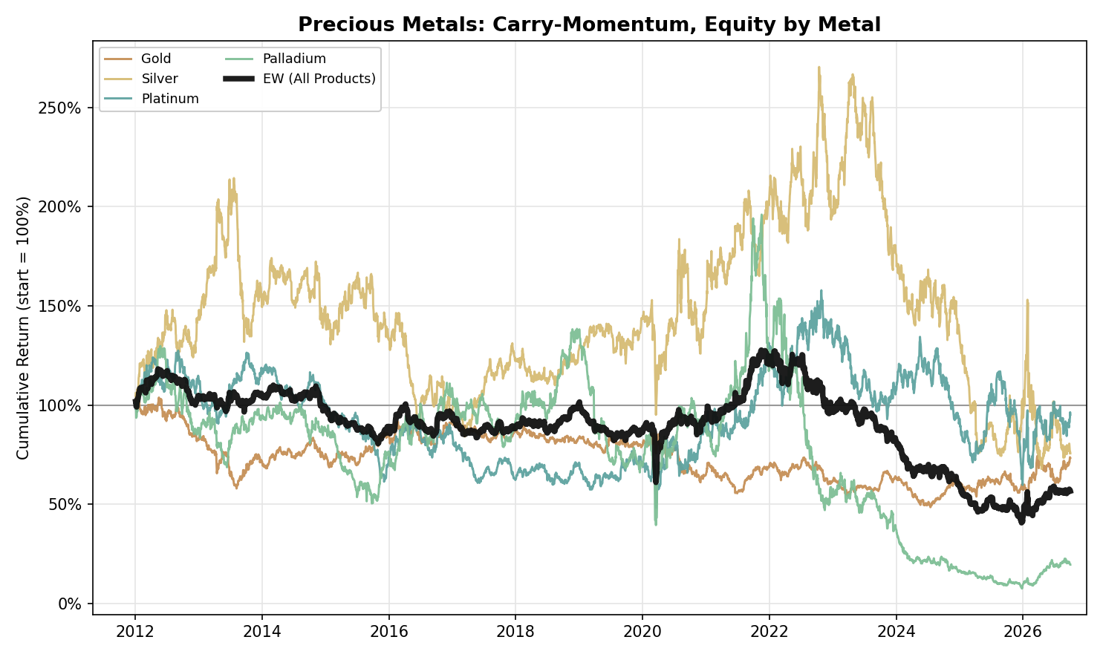
Figure A18. Precious Metals, Carry-Momentum: Equity Curve by Metal (2012-2026)
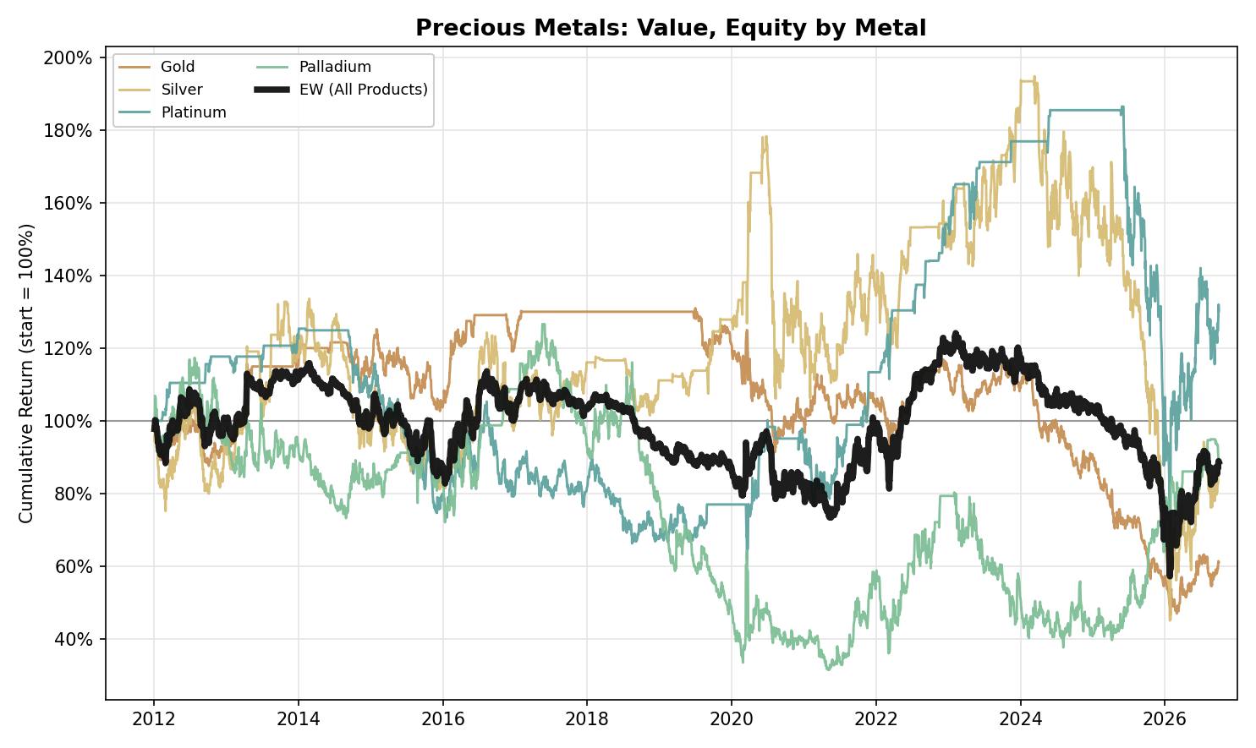
Figure A19. Precious Metals, Value: Equity Curve by Metal (2012-2026)
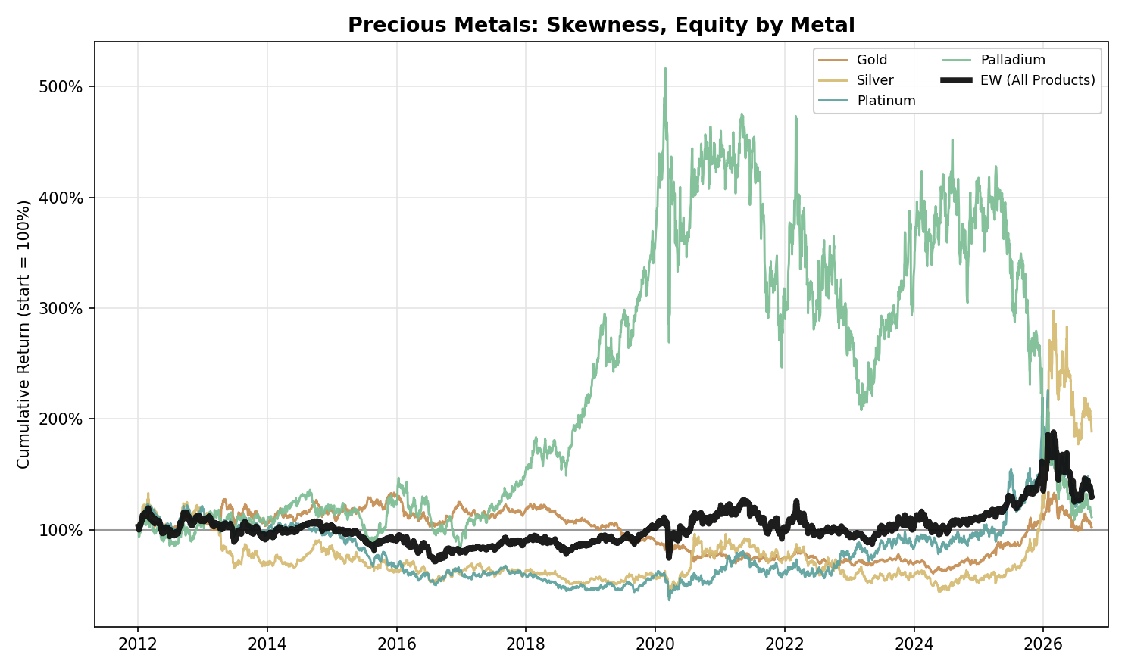
Figure A20. Precious Metals, Skewness: Equity Curve by Metal (2012-2026)

NGL
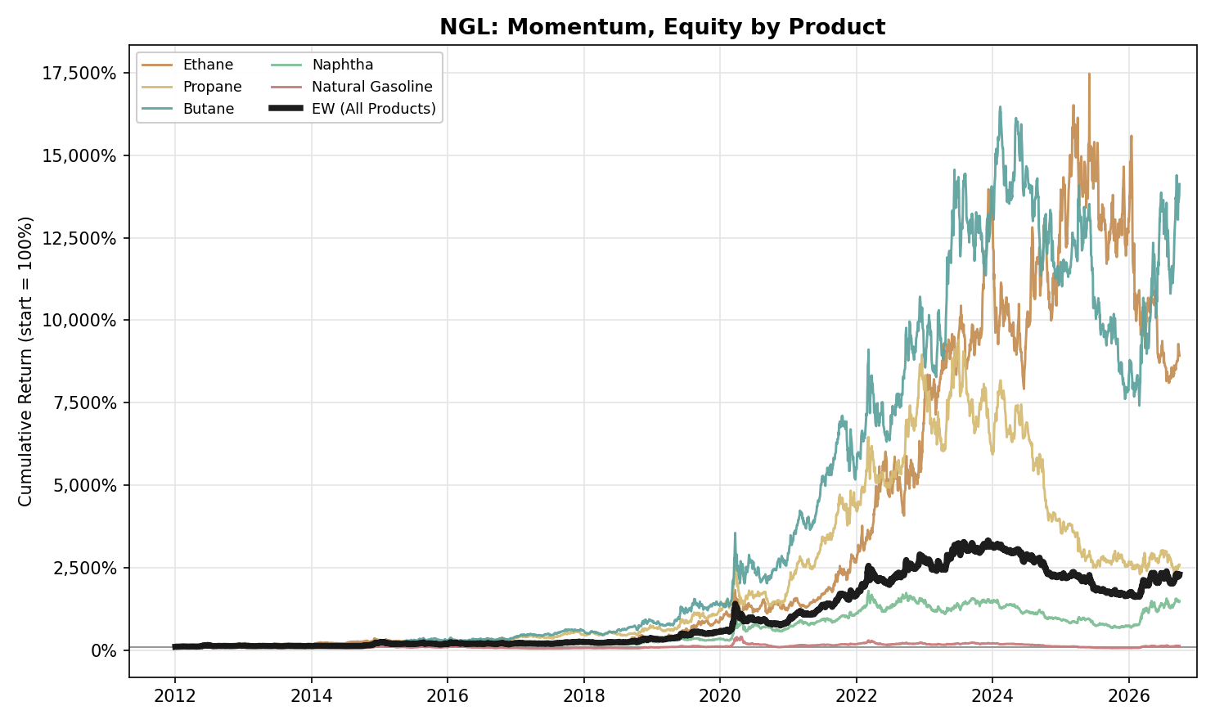
Figure A21. NGL, Momentum: Equity Curve by Product (2012-2026)
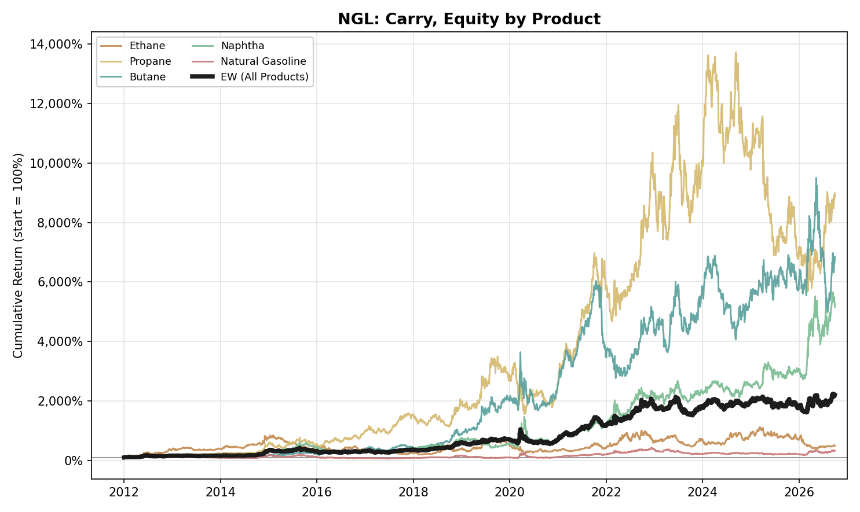
Figure A22. NGL, Carry: Equity Curve by Product (2012-2026)
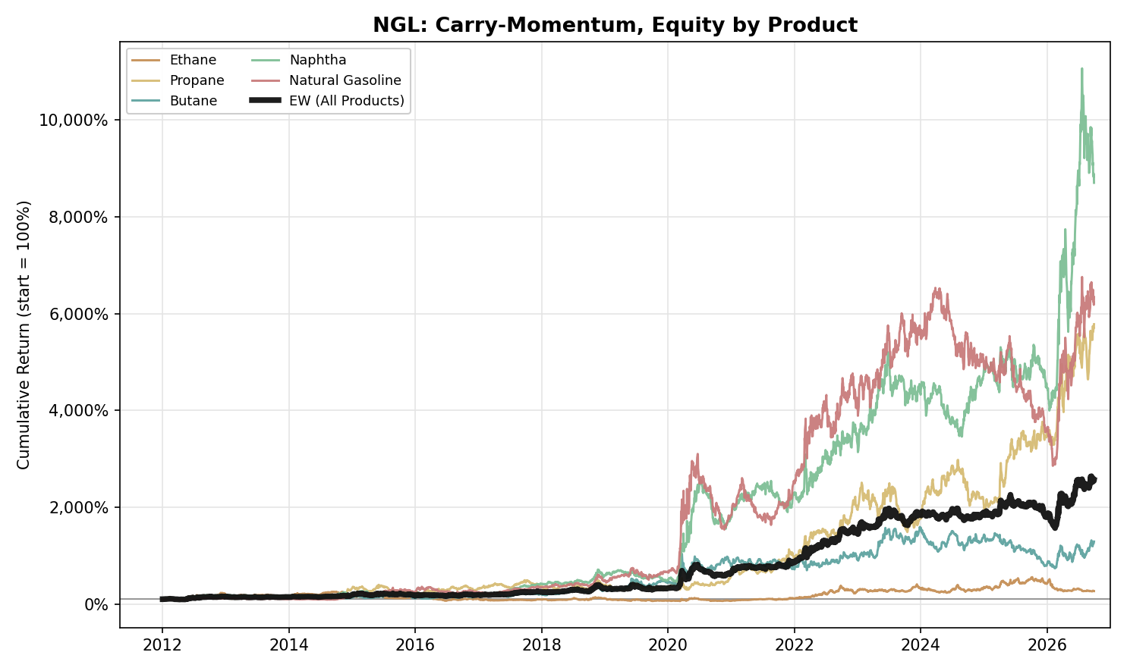
Figure A23. NGL, Carry-Momentum: Equity Curve by Product (2012-2026)
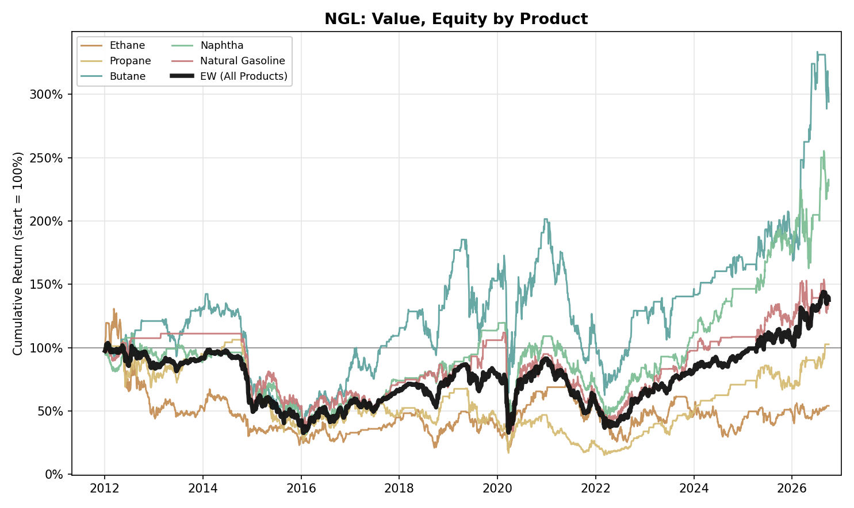
Figure A24. NGL, Value: Equity Curve by Product (2012-2026)
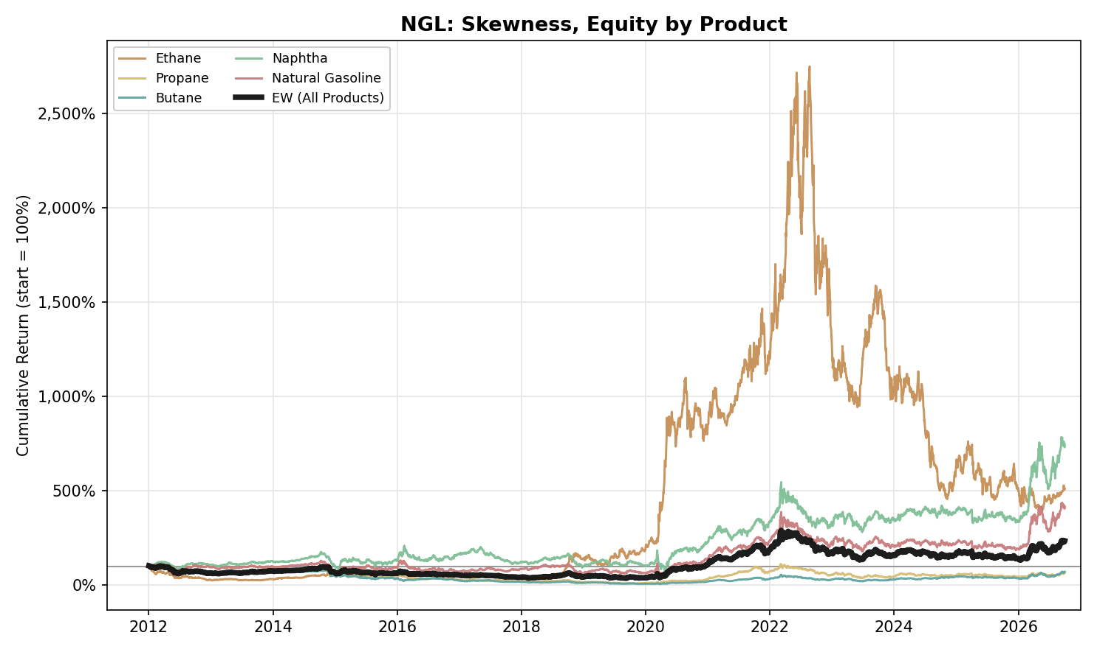
Figure A25. NGL, Skewness: Equity Curve by Product (2012-2026)

Agriculture
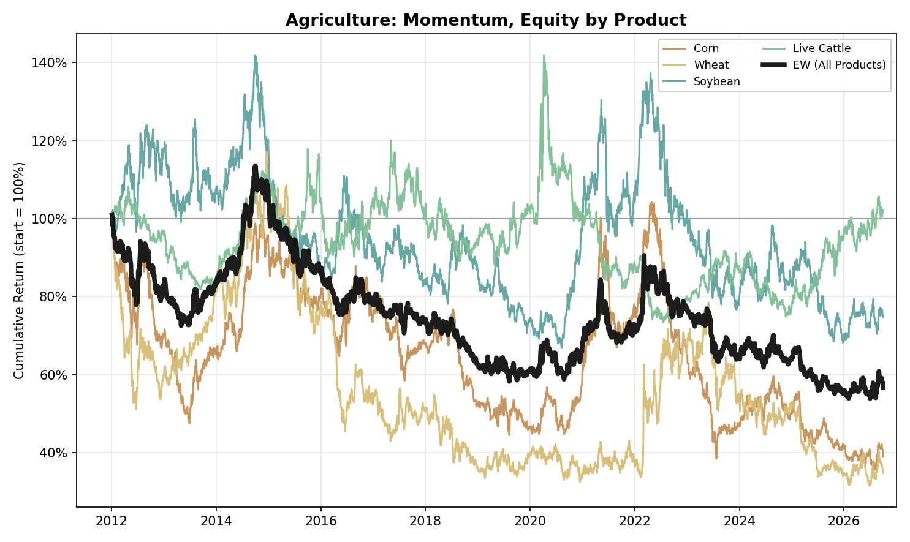
Figure A26. Agriculture, Momentum: Equity Curve by Product (2012-2026)
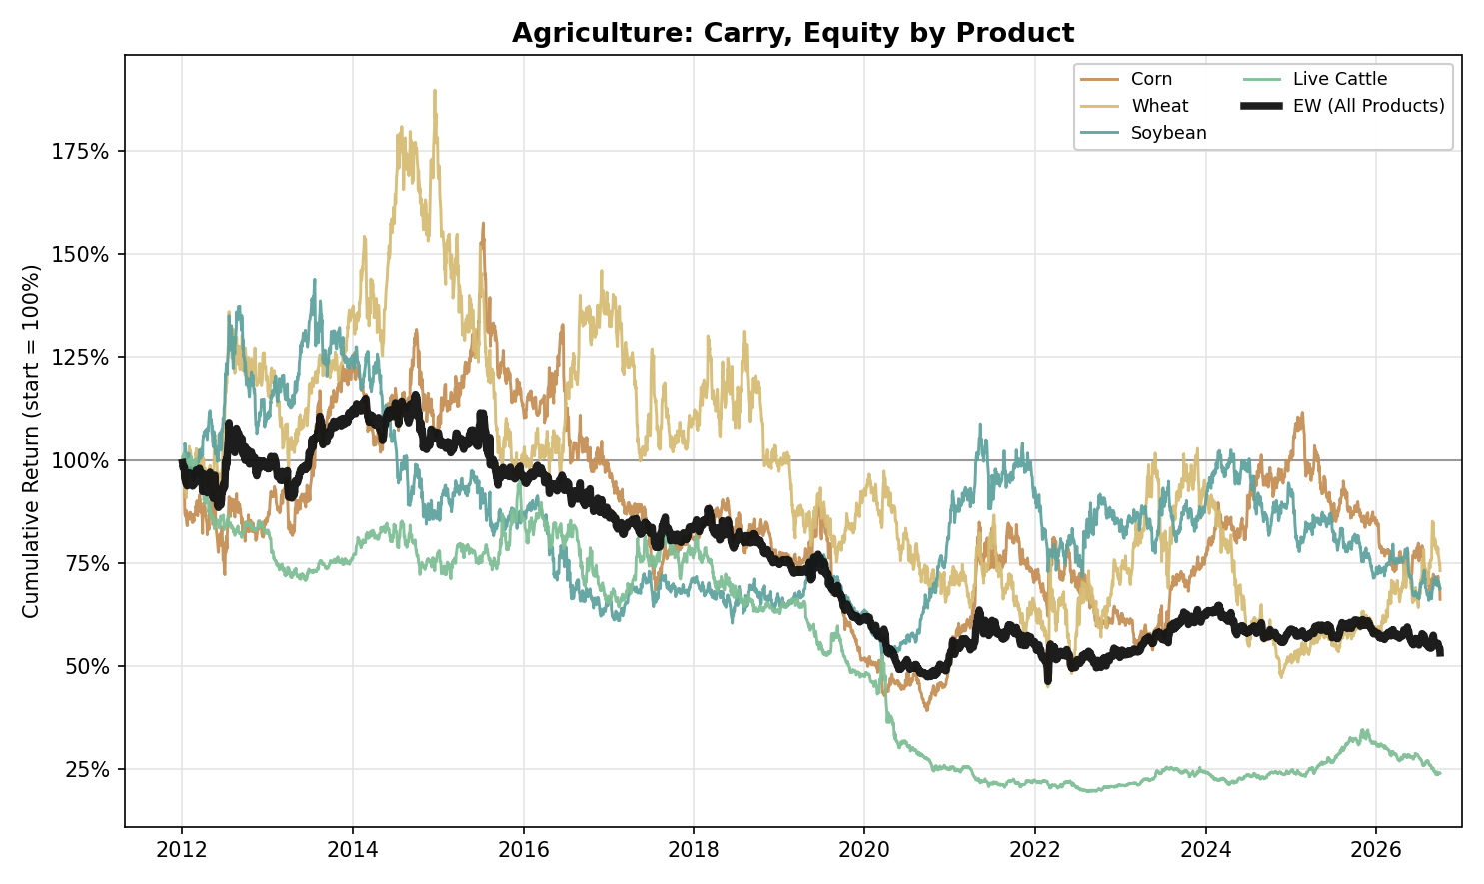
Figure A27. Agriculture, Carry: Equity Curve by Product (2012-2026)
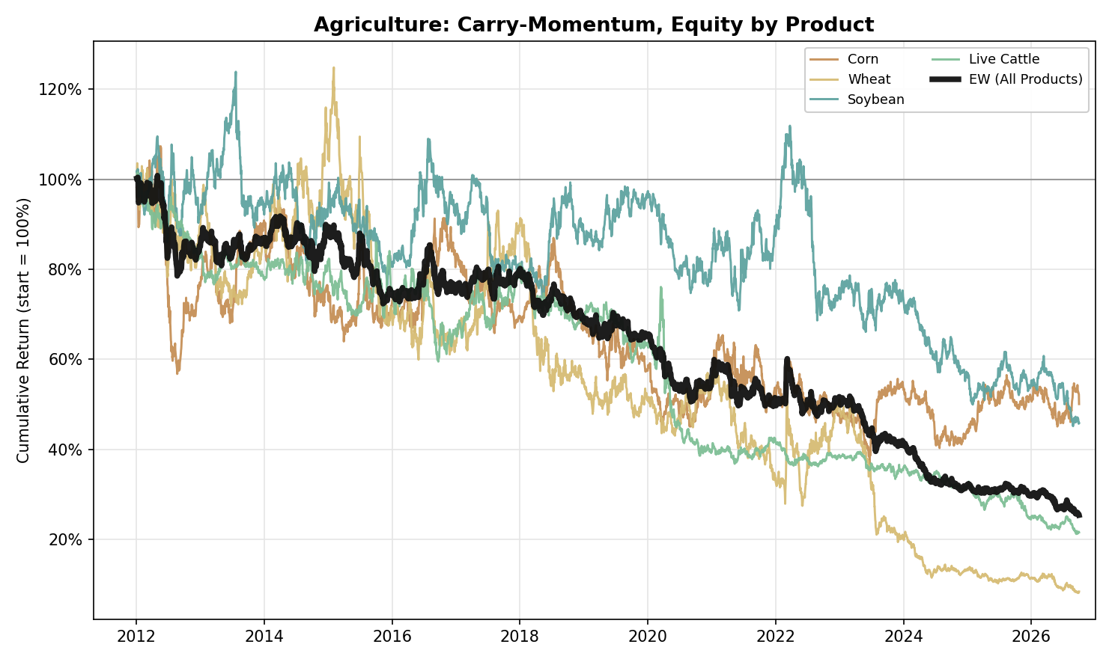
Figure A28. Agriculture, Carry-Momentum: Equity Curve by Product (2012-2026)
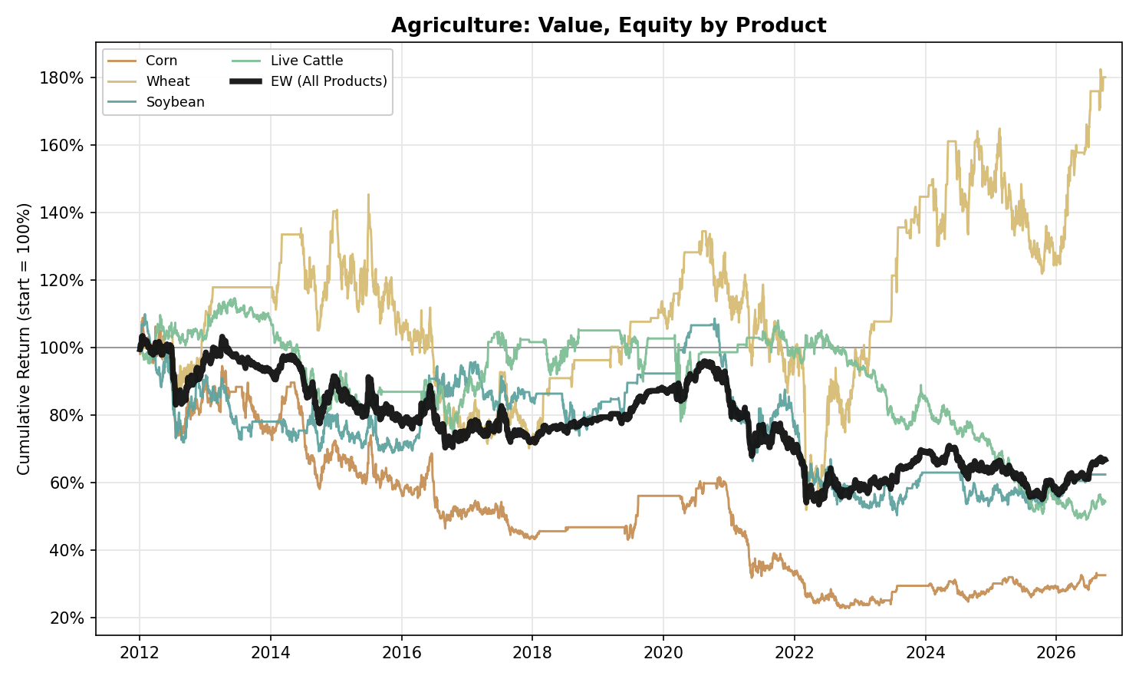
Figure A29. Agriculture, Value: Equity Curve by Product (2012-2026)
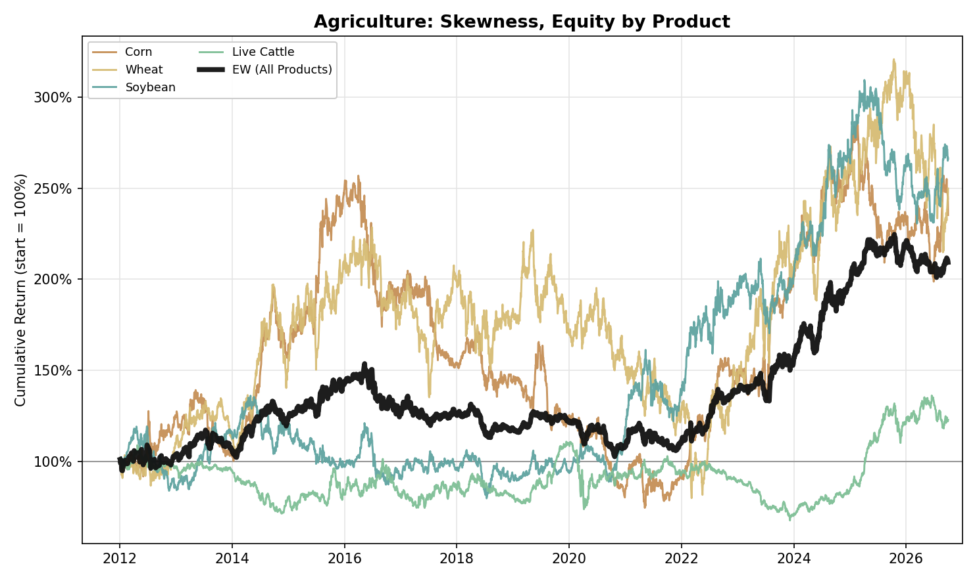
Figure A30. Agriculture, Skewness: Equity Curve by Product (2012-2026)

Softs
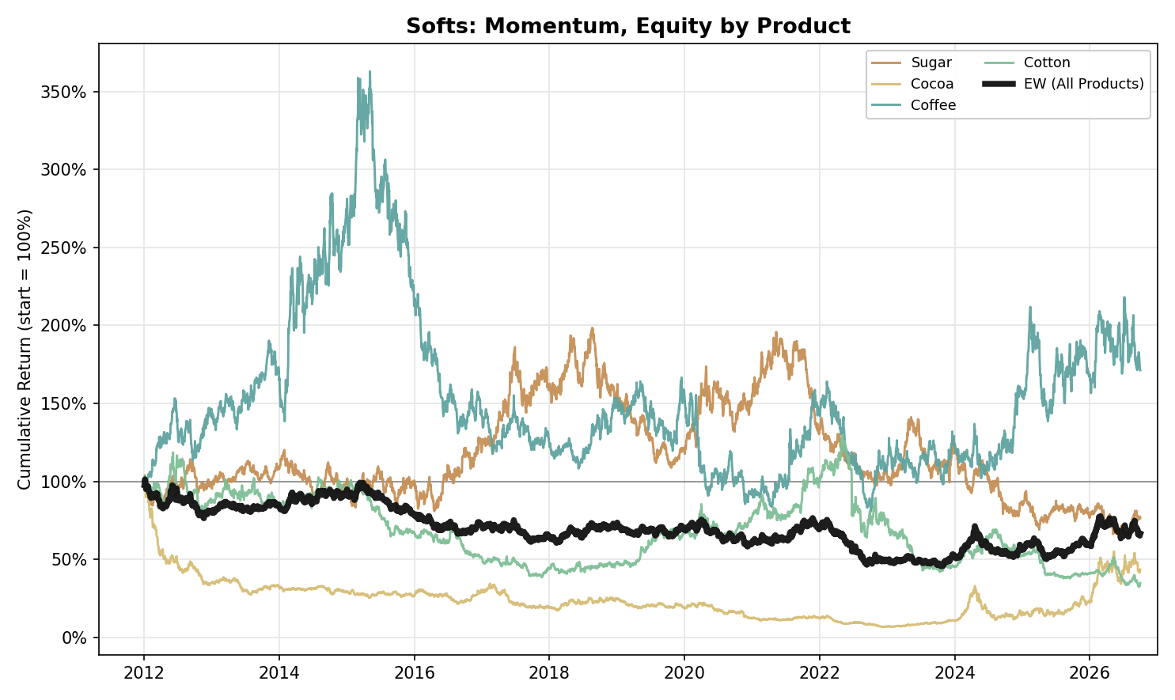
Figure A31. Softs, Momentum: Equity Curve by Product (2012-2026)
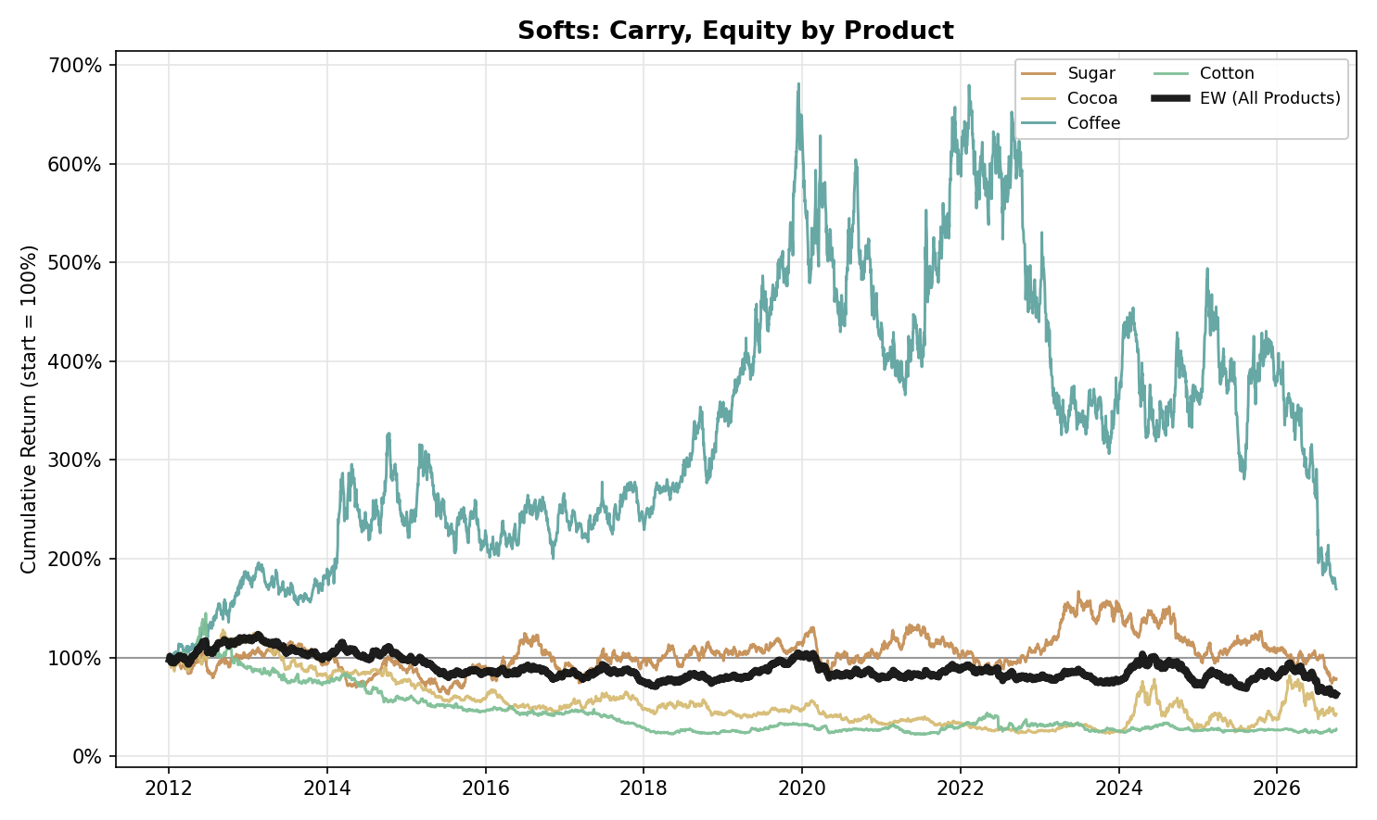
Figure A32. Softs, Carry: Equity Curve by Product (2012-2026)
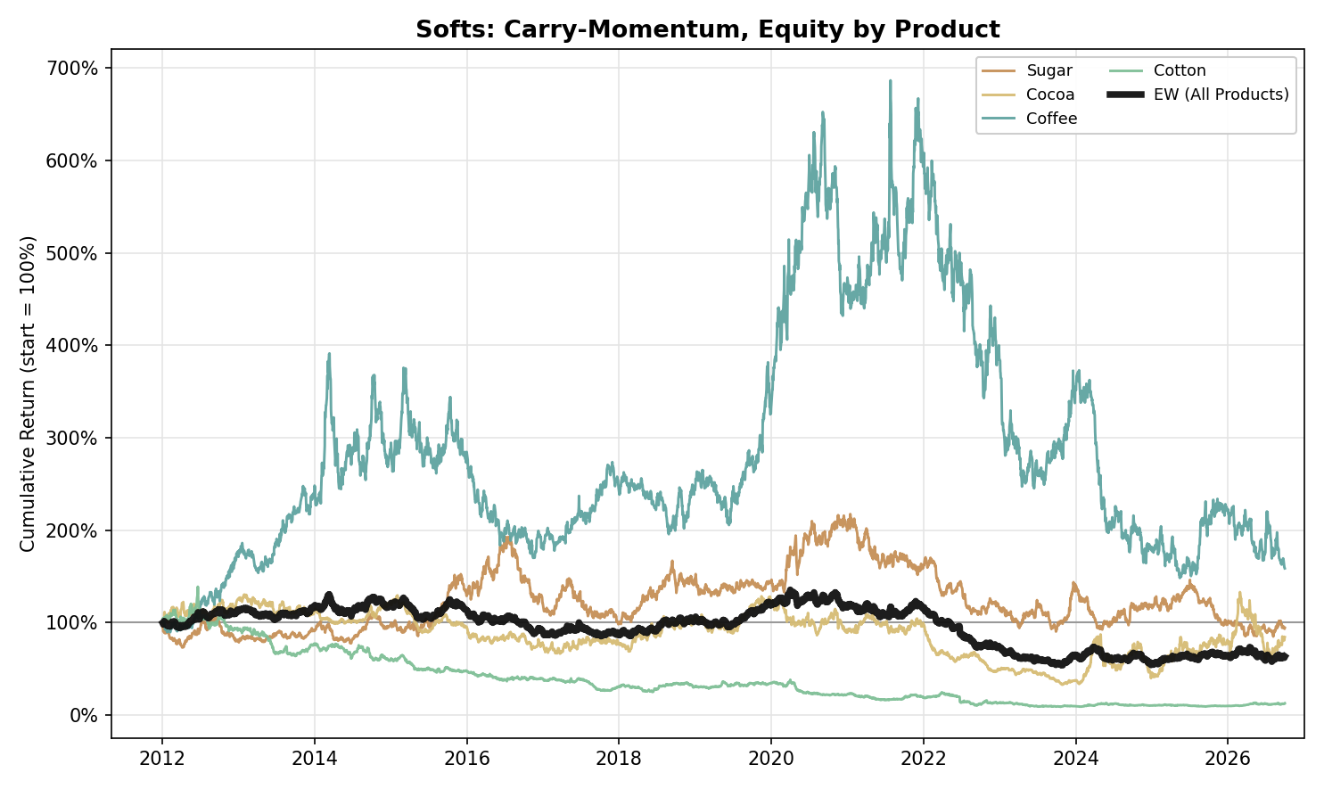
Figure A33. Softs, Carry-Momentum: Equity Curve by Product (2012-2026)
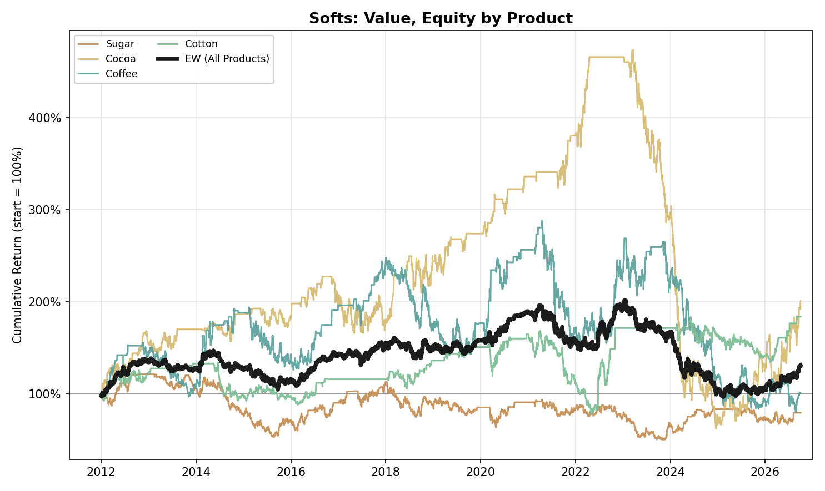
Figure A34. Softs, Value: Equity Curve by Product (2012-2026)
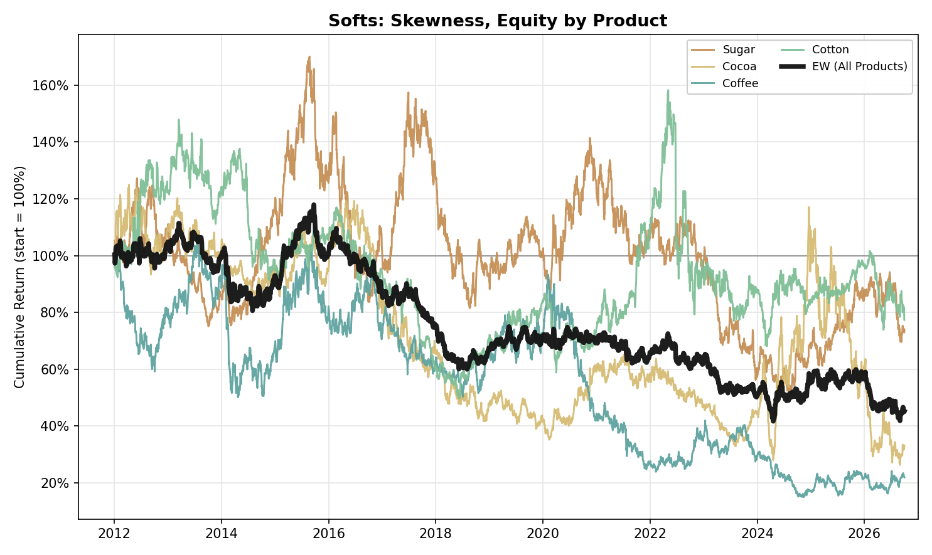
Figure A35. Softs, Skewness: Equity Curve by Product (2012-2026)

US Power (Standalone)
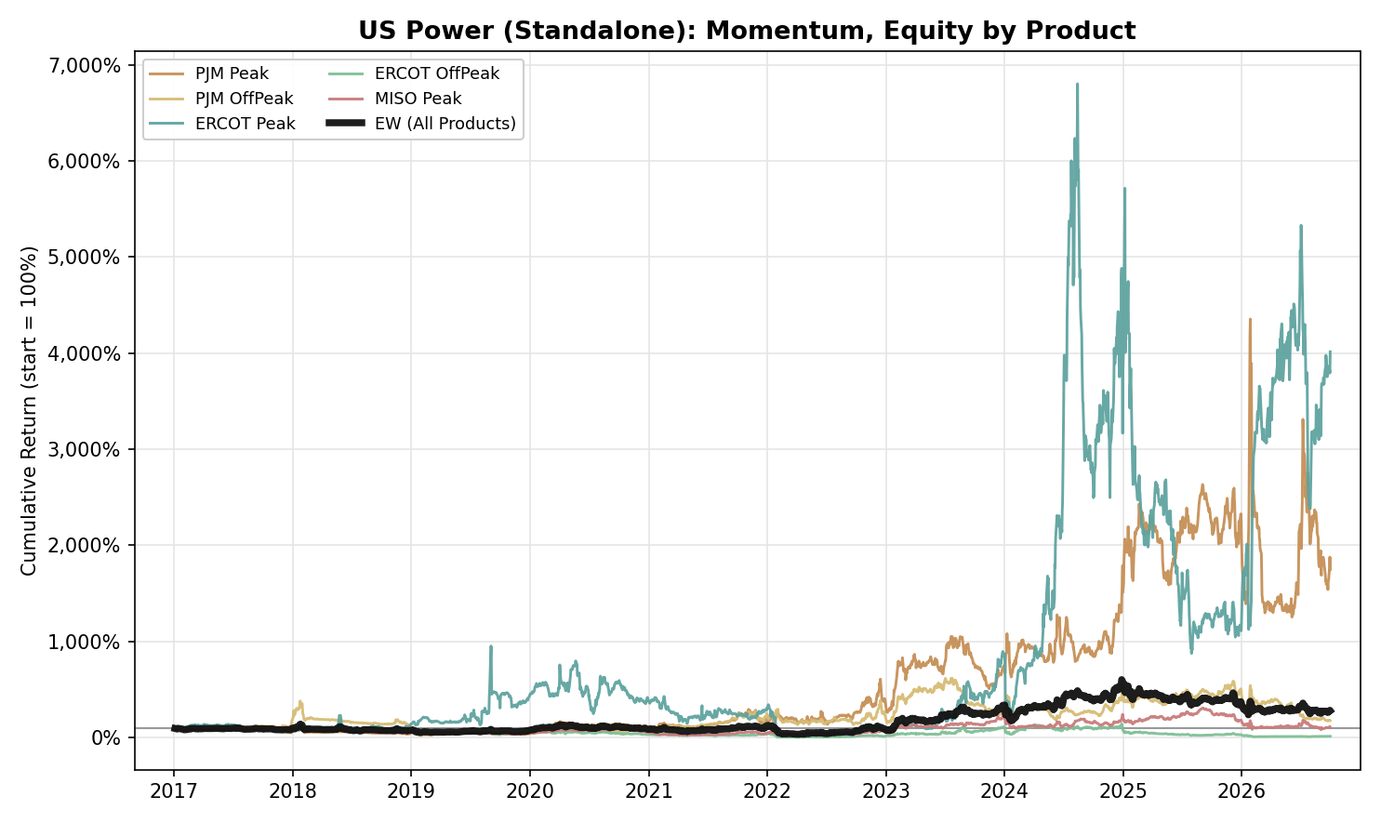
Figure A36. US Power (Standalone), Momentum: Equity Curve by Product (2017-2026)
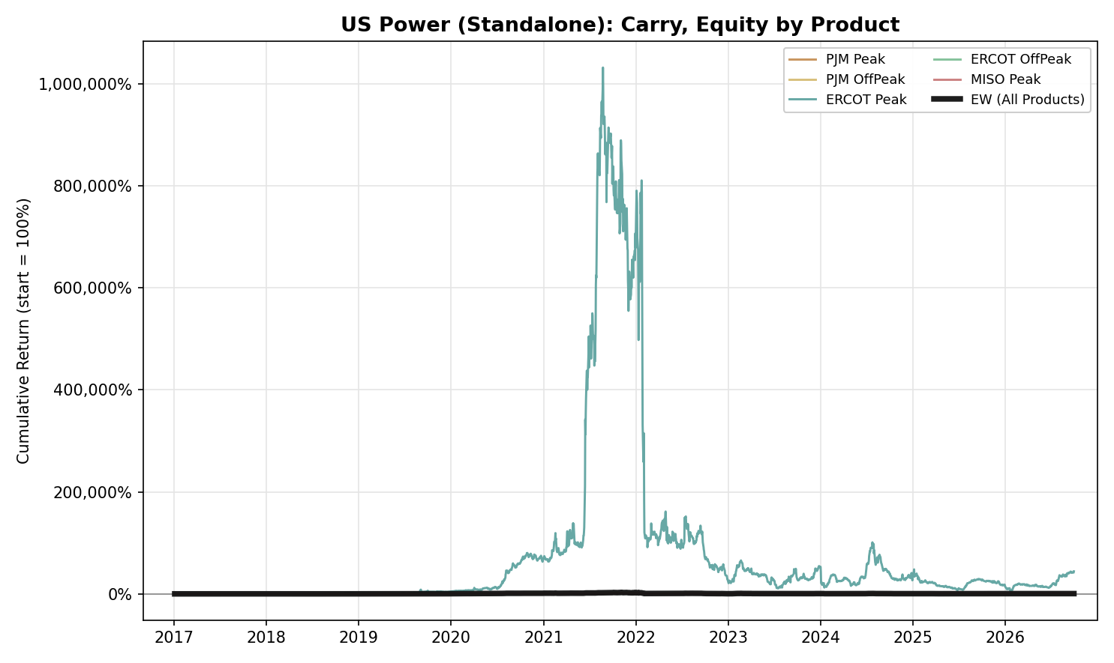
Figure A37. US Power (Standalone), Carry: Equity Curve by Product (2017-2026)
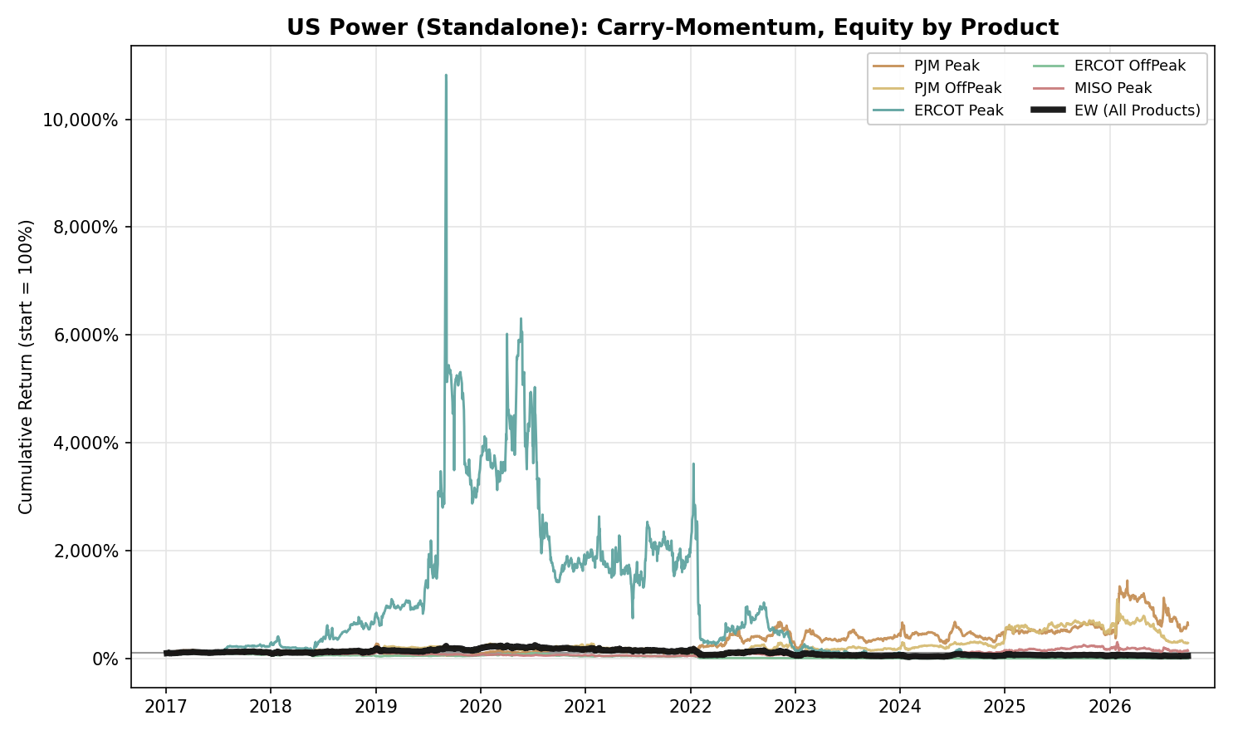
Figure A38. US Power (Standalone), Carry-Momentum: Equity Curve by Product (2017-2026)
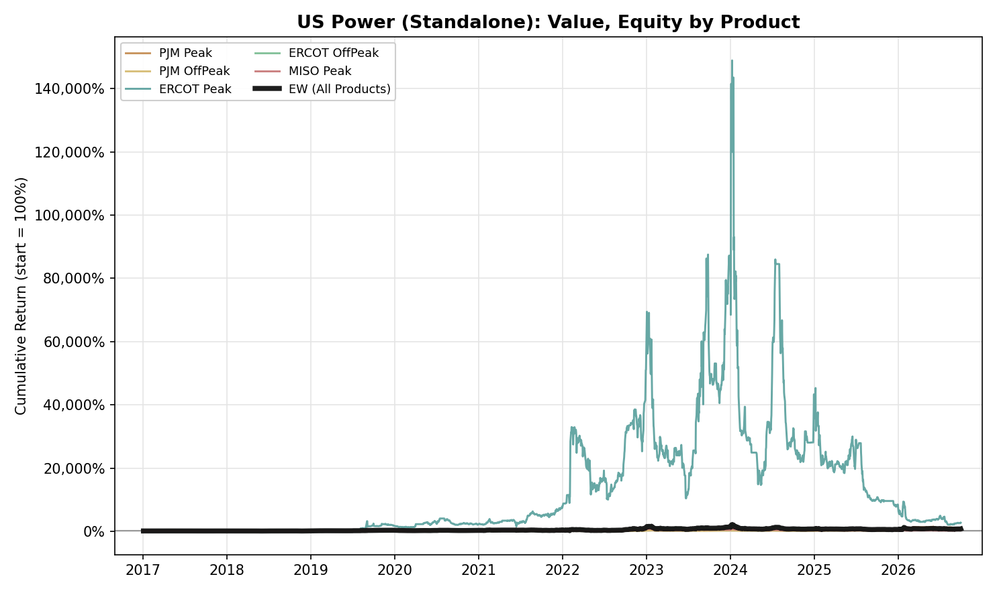
Figure A39. US Power (Standalone), Value: Equity Curve by Product (2017-2026)
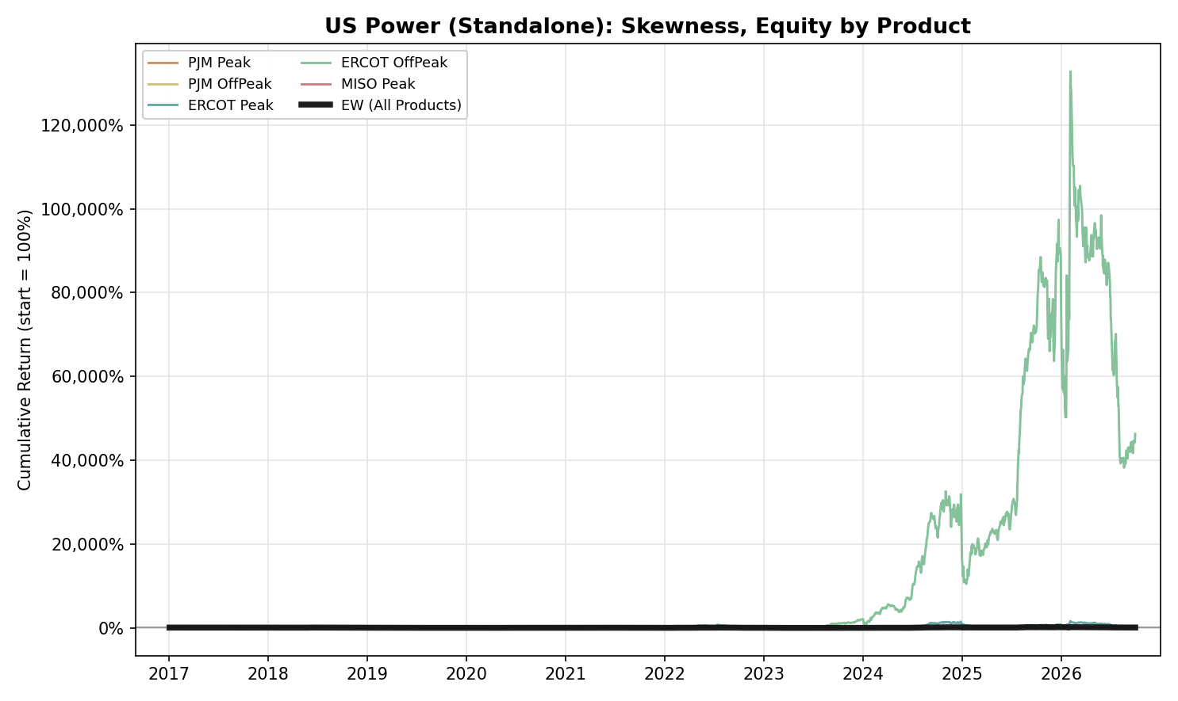
Figure A40. US Power (Standalone), Skewness: Equity Curve by Product (2017-2026)

Cross-Pair Portfolios
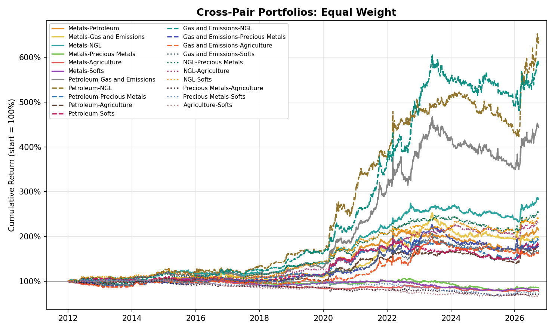
Figure A41. Cross-Pair Portfolios, Equal Weight: Equity Curve by Bucket Pair (2012-2026)
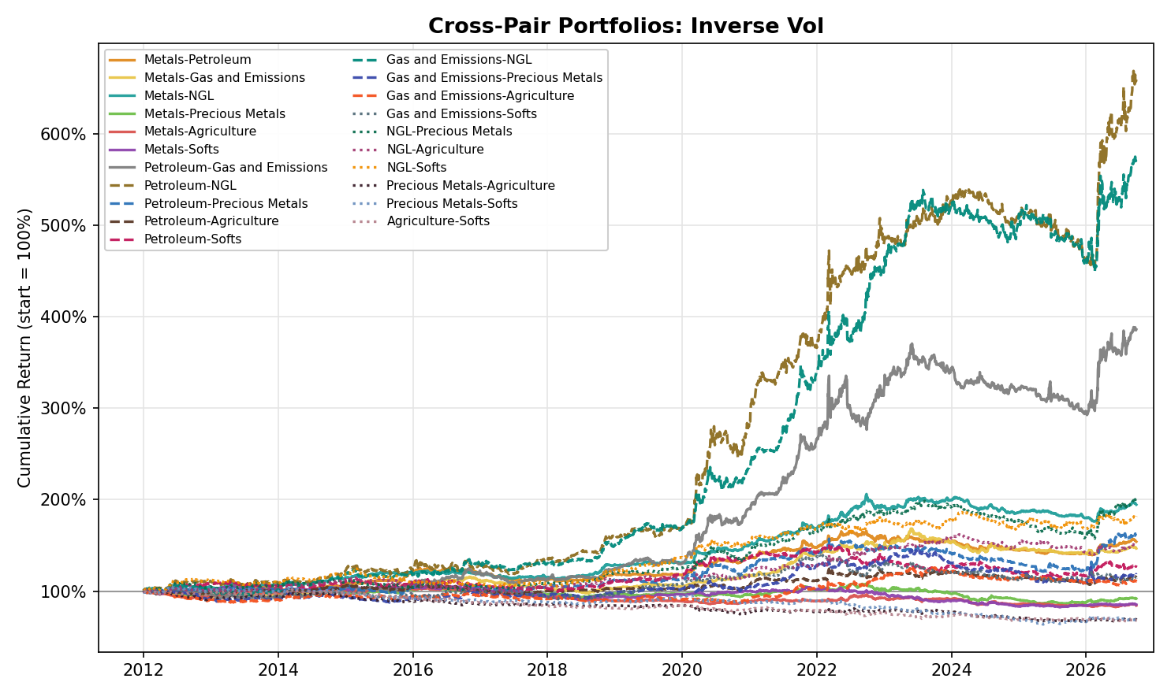
Figure A42. Cross-Pair Portfolios, Inverse Vol: Equity Curve by Bucket Pair (2012-2026)

Appendix: Liquidity by Product, Calendar 2025
Table A35. Dollar Risk Turnover by Product, Calendar 2025 (36 Products, Seven Buckets and US Power)
Product | Strip | ADV (lots/day) | P̄ (USD) | σ (%) | m (units) | c (USD) | x (USD m/day) | L (days) | Rank | Days traded
Metals
Copper | F1-F12 | 83,063 | 9,964.66 | 1.18 | 25 | 2,947 | 244.8 | 0.0041 | 9 | 100%
Aluminium | F1-F12 | 157,841 | 2,636.31 | 0.97 | 25 | 640 | 101.0 | 0.0099 | 14 | 100%
Zinc | F1-F12 | 64,414 | 2,856.45 | 1.27 | 25 | 904 | 58.3 | 0.017 | 18 | 100%
Lead | F1-F12 | 42,887 | 1,973.80 | 0.91 | 25 | 449 | 19.3 | 0.052 | 24 | 100%
Petroleum
Brent | F1-F12 | 1,116,127 | 67.65 | 1.75 | 1,000 | 1,187 | 1,324.9 | 0.0008 | 1 | 100%
WTI | F1-F12 | 837,025 | 64.46 | 1.93 | 1,000 | 1,242 | 1,039.9 | 0.0010 | 3 | 100%
Singapore Gasoil† | F1-F12 | 351,370 | 676.38 | 2.10 | 100 | 1,418 | 498.3 | 0.0020 | 5 | 100%
Heating Oil | F1-F12 | 195,204 | 2.28 | 1.88 | 42,000 | 1,801 | 351.5 | 0.0028 | 7 | 100%
RBOB | F1-F12 | 188,064 | 2.02 | 1.60 | 42,000 | 1,362 | 256.1 | 0.0039 | 8 | 100%
Gas and Emissions
Henry Hub (Nat Gas) | F1-F12 | 515,680 | 3.68 | 3.52 | 10,000 | 1,296 | 668.3 | 0.0015 | 4 | 100%
TTF | F1-F12 | 270,092 | 41.20 | 2.61 | 730.5 | 784 | 211.9 | 0.0047 | 10 | 99%
EUA | F1-F4 | 30,103 | 83.93 | 1.55 | 1,000 | 1,300 | 39.1 | 0.026 | 20 | 99%
UK Gas (NBP) | F1-F12 | 31,979 | 1.19 | 2.72 | 30,417 | 982 | 31.4 | 0.032 | 22 | 100%
Precious Metals
Gold | F1-F6 | 254,407 | 3,459.01 | 1.30 | 100 | 4,486 | 1,141.2 | 0.0009 | 2 | 100%
Silver | F1-F5 | 86,216 | 40.33 | 2.37 | 5,000 | 4,777 | 411.8 | 0.0024 | 6 | 100%
Platinum | F1-F4 | 38,905 | 1,295.86 | 2.61 | 50 | 1,694 | 65.9 | 0.015 | 16 | 100%
Palladium | F1-F4 | 7,094 | 1,171.46 | 2.88 | 100 | 3,374 | 23.9 | 0.042 | 23 | 100%
NGL
Propane* | F1-F12 | 8,273 | 0.740 | 1.89 | 42,000 | 586 | 4.85 | 0.206 | 27 | 100%
Butane* | F1-F12 | 2,907 | 0.900 | 1.65 | 42,000 | 624 | 1.81 | 0.551 | 30 | 100%
Natural Gasoline* | F1-F12 | 827 | 1.331 | 1.74 | 42,000 | 971 | 0.803 | 1.2 | 31 | 99%
Ethane* | F1-F12 | 1,203 | 0.255 | 2.71 | 42,000 | 290 | 0.349 | 2.9 | 32 | 99%
Naphtha* | F1-F12 | 12 | 558.38 | 1.65 | 1,000 | 9,234 | 0.107 | 9.4 | 35 | 55%
Agriculture
Soybean | F1-F7 | 288,372 | 10.40 | 1.05 | 5,000 | 545 | 157.1 | 0.0064 | 11 | 100%
Corn | F1-F5 | 425,628 | 4.39 | 1.17 | 5,000 | 258 | 109.8 | 0.0091 | 13 | 100%
Live Cattle | F1-F6 | 78,005 | 2.174 | 1.07 | 40,000 | 928 | 72.4 | 0.014 | 15 | 100%
Wheat | F1-F5 | 135,652 | 5.34 | 1.41 | 5,000 | 377 | 51.1 | 0.020 | 19 | 100%
Softs
Coffee | F1-F5 | 34,914 | 3.66 | 2.34 | 37,500 | 3,207 | 112.0 | 0.0089 | 12 | 100%
Cocoa | F1-F5 | 23,510 | 8,166.22 | 3.41 | 10 | 2,785 | 65.5 | 0.015 | 17 | 100%
Sugar | F1-F4 | 122,500 | 0.169 | 1.49 | 112,000 | 283 | 34.7 | 0.029 | 21 | 100%
Cotton | F1-F5 | 43,398 | 0.655 | 1.09 | 50,000 | 358 | 15.5 | 0.064 | 25 | 100%
US Power (Standalone)
PJM Peak | F1-F12 | 14,010 | 59.43 | 3.52 | 340 | 711 | 9.96 | 0.100 | 26 | 100%
ERCOT Peak | F1-F12 | 2,627 | 52.44 | 5.97 | 340 | 1,065 | 2.80 | 0.358 | 28 | 99%
PJM OffPeak | F1-F12 | 3,881 | 41.66 | 3.37 | 390 | 547 | 2.12 | 0.471 | 29 | 99%
ERCOT OffPeak | F1-F12 | 292 | 39.23 | 4.80 | 390 | 734 | 0.214 | 4.7 | 33 | 73%
MISO Peak | F1-F12 | 386 | 53.22 | 3.05 | 340 | 551 | 0.213 | 4.7 | 34 | 98%
MISO OffPeak‡ | F1-F12 | 201 | 38.02 | 3.38 | 390 | 502 | 0.101 | 9.9 | 36 | 86%
Note: Calendar 2025 only (1 January to 31 December); volume, prices and volatility all come from 2025. The table covers 36 products: the 29 of the seven buckets, the five US Power series of the standalone Power section, Singapore Gasoil† and MISO OffPeak‡, ranked by x across all buckets (Rank 1 = most liquid). ADV is the mean daily volume in lots summed over the twelve-month strip (a day without a print counts as zero); Days traded is the share of days on which the strip printed any volume. P̄ is the mean 2025 price of the contract held, in USD per contract unit (barrel, gallon, ounce, tonne, bushel, pound, MMBtu, MWh or allowance); EUA and TTF are converted from EUR at 1.1300 and UK Gas from pence per therm at 1.3184 USD/GBP (the 2025 mean of the ECB crosses; its lot is 1,000 therms a day over an average month, 30,417 therms). c = m · P̄ · σ, x = ADV · c, and L = K / x with K = USD 1 million of one-sigma daily risk. * NGL volumes are the CME contracts only (ICE is not included) and Naphtha volume is the Bloomberg series, a partial view of the swap market, so these figures are lower bounds. ‡ MISO OffPeak (time to trade one sigma of risk 9.9 days) is not in the Power results. US Power lots are 1 MW for every hour of the delivery month (ICE), taken as 340 MWh for peak and 390 MWh for off-peak contracts (304 to 368 and 352 to 417 MWh across the 2025 months). † The series is ICE Low Sulphur Gasoil (Bloomberg root QS), carried under the name Singapore Gasoil in the research files; it is not one of the four Petroleum products in the strategy results. Ethane volume may be understated: our series reached 60 to 65% of CME's published volume on two days checked, against about 1% for the other products.

Appendix: Verification Log (v3_2012 to v8)
Every figure in this document was recomputed from the per-product net returns of the pipeline in scripts/final_dashboard (rebuilt locally with the Carry rule adopted on 13 October 2026; the embedded dataset of Final_Research_Dashboard_2012.html is reproduced exactly) and cross-checked: 3,504 numbers (every asset-class tab, all 23 products, both combined books, the by-style portfolios and all Cross-Pair portfolios) were recomputed with separate code and agree with the dashboard to within 0.0005, and the Skewness sleeve agrees with Skewness_Research.html and with the Streamlit dashboards' Portfolio tabs and the hub's Cross-Asset tab. Figures are formatted from full-precision values, so a second-decimal digit can differ from the dashboard's three-decimal rounding. External facts were re-checked against sources on 13 October 2026. Statements changed or corrected in v4 and carried into v5, and the statements changed by the 13 October 2026 Carry rule, are listed below.
v6 (1 November 2026) covers the Metals and Petroleum sections only. Their per-product net returns come from the pipeline run on the data cut at 30 September 2026 (tag 0930); for every Metals and Petroleum product and sleeve they are identical to the v5 series on every date to 23 September (difference 0.0 on all 40 series, checked cell by cell including missing values), and add five trading days (24 to 30 September). The class-level statistics of the 7 series in each of the 4 windows (56 rows, four statistics each) agree with the 0930 research dashboard dataset to within 0.0005, all 15 'Return, Vol, Max Drawdown, IR' lines of the two sections and all 96 cells of Tables A1 to A6 were found in or equal to that dataset, and the within-class correlations agree with it to within 0.0005. The Skewness signal was recomputed separately from the rolled log prices (pandas skewness, identical sign on every day for all eight products) and the leg P&L reproduces under the engine's one-day execution delay; the contango averages and backwardation shares and the WTI and metals price levels were recomputed from the curve files. Every sentence-level claim in the two sections is asserted in code before the text is written, so a claim that fails stops the build. External facts were re-checked on 1 November 2026 (see the last three rows below). The rest of the document keeps the v5 verification.
v7 (1 November 2026) extends the v6 verification to Precious Metals and Agriculture and to the Key Findings of the four updated classes. The 0930 pipeline (scripts/final_dashboard, tag 0930) was re-run after Dimil Patel's commit 5ebe183 (Value on the F2 contract for Precious Metals and Agriculture); it reproduces the committed Final_Research_Dashboard_2012_0930.html exactly (3,072 numbers, maximum difference 0.0). Against the run used for v6 only the Value sleeves of the ten Precious Metals and Agriculture products changed; every Metals, Petroleum, NGL, Power, Emissions and Nat Gas series is identical (difference 0.0), so the v6 sections stand. The class-level statistics of the 7 series in each of the 4 windows for the four updated classes agree with the dashboard dataset to within 0.0005; all 30 'Return, Vol, Max Drawdown, IR' lines in the four sections and all 202 cells of the appendix tables for the four classes (Tables A1 to A9 and A14 to A16) were found in or equal to that dataset. The single-pair Carry tables (A10, A17) come from a separate run of compute_products.py on Prices_0930, and the two-pair sums in them equal the dashboard's Carry. The gold real-yield correlations use FRED DFII10 downloaded on 1 November 2026 and cut at 30 September 2026. As in v6, every sentence-level claim in the sections and in the Key Findings is asserted in code before the text is written. External facts re-checked on 1 November 2026: central bank gold purchases of 863 tonnes in 2025 against a 2010-2021 average of 473 tonnes (World Gold Council), FAO Food Price Index 159.3 in March 2022 and a 2023 average 13.7% below 2022, the USDA August 2012 corn price projection of $7.50 to $8.90. Facts not listed here keep their v5 verification of 13 October 2026.
v8 (10 November 2026) extends the verification to all seven buckets, the Correlation Analysis, the Cross-Commodity Portfolio and the liquidity table. The per-product net returns come from the 0930 pipeline (scripts/final_dashboard, tag 0930), which includes UK Gas, Naphtha, Natural Gasoline and the Agriculture and Softs products of the 10 November 2026 Bloomberg pull and no longer includes Isobutane (removed on 9 November 2026 for lack of liquidity) or Soybean Oil; the 0930 dashboard dataset (final_v3.json) is the reference. Recomputed with separate code from the per-product returns and equal to the dataset to within rounding (0.001): the class-level statistics of the 7 series in each of the 4 windows for all seven buckets (196 cells), the cross-commodity by-style books and the four two-stage combinations (44 cells), the IRs of all twenty-one bucket pairs under both constructions, and the EW PORT cross-bucket correlation matrix. All 62 'Return, Vol, Max Drawdown, IR' lines of the text are rows of the dataset; all 341 cells of the Strategy, Portfolio Construction and Individual-Product tables of the seven buckets, the 28 cells of the cross-commodity strategy and construction tables (A29 and A30), the 21 pair rows (Table A31 and the table in the Correlation Analysis, including each pair's EW PORT correlation) and the 35 Skewness correlations of Table A34 equal the dataset. The two Carry tenor-pair tables (Tables A20 and A24) were recomputed with separate code from the curves and the roll calendars; their two-pair columns equal the bucket Carry and Carry-Momentum sleeves of the dataset and all 16 comparisons agree. The benchmark correlations (Table A28), the without-Skewness rows, the Skewness leg table (A32) and the liquidity table (A35) are not in the dataset; they are computed in the build from the same net returns, the ETF file cut at 30 September 2026 and the two liquidity result files (Liquidity_Cal2025_results.csv and Power_Liquidity_Cal2025_results.csv), and the 36 rows of the liquidity table were checked cell by cell against those files (ADV, risk turnover, time to trade, rank, days traded, volatility and multiplier). Every sentence-level claim in the new and rewritten sections and in the Key Findings is asserted in code before the text is written; several drafting claims of the 10 November 2026 update failed those assertions in a trial run and were corrected (adding Natural Gasoline lowers the NGL Equal Weight IR in every period, including P2; Petroleum-NGL is the best pair under Equal Weight but Gas and Emissions-NGL under Inverse Vol; with Agriculture and Softs, Gas and Emissions has the third deepest Equal Weight drawdown, not the deepest). No new external facts were added: the NGL facts (EIA, OPIS, Veson Nautical, S&P Global) keep their v5 and v6 verification, the Coffee episodes in Softs (the July 2021 frost and the February 2025 high) are those verified in v7, and the Gas and Emissions price levels (TTF EUR 19.84/MWh on 4 January 2021, EUR 339.2 on 26 August 2022 and EUR 72.36 on 30 September 2026; the UK Gas and Naphtha levels) and the Cocoa high (USD 12,565 per tonne on 18 December 2024) are read from our own series. The US Power section (standalone, from 2017) was recomputed from the Power pipeline's per-product returns with the dashboard's own bucket construction: all 112 bucket values (IR, return, volatility and maximum drawdown of the 7 series in the 4 windows) equal the dashboard's Power tab (power_tab_0930.json) and the 46 cells of its three appendix tables (A25 to A27) equal that file; its Calendar-2025 times to trade one sigma of risk come from Power_Liquidity_Cal2025_results.csv. Table and figure numbers changed because Gas and Emissions and Softs were inserted and Table A22 of v7 (Energy pairs excluding Natural Gas) was removed; references in the text were renumbered with them.
Earlier statement | Treatment | Source
Copper 'record $14,851 on 22 Sep 2026' | Kept as the high of our series; market sources put the LME three-month record at about $14,800 to $14,875 on 9 to 10 Sep 2026 (sources differ by contract and time of day) | Series check; Bloomberg (record $14,802.50, reported 10 Sep), Erbakir and Discovery Alert ($14,875 on 10 Sep)
Aluminium peak '$3,876 on 4 Mar 2022' | Kept as the settlement peak of our series; LME intraday record of about $4,070 to $4,073 in March 2022 added (the exact day is not confirmed) | Series check; Harbor Aluminum, MetalCharts
WTI '$105 in June 2014' | $107 on 20 June 2014 in our series; $26 on 11 Feb 2016 | Series check
Energy Momentum 'March 2022 spike (a further 14% of the total)' | 14% is calendar 2022; March 2022 alone is 7% | Recomputed from sleeve returns
Gold 'sleeve lost 0.45 in 2025' | It is Gold's Value position (-0.45); the Precious Metals Value sleeve lost 0.31 | Recomputed
Producer hedge book '182 tonnes at end-2024' | 182 tonnes was the first WGC estimate; with the end-2025 estimate of about 120 tonnes after a fall of 74 tonnes, the implied revised end-2024 figure is about 194 tonnes. 218 tonnes in Q3 2017 confirmed | World Gold Council Gold Demand Trends Q3 2017, full-year 2024 and full-year 2025 (supply pages)
Mont Belvieu propane discount '$0.89/gal (Hydrocarbon Engineering)' | Figure confirmed; source is EIA Today in Energy (November 2015) | EIA Today in Energy, id 23612
LPG 'nearly 40% of global export supply (OPIS, 10 June 2026)' | Not confirmed as worded; replaced by about 30% of global LPG supply (Veson Nautical; Argus gives 30% of seaborne exports, Drewry 40%) and the record 3.3 million b/d of US LPG exports in April 2026 (S&P Global Commodities at Sea; Vortexa puts it at 2.8 million b/d) | Veson Nautical via Naftemporiki, Argus, S&P Global
Propane exports 'record 2.011 million b/d in November' | EIA: record 1.8 million b/d average in 2024; exports first topped 2 million b/d in November 2024; record 2.1 million b/d in April 2026 (the October 2026 EIA note also says April 2026 was the first month above 2 million b/d, which conflicts with the 2025 note, so the document states only the April 2026 record) | EIA Today in Energy, id 64724 and id 68244
Arabica 'lifted by 32% in a week' (July 2021) | +34% from 19 to 26 July 2021 in our series; highest front-month since October 2014 confirmed | Series check; Reuters, 26 July 2021
Coffee 'record $4.39/lb on 13 Feb 2025'; later 'all-time high $4.38 on 23 Oct 2025' | Our series is the front-month (March) contract, settle $4.389 on 13 Feb 2025; the most active contract set its record at about $4.30 that month (Barchart $4.2995 intraday, Reuters above $4.30). The $4.38 record of 23 Oct 2025 could not be confirmed and was removed | Series check; Barchart; Reuters
Henry Hub 2012 'mild winter, record storage' | EIA describes high, not record, storage; the text now says high storage | EIA Today in Energy, id 9490
Gold 'fell 28% in 2013' | Confirmed in our series (-28.3%); Reuters reported a 28% fall, the largest since 1981; gold ETF holdings fell about 33% | Series check; Reuters, Bloomberg
Gold/real-yield correlation, P3 '-0.25'; P3 real yield '1.61%' | -0.24 and 1.60% on FRED DFII10 data downloaded 12 Oct 2026 (end date 23 Sep 2026) | FRED
NGL F2-F4 slope '+3.8% / -1.6%' | +3.7% / -1.7% on the pooled product-days | Recomputed from curves
Page footer listed the old four regimes (R1 2011-2015 to R4 2022-2026) | Replaced by the three periods used throughout the document (P1 2012-2016, P2 2017-2021, P3 2022-2026) | Consistency fix (the same footer is in v2 and v3)
Cross-commodity benchmark correlations | Recomputed on refreshed ETF prices; unchanged four-sleeve values differ by at most 0.01 from v3 | Yahoo Finance via yfinance
v4: Carry and Carry-Momentum combine the two tenor pairs by a sign vote | Replaced on 13 October 2026 by the sign of the summed z-scores (Carry) and of the summed raw 20-observation slope changes (Carry-Momentum); the last signal is kept when a value is missing. Every Carry, Carry-Momentum, portfolio, ranking, correlation and cross-commodity figure is re-derived | Pipeline commit 446b360; reproduced locally, dataset identical, 3,504 numbers verified
v4: Energy ex-NatGas 'improves every sleeve' | No longer true: it improves Momentum, Value and Skewness but lowers Carry (+0.46 to +0.40) and Carry-Momentum (+0.78 to +0.72) | Recomputed
v4: Agriculture 'every core strategy is net negative' | Carry is now flat (+0.01); Momentum, Carry-Momentum and Value remain negative | Recomputed
v4: NGL 'Inverse Vol has the shallower drawdown' | Equal Weight now has the shallower drawdown (-20.9% against -21.5%); Inverse Vol keeps the marginally lower volatility | Recomputed
v4: Metals Carry P1 'concentrated in Aluminium and Zinc' | Aluminium, Zinc and Lead all earn it (IR +0.62, +0.36, +0.36); Copper loses (-0.29) | Recomputed; slopes from the curves
v4: negative asset-class pairs 'negative in both P2 and P3 under Equal Weight' | Negative in P3 under both constructions; P2 is close to zero or slightly positive for two of the three | Recomputed
v4: Inverse Vol pulls Precious Metals-NGL down most | NGL-Agriculture is now the pair it pulls down most (+1.02 to +0.72) | Recomputed
Cross-commodity correlation text: 'joint lowest under Equal Weight'; Value/Skewness 'because'; Carry-Momentum 'most genuinely diversifying' | Reworded: the same pair is the lowest under both constructions; interpretations stated as consistent with the results, not a test; Value and Skewness positions in Precious Metals measured (daily position correlation -0.81 in Palladium, -0.33 in Gold) | Recomputed from positions
v5: Energy section with five products (WTI, Brent, RBOB, Heating Oil, Natural Gas), plus an Energy ex-NatGas paragraph and Table A7 | Replaced by a Petroleum section (the four oil products). Natural Gas moved to the Power, Emissions and Nat Gas bucket, so the Natural Gas figures, the Energy ex-NatGas comparison and Table A7 are removed; tables after A6 are renumbered (old A8 to A26 are now A7 to A25) | ENGINE_CHANGELOG 31 October 2026 (buckets); dashboard tab Petroleum
v5 and v6: charts show cumulative return in % starting at 0 (v6: growth of 1) | All figures (1 to 6 and A1 to A27) are redrawn as a cumulative return index starting at 100% on 3 January 2012 (geometric: the exponential of the cumulative daily net log return). Charts of the sections not updated (NGL, cross-commodity, cross-pair) show the v5 data to 23 September 2026 in the new style | Chart code make_charts_v6.py
v5: Metals and Energy figures end on 23 September 2026 | Metals and Petroleum now end on 30 September 2026 (five more trading days). Metals changes: Momentum IR -0.32 to -0.33 (P3 -0.55 to -0.58), Carry +0.13 to +0.12 (P3 -0.05 to -0.07), Carry-Momentum -0.08 to -0.09, Value P3 +0.76 to +0.79, Skewness -0.08 to -0.09, Equal Weight -0.04 to -0.05, Inverse Vol +0.08 to +0.07; the four-sleeve portfolios -0.01 to -0.02 and +0.16 to +0.14; P3 by metal: Momentum Lead -1.15 to -1.17, Zinc -0.51 to -0.52, Copper -0.32 to -0.33, Aluminium +0.64 to +0.61; Value Lead +0.89 to +0.88, Zinc +0.71 to +0.73, Aluminium +0.58 to +0.61, Copper +0.13 to +0.15; Aluminium long on 23% to 24% of Skewness days | Recomputed; dashboard tag 0930
v5: Energy Momentum 'calendar years 2014, 2015, 2020 and 2021 account for 95%' | 95% was the five-product figure; for Petroleum these four years are 87% (2022 adds 14%, the first nine months of 2026 add 24%, previously 23%) | Recomputed from sleeve returns
v5: Energy Carry 'weakest in P3 (IR +0.20)' | Petroleum Carry is close to flat in P3 (IR +0.04; WTI -0.31, Brent -0.37, RBOB +0.21, Heating Oil +0.73), still positive in every period | Recomputed
v5: Energy Value 'negative in four of the five products'; Natural Gas decomposition and Natural Gas Skewness sentences | Petroleum Value is negative in three of the four products (-0.23 to -0.07) and flat in Brent (+0.02); the Natural Gas sentences are removed with the product | Recomputed
v5: Energy portfolios 'almost identical' (Equal Weight +0.76, Inverse Vol +0.78) | Petroleum Equal Weight +0.84 and Inverse Vol +0.89: Inverse Vol is ahead by 0.04 with slightly lower volatility and a shallower drawdown, against 0.12 in Metals; Skewness lifts Equal Weight +0.67 to +0.84 and Inverse Vol +0.71 to +0.89 | Recomputed
v5: 'the LME's first queue report, May 2014, put the longest aluminium wait at 748 days' | Not confirmed in any source found on 1 November 2026 (LME and Fastmarkets figures for 2014 range from 625 days at Detroit to queues of more than two years at Vlissingen); replaced by the confirmed statement that the Vlissingen queue peaked in 2014 at more than two years | Fastmarkets (Access World Vlissingen delisting article)
Copper 'high of our series, $14,851 on 22 September 2026' | Still the high of the series to 30 September. Market reports found on 1 November 2026 give LME three-month records of about $14,500 on 7 to 8 September and above $14,800 on 10 September (v5 sources); a later September LME record could not be confirmed | Series check; XTB and Sentisense (7 to 8 September), v5 sources
Iran war and Brent text ('the largest in the history of the oil market', IEA) | Confirmed: the IEA described the disruption as the largest supply disruption in the history of the oil market in its March 2026 report | IEA Oil Market Report, March 2026, as reported by Bloomberg and Reuters
v5: Precious Metals and Agriculture Value on the F3 contract | Value is on the F2 contract from 1 November 2026 (sparse contract cycles put F3 four to six months from the front; commit 5ebe183). Only the Value sleeves of the ten products change. Precious Metals Value IR -0.06 to -0.05 (P1 +0.05 to +0.01, P2 -0.07 to -0.05, P3 -0.13 to -0.08); Platinum +0.11 to +0.08, Gold -0.23 to -0.22, Gold P3 -0.61 to -0.56. Agriculture Value IR -0.10 to -0.14 (P1 -0.01 to -0.11, P2 -0.24 to -0.26, P3 -0.07 to -0.06); Corn -0.30 to -0.36, Wheat +0.09 to +0.17. The basis paragraph now states the Value contract | ENGINE_CHANGELOG 1 November 2026; pipeline re-run, dashboard reproduced exactly
v5: Agriculture Value 'flat in P1 (IR -0.01)', 'the class is flat only because Coffee offsets it'; Corn P1 -0.50 | Value is negative in every period (P1 -0.11, P2 -0.26, P3 -0.06); Corn P1 is -0.54 and Wheat -0.24, with Coffee (+0.53, previously +0.58) the offset; Corn loses in every year 2012 to 2016 (log returns -0.13, -0.16, -0.07, -0.19, -0.12, previously -0.03, -0.20, -0.05, -0.19, -0.12) | Recomputed
v5: Precious Metals and Agriculture figures end on 23 September 2026 | Now 30 September 2026. Precious Metals: Momentum IR -0.24 to -0.22, Carry -0.08 to -0.07 (P3 -0.02 to 0.00), Skewness +0.10 to +0.09, Equal Weight -0.23 to -0.22, Inverse Vol -0.29 to -0.28; Silver Skewness 2026 +0.52 to +0.45 and Gold and Silver long-leg P3 log returns +0.51 and +0.91 to +0.47 and +0.84. Agriculture: Momentum -0.12 to -0.14, Carry +0.01 to -0.01 (still flat), Carry-Momentum -0.34 to -0.35, Skewness +0.25 to +0.24, Equal Weight -0.15 to -0.19, Inverse Vol -0.18 to -0.20 | Recomputed; dashboard tag 0930
v5: price levels at 23 September 2026 (Wheat $7.09/bu, Corn $5.29, Soybean Oil 67.3 cents/lb, Coffee $2.76/lb) | At 30 September 2026 in our series: Wheat $6.76, Corn $5.01, Soybean Oil 67.85 cents, Coffee $2.91 | Series check
v5: Gold F1-F7 curve 'averaged -4.5% in P3' | -4.6% to 30 September 2026 (Silver F1-F6 -4.5%); the real-yield correlations (full sample -0.39, P2 -0.64, P3 -0.24) and the P3 average real yield (1.60%) are unchanged on the data to 30 September | Recomputed from curves; FRED DFII10 downloaded 1 November 2026
v5 Key Findings: Energy at +0.76 and +0.78, 'excluding Natural Gas ... improves Momentum, Value and above all Skewness'; Metals Equal Weight -0.04; Precious Metals -0.23 and -0.29; Agriculture -0.15 and -0.18 | Key Findings rewritten for Metals, Petroleum, Precious Metals and Agriculture on the 30 September data (Petroleum +0.84 and +0.89; Metals -0.05 and +0.07; Precious Metals -0.22 and -0.28; Agriculture -0.19 and -0.20). The NGL bullet and the Skewness bullet carry a note where they use v5-basis figures, and the Energy-NGL, cross-commodity and diversification bullets are unchanged and marked as v5 basis | Recomputed
v5: subtitle 'Metals, Energy, ...' and basis paragraph 'Value starts after 504 observations of F3' | Subtitle names Petroleum; the basis paragraph states the end dates (30 September for the four updated classes, 23 September for the rest) and the Value contract (F3, F2 for Precious Metals and Agriculture) | Consistency fix
v7 NGL figures on the v5 basis (to 23 September 2026): Equal Weight IR +1.25, Inverse Vol +1.16 | Now +1.35 and +1.35 on the 30 September data with five products (the three Mont Belvieu products on the same data: +1.20 and +1.12; with Naphtha as the fourth product: +1.43 and +1.41; Natural Gasoline, the CME MMB swap, is the fifth and lowers the bucket IR); Naphtha series from the Bloomberg KI swap sheet with the Bloomberg expiry calendar, Carry on F2-F4 only; Natural Gasoline from the Bloomberg MMB sheet with the Bloomberg expiry history, Carry on F2-F4 and F2-F14 | Recomputed; 0930 dashboard dataset
v8 as first issued (6 November 2026): NGL of five products including Isobutane, Equal Weight IR +1.44, Inverse Vol +1.39 | Isobutane removed from every bucket, portfolio, pair, correlation and table on 9 November 2026 because it is the least liquid of the 36 products then measured (about 10 lots a day on its 12-month strip, a USD 1 million one-sigma position equals 156 days of its risk turnover): NGL +1.43 and +1.41 with four products; six-bucket book +1.06 and +1.12 (26 products in the buckets) | Recomputed; 0930 dashboard dataset; Liquidity_Cal2025_results.csv
v8 before 10 November 2026: Agriculture of six products (Corn, Wheat, Soybean, Soybean Oil, Coffee, Sugar), Equal Weight IR -0.19, Inverse Vol -0.20; NGL of four products, +1.43 and +1.41 | Agriculture split in two on 10 November 2026: Agriculture (Corn, Wheat, Soybean, Live Cattle) -0.52 and -0.50; Softs (Sugar, Cocoa, Coffee, Cotton) -0.36 and -0.31; NGL with Natural Gasoline +1.35 and +1.35. Soybean Oil is dropped. Corn, Wheat and Coffee sleeves are equal to the previous ones to 1e-15 on the new data, Soybean and Sugar differ only in Carry and Carry-Momentum (new long legs F1-F7 and F1-F6) | Recomputed; 0930 dashboard dataset; ENGINE_CHANGELOG 2026-11-10
v7: Energy-NGL the best of ten pairs (Equal Weight +1.23, Inverse Vol +1.21; +1.28 and +1.30 without Natural Gas) | Petroleum-NGL is the best of twenty-one pairs under Equal Weight (+1.21, +1.29); Gas and Emissions-NGL is the best under Inverse Vol (+1.32, +1.20); the Energy-ex-NatGas comparison no longer applies because Natural Gas is in Gas and Emissions; the only negative pairs are the six built from Metals, Precious Metals, Agriculture and Softs | Recomputed; 0930 dashboard dataset
v7: cross-commodity book Equal Weight IR +0.87, Inverse Vol +0.91 at 4.9% and 5.0% volatility (five asset classes, Energy including Natural Gas) | Seven buckets, 29 products, 2012 to 30 September 2026 (US Power is not in the book): +0.84 and +0.90 at 4.8% and 4.8% volatility, positive in every period; commodity-index correlation +0.18 and +0.15; the six-bucket book before the split was +1.06 and +1.12 | Recomputed; 0930 dashboard dataset
v7: Skewness correlation with the commodity index +0.46 in the five-class book | +0.41 in the seven-bucket book (equity +0.16, gold +0.14) | Recomputed; ETF file cut at 30 September 2026
v7: bucket 'Power, Emissions and Nat Gas' (Henry Hub, TTF, EUA) | Gas and Emissions with UK Gas added (Henry Hub, TTF, UK Gas, EUA); UK Gas from the Bloomberg NBP sheet, Bloomberg expiry history | Recomputed; 0930 dashboard dataset
v7 liquidity section: 26 products, Power, Emissions and Natural Gas 17.1-fold spread | 36 products with UK Gas, Naphtha, Natural Gasoline, Live Cattle, Cocoa, Cotton and the six US Power series (five in the Power results, MISO OffPeak flagged); Isobutane, the least liquid product measured (of 40), is outside the table; Cotton (15.5) is now the least liquid product outside NGL and US Power, ahead of Lead (19.3); Natural Gasoline 1.25 days to trade one sigma of risk; Gas and Emissions spread 21.3-fold (Henry Hub to UK Gas); Naphtha 9.4 days (Bloomberg volume, lower bound); US Power 0.10 to 4.7 days | Liquidity_Cal2025_results.csv; Power_Liquidity_Cal2025_results.csv; scripts/liquidity_cal2025_1110.py
v7 Key Findings marked 'v5 basis' (NGL, Energy-NGL pair, cross-commodity book) | Rewritten on seven buckets; the Petroleum and Metals findings are unchanged and the Precious Metals and Agriculture finding is replaced by one on Precious Metals, Agriculture and Softs | Recomputed
v7: no US Power coverage | New standalone US Power section (outside the seven-bucket book): five ICE series (PJM Peak and OffPeak, ERCOT Peak and OffPeak, MISO Peak; MISO OffPeak excluded at 9.9 days), data to 30 September 2026, reported from 2017 (no P1); Equal Weight IR +0.30, Inverse Vol +0.31 | Recomputed; dashboard Power tab (power_tab_0930.json); Power_Liquidity_Cal2025_results.csv
v8 Agriculture section: table of single-pair, long-pair and two-pair Carry and Carry-Momentum IRs (six products) | Recomputed for the pairs fixed on 10 November 2026 (F1-F2 plus F1-F6; F1-F7 for Soybean and Live Cattle), in Agriculture and in the new Softs bucket; the two-pair series are equal to the reported bucket sleeves (difference below 1e-9). Agriculture Carry -0.10 / -0.31 / -0.34 (short / long / sum); Softs -0.51 / -0.07 / -0.20 | Recomputed; facts_tenor.py
v8 data: Agriculture prices from the 24 September and 29 October pulls (six products) | Agriculture, Softs and Natural Gasoline from the Bloomberg pull of 10 November 2026, cut at 30 September. Prices of Corn, Wheat, Soybean, Coffee and Sugar equal the earlier files on every overlapping cell (except the 29 October row, an intraday print in the old file, and Soybean F18); calendar last trade dates equal the validated calendars on every overlapping contract; exchange-holiday rows with a blank front month are removed (Wheat 25 May 2009, Soybean 26 November 2009, Cocoa 4 September 2017, Cotton 2007); Cotton rolls about one day before expiry because its last trade date falls on the 6th to 9th of the month | data/Prices_1110; ENGINE_CHANGELOG 2026-11-10

